Click Here to Enter Local Area WDB Name.

Workforce Innovation and Opportunity Act

Comprehensive Four-Year Title I Plan

July 1, 2024 - June 30, 2028

North Carolina Department of Commerce
Division of Workforce Solutions
313 Chapanoke Road, Suite 120
4316 Mail Service Center
Raleigh, NC 27699-4316

Introduction and Instructions
The Workforce Innovation and Opportunity Act (WIOA) requires each Local Area Workforce Development Board (WDB) to develop and submit, in partnership with the chief local elected official (CLEO), a comprehensive four-year plan.
The WIOA Comprehensive Four-Year Title I Plan is to provide current information and be effective July 1, 2024 - June 30, 2028 and will include required current local policies. The Local Area Plan will support the alignment strategy described in the 2024-2025 NC Unified State Plan in accordance with WIOA Section 102(b)(1)(E), and otherwise be consistent with the NC Unified State Plan. North Carolina Governor Roy Cooper’s mission is to ensure North Carolinians are better educated, healthier, and have more money in their pockets so that they can live more abundant, purposeful lives. The cornerstone to achieving this goal is to help people get good-paying jobs to support themselves and their families. Through NC Job Ready, Governor Cooper’s workforce development initiative, North Carolina is working to build a stronger and better workforce. NC Job Ready is built on three core principles: education and skills attainment are the foundation to a strong and resilient workforce; an employer-led workforce development system is key to the growth of a highly skilled and job ready workforce; and local innovation is critical to a dynamic and effective workforce system. In addition, Local Area WDBs shall comply with WIOA Section 108 in the preparation and submission of the plan.
The NCWorks Commission developed the strategic vision and mission for North Carolina’s Workforce System based on Governor Cooper’s NC Job Ready Initiative. This vision is to build a job-ready workforce to strengthen North Carolina companies, attract new businesses, and ensure our state can adapt to a changing economy. The mission of the state’s workforce development system is to ensure North Carolina has an innovative, relevant, effective, and efficient workforce development system that develops adaptable, work-ready, skilled talent to meet the current and future needs of workers and businesses to achieve and sustain economic prosperity, and to ensure North Carolinians are ready for the jobs of today and tomorrow by increasing access to education and skills training, fostering employer leadership to prepare workers, and supporting and scaling local innovation.

Plans are reviewed by the Division of Workforce Solutions and NCWorks Commission staff. Upon completion of Plan reviews and the resolution of any concerns, as applicable, fully compliant Plans will be given Final Approval. Approval letters are distributed through Workforce Information System Enterprise (WISE). Local WDBs must have a compliant workforce board in place to receive Final Plan Approval and distribution of formula WIOA program year funding. [WIOA Section 108(e)]

Federal and State Requirements for Local Administration of the
Workforce Innovation and Opportunity Act

Local Area WDBs should reference the Workforce Innovation and Opportunity Act, Public Law 113-128, enacted July 22, 2014. Additional information is available at the U.S. Department of Labor Employment and Training Administration website: https://www.dol.gov/agencies/eta.
North Carolina policy information is available at: https://www.commerce.nc.gov/jobs-training/workforce-professionals-tools-resources/workforce-policies. Local Area WDBs should reference the North Carolina WIOA Unified State Plan to be posted March 2024.
Local Area Plan Submission and Due Date
The Local Area Plan must be submitted through Workforce Information System Enterprise (WISE), the Division’s web-based financial system.

The Program Year 2024 - 2028 Plan is Due: May 1, 2024

Each attachment must be clearly labeled in either Word or PDF format. Forms requiring original signatures may use DocuSign® (or similar) and may be uploaded in WISE.

If original signatures are obtained, forms may be mailed (and must be uploaded in WISE) to the Local Area WDB’s assigned Planner at:
Division of Workforce Solutions
313 Chapanoke Road, Suite 120
4316 Mail Service Center
Raleigh, NC 27699-4316

- Local Area Workforce Development Board (WDB) Overview
The Local Area WDB Overview provides important contact information that is used throughout the Division of Workforce Solutions (DWS). It is important that this section remain current during the Program Year. Updates should be submitted to the Local Area WDB’s assigned DWS Planner when changes occur.

In the first section and anywhere else in the Local Area Plan, please include the appropriate salutation along with Titles such as Dr., The Honorable, Chairperson, and Judge.

- Provide the Local Area WDB’s official (legal) name as it appears on the local Consortium Agreement established to administer the WIOA or, if not a Consortium, in the formal request for Local Area designation.
Kerr-Tar Workforce Development Consortium

- If the Local Area is a Consortium, attach a copy of the current Consortium Agreement.
  - Name document: Local Area WDB Name Consortium Agreement.

- If the Local Area is not a Consortium, attach a copy of the formal request for Local Area designation.
  - Name document: Local Area WDB Name Local Area designation letter.

- If the Local Area WDB officially changed its name, please attach a copy of the Status of Incorporation, attorney’s letter, or other document.

- List the counties served by the Local Area WDB.

Kerr-Tar Workforce Development Board

- Provide the name, title, organization name, address, phone number, and email address of the Local Area WDB Director.
Name: Lou Grillo | Title & Salutation: Workforce Development Director
Organization Name: Kerr-Tar Regional Council of Governments | Address: P.O. Box 709  Henderson, N.C. 27536
Phone Number: (252) 436-2040 | Email Address: lgrillo@kerrtarcog.org

- Provide the name, elected title, local government affiliation, address, phone number, and email address of the Chief Local Elected Official (CLEO).
Name: Derrick Sims | Elected Title & Salutation: County Commissioner
Government Affiliation: Person County Government | Address: 304 S. Morgan Street  Roxboro, N.C. 27573
Phone Number: (919) 645-6040 | Email Address: dsims@usleaf.com

- Provide the name, title, business name, address, phone number, and email address of the individual authorized to receive official mail for the Chief Local Elected Official (CLEO), if different than question 4.
Name: Click here to enter text. | Title & Salutation: Click here to enter text.
Business Name: Click here to enter text. | Address: Click here to enter text.
Phone Number: Click here to enter text. | Email Address: Click here to enter text.

- Provide the name, address, phone number and email address of the Administrative/Fiscal Agent responsible for disbursing Local Area WIOA grant funds. This is the entity responsible for the disbursal of grant funds. [WIOA Sections 107(d)(12)(B)(i)(III) and 108(b)(15)].
Name: Patricia S. Cox | Title & Salutation: Executive Director
Organization Name: Kerr-Tar Regional Council of Governments | Address: P.O. Box 709  Henderson, N.C. 27536
Phone Number: (252) 436-2040 | Email Address: dcox@kerrtarcog.org

- Provide the name, title, organization name, address, phone number and email address of the Administrative/Fiscal Agent’s signatory official.
Name: Patricia S. Cox | Title & Salutation: Executive Director
Organization Name: Kerr-Tar Regional Council of Governments | Address: P.O. Box 709  Henderson, N.C. 27536
Phone Number: (252) 436-2040 | Email Address: dcox@kerrtarcog.org

- Attach a copy of the Administrative Entity/Fiscal Agent’s organizational chart with an ‘effective as of date’.
- Name document: Kerr-Tar Regional Council of Governments Organizational Chart.

- Provide the Administrative Entity’s Unique Entity Identifier (UEI) number and assurance that the ‘System for Award Management’ (SAM) status is current. Administrative Entities must register at least annually on the SAM website https://sam.gov/content/home to receive Federal funding [required by Federal Acquisition Regulation (FAR) Section 4.11 and Section 52.204-7].
DUNS number is 040046740, and registration is current on the SAM website

- Provide the name of the Local Area WDB’s Equal Opportunity Officer who shall be responsible for assuring that discrimination does not occur in its programs or projects. (CPS 10-2021, Change 1)
Kelly Hundley

- Composition of the Local Area WDBs shall comply with WIOA Section 107. Local Area WDB Membership Requirements have been provided as a reference at Appendix D.

- Provide each Local Area WDB members’ name, business title, business name and address, phone number and email address on the provided form. The first block is reserved to identify the Local Area WDB chairperson (form provided). Indicate all required representation and indicate if vacant. [WIOA Section 107(b)(2)].
- Name document: Kerr-Tar Workforce Development Board List.

- If a Local Area WDB list is not in compliance, please provide the current list and state the expected date that a compliant list will be provided (detailing vacant positions). Do not change required category names except to clarify those representing multiple categories. When determing the total number of members, representatives serving in more than one category must be counted and listed only once on the form. Identify any names representing a dual category with an asterisk (*).

Notes:
- Please complete the entire form. Check the block on the last page of the form certifying compliance with required WIOA Local Area WDB business nomination process.
- Representatives with expired terms will not be included in the counted list of Board members. Board member terms must stated in a month/date/year format.
- Plans that do not have a compliant workforce Board will not receive Final Approval. Formula funds will not be awarded until the Local Area WDB has a compliant workforce Board. Exceptions are allowed only when realignment is occurring in the upcoming program year.

- Briefly describe how the Local Area WDB works with local elected officials to ensure viable local business representatives are appointed to the Local Area WDB in compliance with WIOA Section 107.
The Local Area works with Clerks to the Board of Commissioners in the region when vacancies on the Board arise. The Chief Elected Official is copied on all correspondene pertaining to Board vacancies and reappointments.

The Chief Local Elected Official must establish by-laws consistent with applicable local procedures, state, and federal laws to include WIOA Final Rules and Regulations 679.310(g). The Local Area WDB shall submit by-laws that clearly demonstrate all WIOA and North Carolina required elements described in Appendix A. Additional by-laws guidance/template and electronic meeting formats have been provided in Appendix B and Appendix C.

- Attach the Local Area WDB By-Laws including date adopted/amended. By-Laws must include the required elements found in Appendix A.
- Name document: Kerr-Tar Workforce Development Board By-Laws.

- To demonstrate that the attached Local Area WDB By-Laws comply, complete By-Laws Required Elements – Crosswalk chart (form provided).

Sunshine Provision – The Local Area WDB shall make available to the public, on a regular basis through electronic means and open meetings, information regarding the activities of the Local Area WDB, including information regarding the Local Area Plan prior to submission of the Local Area Plan, and regarding membership, the designation and certification of one-stop operators, and the award of grants or contracts to eligible providers of youth workforce investment activities, and on request, minutes of formal meetings of the Local Area WDB. [WIOA Section 107(e)]

- Describe how the Local Area WDB will make copies of the proposed Local Area Plan available to the public. If stating the Local Area Plan will be on the Local Area WDB website, provide link, as well as individual’s contact information for distribution of Plan. [WIOA Section 108(d) and 108(b)(20)]
Local Area Plans are posted on the Administrative Entity’s website (Kerr-Tar COG) under Wokforce Development and a hardcopy of the completed plan is available for review in the office.
www.kerrtarcog.org

Public Comment – The Local Area WDB shall make copies of the proposed Local Area Plan available to the public through electronic and other means, such as public hearings and local news media; allow for public comment not later than the end of the 30-day period beginning on the date the proposed Local Area Plan is made available; and, include with submission of the Local Area Plan any comments that represent disagreement with the Local Area Plan. [WIOA Section 108(d) and 108(b)(20)]

- Attach a copy of the Local Area WDB’s organizational chart with an ‘effective as of date.’ Include position titles, names, and contact information.
- Name document: Kerr-Tar Workforce Development Board Organizational Chart.

- Complete the following chart for the PY2024 Local Area WDB’s planned meeting schedule to include, date, time, location, and virtual link (if applicable). (Expand form as needed)
Date | Time | Location (include address, room #  and virtual link)
September 10, 2024 | 6:00 p.m. | Kerr-Tar COG, 1724 Graham Avenue, Henderson, N.C. Board Room
December 10, 2024 | 6:00 p.m. | Kerr-Tar COG, 1724 Graham Avenue, Henderson, N.C. Board Room
March 11, 2025 | 6:00 p.m. | Kerr-Tar COG, 1724 Graham Avenue, Henderson, N.C. Board Room
June 10, 2025 | 6:00 p.m. | Kerr-Tar COG, 1724 Graham Avenue, Henderson, N.C. Board Room

Note: All Local Area WDB meetings shall be held in accessible facilities. All materials and discussions should be available in an accessible format upon request as indicated under North Carolina specific requirements detailed in Appendix A.

The Comprehensive Four-Year Plan is developed in partnership with the chief local elected official and approved by the Local Area WDB. This approval should be reflected in the Local Area WDB meeting minutes as an Action item.

- Provide the Month and Date of the Local Area WDB meeting that the Comprehensive Four-Year Plan was approved. Attach a copy of the Local Area WDB minutes that reflect this action item.

- Name document: Kerr-Tar Workforce Development Board Plan Approval Minutes.

- Attach a copy of the signed ‘Certification Regarding Debarment, Suspension, and other Responsibility Matters – Primary Covered Transactions’ Form (form provided). [Required by the Regulations implementing Executive Order 12549, Debarment and Suspension, 2 CFR 180, participants’ responsibilities.]
- Name document: Kerr-Tar Workforce Development Board Certification Form.

Document must have the original signature or DocuSign® (or similar) of the Administrative Entity signatory official. If using original signatures, mail the signed Certification form to the assigned DWS Planner at:

N.C. Division of Workforce Solutions
313 Chapanoke Road, Suite 120
4316 Mail Service Center
Raleigh, NC 27699-4316

- Submit the original Local Area WDB and Chief Local Elected Official (CLEO) Signatory Page (form provided), bearing the original signatures of the CLEO(s) and the Local Area WDB Chairperson, and attach a copy of the signed document if not using DocuSign® (or similar).
- Name document: Kerr-Tar Workforce Development Board Signatory Page.

If using original signatures, mail the Signatory Page to the assigned DWS Planner at:

N.C. Division of Workforce Solutions
313 Chapanoke Road, Suite 120
4316 Mail Service Center
Raleigh, NC 27699-4316

- Local Area WDB Strategic Planning

The Local Area WDB is required to the keep the Local Area Plan up to date and adaptable as events and funding changes occur, which may require local area responses. Local Area Plans will require an annual modification. North Carolina has implemented integrated services delivery with an enhanced emphasis on regional planning and services. This approach is consistent with federal, state, and regional initiatives and opportunities. North Carolina’s workforce development system includes businesses, organizations, agencies, employed and unemployed persons, training and educational institutions, adults, and youth. To enhance services to all constituents, aligning workforce development planning and services with regional labor markets is both effective and productive. North Carolina Governor Roy Cooper’s NC Job Ready Initiative is built on three core principles: skills and education attainment are the foundation to a strong and resilient workforce; an employer-led workforce development system is key to the growth of a highly skilled and job ready workforce; and local innovation is critical to a dynamic and effective workforce system.

At the local level, the Local Area WDBs are creatively working to address the new challenges of job growth and expansions. Employers in Local Area WDB areas continue to have a shortage of lower-wage, entry-level and middle-skilled level workers. As a Local Area WDB and workforce system, Local Area WDBs are leveraging resources and engaging in new partnerships that include the business community, economic developers, chambers of commerce, NCWorks Career Centers, community colleges, public schools, and community partners. Working together, Local Area WDBs are paving the way for an even stronger economy through sector partnerships and career pathways initiatives.

- Provide a description of the Local Area WDB’s strategic vision and goals for preparing an in-demand industry-driven, educated, and skilled workforce, including youth and individuals with barriers to employment. Include goals relating to the performance accountability measures based on primary indicators of performance and how it aligns with regional economic growth, industry sectors, and economic self-sufficiency. [WIOA Section 108(b)(1)(E)]
(COPY)
The Kerr-Tar WDB’s strategic goal involves enforcing an innovative and relevant vision that is aligned with the NCWorks Commission’s vision for the North Carolina’s Workforce System. The mission is to prepare and educate a skilled workforce that meets the needs of our local industry, by increasing opportunities for short-term occupational skills training and work-based learning, through the use of recruiting efforts to expand the number of available certified and eligible training providers and in-demand credential-based online and virtual trainings, and by improving access to education and workforce services for individuals with significant barriers to employment.
The Kerr-Tar WDB board provides services to youth by working closely with the Career and Technical Education (CTE) Coordinators in the five county region k-12, the local Community College system, and myFutureNC, to work on strategies that will help to prepare the youth for industry driven jobs for a skillful and talented workforce. The training programs and ETPL is consistently updated with new training programs that are proved to be high in demand industries for the current workforce. More training opportunities are becoming available so that youth seeking training can participate in the training programs of their interest. The training programs align with the performance accountability measures that are based on the local areas' current performance goals as set forth by the Division of Workforce Solutions. All training programs that are approved by the board lead to a credential which leads to measurable skills gain for those customers seeking to attain a credential, degree, diploma, license, or certification.
Effectively trained career center advisors have been provided information to distribute to customers on Certified Career Pathways to facilate career growth planning with customers. Comprehensive Assesments and Individual Employment Plans or Service Stategies are developed for all job-seekers prior to entering training and serves as a roadmap to facilitate the development of a skilled and job-ready workforce.
The Kerr-Tar WDB adheres to a performance-based, data-driven strategies to enhance services and improve access to education and workforce services for the unemployed, individuals with disabilities, out-of-school and at-risk youth, some veterans and other populations with significant barriers to employment. Performance measurement based on primary indicators will take into account the differences in the populations served to remove any disincentives to serving those who need the most help with achieving a career goal and ensures that everyone has an opportunity for economic self-sufficiency. Indicators to be reviewed for performance are the number of job seekers who entered employment, measurable skill gains, credential attainment, median earnings and regional employment rate data.

- Provide a description of how the Local Area WDB, working with the entities carrying out core programs, will expand access to employment, training, education and supportive services for eligible individuals, particularly eligible individuals with barriers to employment. Include how the Local Area WDB will facilitate the development of career pathways and co-enrollment, as appropriate, in core programs, and improve access to activities leading to a recognized postsecondary credential including a credential that is an industry-recognized certificate or certification, portable, and stackable. Include how these strategies will be a result of regional economic and employer-driven priorities. [WIOA Section 108(b)(3)]
(COPY)
Kerr-Tar WDB will facilitate the development of career pathways and co-enrollment and improve access to activities leading to postsecondary credentials that is an industry-recognized certificate, certification, portable, and stackable by working with partners to create a better understanding of a strong integrated workforce system. In working with training providers, coordination and development of memorandums of understanding will be considered to help provide clear purpose of cooperation to all individuals and employers. Other strategies includes promoting program integration, and goal sharing to help achieve unified goals such as successful credential attainment and unsubsidized employment leading to self-sufficiency; continue providing cross training to all workforce development staff using NCWorks Train’s comprehensive on-line training program for continuous improvement; and maintain frequent communications during weekly All Staff Meeting/Trainings.
Kerr-Tar WDB will continue partnering with community colleges, training providers, and employers that provides education and training for skills that lead to quality employment in high—demand jobs or entry—level occupations that lead to high demand jobs. For the Kerr-Tar area career pathways will be more diverse with multiple entry and exit points allowing individuals of varying abilities, including low—skilled adults and youth with multiple barriers to employment to have realistic access to pathways. By enhancing current career pathway systems as well as developing strategies to integrate new career pathway programs that meets WIOA criteria, participants can enter the pathway at any of levels in addition to entering at the postsecondary level. Kerr-Tar will place emphasis on collaboration, co-enrollment, and comprehensive career pathway system that combines education, training, counseling, and support services from multiple programs including SNAP, Employment and Training, the Community and Technical College System (CTCS) of North Carolina and higher education financial assistance, in addition to core programs of WIOA.
Business Service Team will engage employers to identify career pathways that leads to employment. OJT and IW training under WIOA are expected to be tied to a career pathway in order to accomplish this goal. Career staff are expected to educate individual job seekers and employers and encourage career pathways in training and employment environments. The state has established access to statewide and regional lists of industry—recognized credentials with a focus on identifying credentials along established career pathways, credentials and entry level credentials appropriate for individuals with barriers to employment. The lists will include academic credentials as well as credentials demonstrating job readiness.
The goal for PY23 is to focus more on a program launch that focuses on integrated service delivery for youth, dislocated workers, justice involved individuals, individuals with disabilities, veterans, and adults that fall under priority of services. This launch would utilize the coenrollment process across Title I and III for all recipients of unemployment insurance benefits involved in the Reemployment Services and Eligibility Assessment (RESEA) program. These are individuals that are determined most likely to exhaust UI benefits based on state established criterion. The Career Center and board staff will collaborate with Community partners to develop a process that removed silos and increases access to services for that population. During the intake process, the goal is ultimately to establish a process that coenrolls customers in all programs they are eligible for at the time of intake so that the widest array of services is available in the most seamless way possible.

- Considering the analyses described in the Regional Strategic Planning Section III, describe strategies to work with the entities that carry out the core programs that align resources available to the Local Area to achieve the strategic vision and goals. [WIOA Section 108(b)(1)(F)]
- (Review)(copied from CAWD)
- The Kerr-Tar Workforce Board and our NCWorks Career Center Business Services staff utilize a highly collaborative and consultative approach to engage and serve our region’s businesses and industries. By leveraging technology and data, partner relationships, outreach and awareness events, and other traditional methods, we create and foster an innovative and effective workforce system that strives to fully meet employer needs. Technology plays a vital role in our ability to identify and connect with employers, including but not limited to our use of the NCWorks Online System and our social media platforms.
- The staff regularly references tools within NCWorks to obtain critical labor market data that is valuable in conversations with employers regarding wages, talent supply, educational attainment and more.
- Our use of social media has greatly increased our capacity to reach a broad and diverse audience and positions our organization as subject matter experts for workforce development. Through these channels, we have raised awareness of job opportunities in our communities, promoted and significantly increased attendance at our sponsored events and workshops, and kept our business community informed of valuable resources, programs, and initiatives that strengthen our region and workforce.
- With the involvement and commitment of our Business Services team, our region has built an incredibly robust partner network that is an excellent source of referrals for business customers and job seekers. Our relationships with economic development, local chambers of commerce, industry associations, educational institutions, and other community partners have been invaluable in helping our team establish high-quality connections with business leaders and elevate our service delivery and impact.

- The Business Services team gets actively involved in the communities they serve - regularly attending local and regional networking events, serving as exhibitors and community sponsors for job fairs and career awareness events and conducting speaking engagements for workforce-related events and conferences. Being active and engaged in our region helps staff gain critical business intelligence on current challenges and opportunities, workforce needs, gaps in resources, growth trends and more. We develop relationships and interactions with employers of all sizes and across multiple industry sectors.

- These employer relationships have been instrumental in our various sector partnership initiatives, employer roundtables, career awareness events, and professional development for our staff. Having access to their insights and expertise helps to ensure that our full team stays on top of our growing sectors and regional workforce needs.

- In summary, the Business Services team partners with employers to deliver high-quality talent and workforce solutions. This includes but is not limited to: Recruitment and Screening; Training and Education; Retention and Up-Skilling; Transitional Services; and access to Workforce Information and Data. Additionally, work-based learning incentives such as On-the-Job Training, Work Experience, Incumbent Worker Training programs are also utilized to ensure that the vast needs of employers are met.

- Provide a description of strategies concerning maximizing coordination of services provided under the Wagner-Peyser Act and services provided in the Local Area through the NCWorks Career Center system. Include how this coordination of services improves service delivery and avoids duplication of services. [WIOA Section 108(b)(12)]
(COPY)
The Local Area WDB coordinates with the local community colleges to provide Adult Education and Literacy activities. ABE Coordinators and WDB Directors review each entity’s State Plan to assure alignment in Career Pathway implementation and avoid duplication of services when addressing students with barriers to the workforce. Currently the Vance Granville Community College Dean of Continuing Education & College + Career Readiness, who oversees ABE for VGCC, sits on the WDB. HRD & ABE Coordinators are invited to the NCWorks Career Center weekly update meetings which creates opportunities to discuss current trends and opportunities as well as services that are available for customers in need. When class sizes permit, HRD classes are executed at the NCWorks Career Centers. Referrals are made between ABE and the NCWorks Career Center and both entities cross promote events, classes, training sessions and other services available to the community.

- Describe how the Local Area WDB implements each of the following initiatives: incumbent worker training programs, on-the-job training programs, customized training programs, industry and sector strategies, career pathways initiatives, layoff aversion, utilization of effective business intermediaries, and other employer services and strategies, designed to meet the needs of employers in the corresponding region in support of the regional strategy to meet the needs of businesses. [WIOA Section 108 (b)(4)(B)]
(Copy)
• Incumbent Worker Training Program (Catalyst 2020): The Local WDB Board educates businesses on this program at partnership meetings, through Economic Development and other community partners. Each application is brought before the approval committee, which consists of the Economic Development Directors in the region. Through this method it also gives the Economic Developers in the region insight on how the program works, creating a domino effect with other businesses in the region taking advantage of the program. Through this program we have helped local companies increase the competiveness of the company and the skill sets of their employees.
• On-the-Job Training: The Kerr-Tar WDB Business Services Manager assures that businesses are aware and understand the On-the-Job Training program. The best utilization of this program is filling higher skilled positions with candidates who are trainable and skill gaps are defined. OJT has created opportunities for candidates that were job ready but often lacking the full skill set an employer was looking for an opportunity to prove and improve themselves while in a full time position.
• Customized Training Programs: As the Business Services Manager learns of employers’ needs, it is determined if a specific training plan can be utilized. Once this is determined, the Business Services Manager connects the employer with the Customized Training Director at the community college. Joint visits to employers with Economic Development and the Customized Training Directors are often made as well.
• Industry & Sector Strategies: The Business Services Manager and staff works with employers to understand their specific needs and the needs of other local employers in a common industry. Determining where their current workforce is coming from, what their future workforce needs will be and who they are targeting helps with creating a strategy for training and recruiting that works for multiple companies with similar needs. One strategy that works well is being involved in the K-12 CTE Business Advisory meetings and the Caommunity College business seminars and advisory groups. Multi-Employer Job Fairs in each county of the region has been a great success in connecting employers in similar industries with candidates across the five counties and this activity also fosters conversations about attracting the necessary workforce to certain industries.
• Career Pathways Initiatives: The 4 KTWDB Certified Career Pathways have been the guide for serving our local industries and ensuring we are on target with preparing the local workforce for the needs of local industry. Events and presentations point to the Career Pathways as the local guide and the discussion affords the opportunity to discuss the collaboration that took place between local and regional workforce partners for its creation. NCWorks Business Services team identifies employers and the opportunities they have fitting in the four career pathways as these are great opportunities to utilize and justify using the work-based learning programs. Career Center Career Advisors use the Career Pathways and the events to guide job seekers but also to help show how certain skillsets can have multiple career opportunities.
• Layoff Aversion: The Kerr-Tar WDB Business Services Manager stays abreast of the employers’ needs and challenges through frequent communication with local Economic Developers, Chambers of Commerce, Community College representatives and the NCWorks business services team. These collaborative conversations create opportunities to discuss activities and potential strengths or signs of weakness in local companies. Information learned through partner disucssons and WDB related visits allows the local workforce partners to facilitate follow up discussions that can be the support a company needs to stay in the area or even stay in business.
• Utilization of Effective Business Intermediaries: The KTWDB has a close partnership with a number of organzations in the Local Area including the local Economic Developers, Community College Customized Training and HRD staff, local Chambers of Commerce, Vocational Rehabilitation Field Representatives, K-12 CTE Directors, as well as community organizations, community leaders and elected officials who have their own unique relationships with businesses and business owners in the Local Area. The KTWDB staff is active in the community to ensure we are in a position to be visible and available in case someone knows of a business or workforce related opportunity where we can be of assistance wether we are hosting event or attending a partner or community event.

- Provide a description of how the Local Area WDB coordinates workforce investment activities – including strategies enhancing services, promoting participation in training programs, and avoiding duplication of services – is carried out in the Local Area with the provision of Adult Education and Literacy activities. [WIOA Section 108(b)(13)]
(COPY)
In order to remain a high-performing Board, WDB staff will continue extensive collaboration with Local Area Economic Developers, Community Colleges, K-12 School Systems and Chambers of Commerce in the region to support existing and developing industry efforts. Board staff has increased employer engagement via Focus Groups, Chamber of Commerce speaking engagements, and regional collaboration with contiguous Workforce Boards (Capital Area and Durham) in Career Pathway Development/Implementation, similar Incumbent Worker application processes, Regional Virtual & In-Person Job Fairs and Rapid Response coordination between the three boards when layoffs and closures affect employees in multiple Local Areas, and a business may be located in one of the three.

- Describe the Local Area’s workforce development system. Identify the following: the programs that are included in the system, how the Workforce Development Board will work with the entities administering core programs and other workforce development programs to support alignment and provision of services, and the programs of study authorized under the Carl D. Perkins Career and Technical Education Act of 2006 (20 U.S.C. 2301 et seq.). [WIOA Section 108(b)(2)]
Click here to enter text.

- Provide a description of (a) cooperative agreements, as defined in WIOA Section 107(d)(11), between the Local Area WDB and other local entities described in Section 101(a)(11)(B) of the Rehabilitation Act of 1973 (29 U.S.C. 721(a)(11)(B)) with respect to efforts that will enhance the provision of service to individuals with disabilities and to other individuals, such as cross training of staff, technical assistance, use and sharing of information, cooperative efforts with employers, and other efforts to include cooperation, collaboration, and coordination. [WIOA Section 108(b)(14)]
(COPY old #5)
VR is an intergral partner in the Career Centers in the region. VR staff have already been trained by the Local Area on how to help clients build a NCWorks Profile. Talent Engagement and Talent Development Staff in the Career Centers have been trained to collect information during initial assessment to determine if the customer may be a suitable candidate for VR Services. A NCWorks Online profile is created, and a referral is either made to VR, or an appointment is scheduled for a time when the VR representative is present at the Career Center. VR has a designated partner office to assure confidentiality. The LA Director and VR District Manager who sits on the WDB speak quarterly on how the Board and VR can best collaborate and lessen the likelihood of duplication of services. VR Staff are collaborative partners in NCWorks Career Center events including large regional job fairs and smaller single employer events. VR has hosted and will continue to have opportunities to host events at the LA NCWorks Career Center. WDB Business Services Manager meets with local VR Business Engagement representatives frequently to discuss employer contacts and potential placement opportunities for VR clients and Career Center customers.

- Provide a brief description of the actions the Local Area WDB will take toward becoming or remaining a high-performing Local Area WDB, consistent with the factors developed by the NCWorks Commission. [WIOA Section 108(b)(18)]
(COPY OLD #6)(Review)
In order to remain a high-performing Board, WDB staff will continue extensive collaboration with Local Area Economic Developers, Community Colleges, K-12 School Systems and Chambers of Commerce in the region to support existing and developing industry efforts. Board staff has increased employer engagement via Focus Groups, Chamber of Commerce speaking engagements, and regional collaboration with contiguous Workforce Boards (Capital Area and Durham) in Career Pathway Development/Implementation, similar Incumbent Worker application processes, Regional Virtual & In-Person Job Fairs and Rapid Response coordination between the three boards when layoffs and closures affect employees in multiple Local Areas, and a business may be located in one of the three.
**(REVIEW)**
Other Regional Workforce Boards (list**) are consulted and engaged when opportunities are presented.

- Discuss the increase and expansion of service delivery and awareness efforts to reengage individuals with barriers to include dislocated workers, opportunity youth/high school dropouts, women, people of color in hard-to-reach communities, individuals with disabilities, and justice involved individuals to help reconnect the disconnected workforce. More importantly, clarify how success is measured.
(COPY OLD #8)
Kerr-Tar WDB along with our NCWorks team and NCWorks partnerships have intentionally increased and enhanced our service delivery and program awareness efforts through expanded outreach in the community with community partners and organizations that serve individuals with barriers to employment, including but not limited to individuals that are dislocated workers, homeless, justice-involved, women, and minorities. Our outreach efforts with these organizations, such as the Chamber of Commerce HR Committee in Vance, Granville and Person Counties, partnering with local Departments of Social Services and the local Housing Authorities have included face to face information sessions to create awareness and connection to our programs. Often, as a result of such meetings, the workforce team is made aware of employment opportunities that re-engages individuals with barriers and disabilities, creates opportunities to reach people of color in hard to reach communities and ultimately creates the opportunity to connect talent to available job opportunities. Below are other partnerships and outreach efforts that have been most impactful:
Kerr-Tar has increased collaborative efforts with in-region businesses and employers to host resource job fairs and hiring events that serves the justice-involved. Recently Kerr-Tar’s Youth Program Coordinator and Business Service Manager was provided an opportunity to participate in a Reentry Simulation event hosted by our Wake County regional partners. The event created an awareness on the deficiencies and barriers experienced by the justice involved population. As a result, the Kerr-Tar WDB reached out to partners in our local community to host a reentry simulation event, create local awareness, reengage the justice-involved population, address barriers, and provide information about access to training and employment opportunities, programs and services available through WIOA funding, community health and dental care, food distribution, and housing resources. Utilizing partner sites for activities and presentations such as the local Housing Authorities in the region, which historically includes a disproportionate number of people of color, as well as locations like the local libraries provides more opportunities to access communities in need. The recently formed Kerr-Tar Reentry Roundtable meets on a monthly basis during which the team shares information regarding the outcomes of expanded service delivery that reengages a disconnected workforce as well.
VR is an integral partner in the Career Centers in the region. VR staff have already been trained by Local Area on how to help clients build a NCWorks Profile. Talent Engagement and Talent Development Staff in the Career Centers have been trained to collect information during initial assessment to determine if the customer may be a suitable candidate for VR Services. A NCWorks Online profile is created, and a referral is either made to VR, or an appointment is scheduled for a time when the VR representative is present at the Career Center. VR has a designated partner office to assure confidentiality. The LA Director and VR District Manager who sits on the WDB speak quarterly on how the Board and VR can best collaborate and lessen the likelihood of duplication of services. This partnership also affords opportunities to discuss opportunities to serve people with disabilities.
Kerr-Tar is actively engaged and provides our youth access to work-based learning with job shadowing work experience opportunities for eligible youth and career exploration opportunities to enhance connection and engagement at all levels. Through our community colleges and training provider partners, we are increasing access to training and careers in multiple industries including manufacturing, technology, healthcare, and transportation, and social services while reengaging all cohorts on various levels. The development of the Marketing team has increased responsiveness of center services by creating content designed to target specific hard to reach populations with barriers. Measurable metrics are available via Facebook
Through the Incumbent Worker training (IW) grant, Kerr-Tar recently awarded local area employers funds to aide in supporting manufacturing industries in the Local Area. The grant supports recruitment, long term retention and career advancement of employees, and educated managers in inclusive workforce culture. Success is measured through career advancement opportunities and wage increases for employees receiving IW training.

- Provide a description of how the Workforce Development Board coordinates workforce investment activities carried out in the Local Area with:
- statewide rapid response activities as described in WIOA Section 134(a)(2)(A).
- specifically describe the coordination and delivery of services to businesses to include systems that are used to determine economic trends and partners within your Early Warning Network to help identify those businesses that are expanding and/or struggling. [WIOA Section 108(b)(8)]

(Desiree added)
a. Once the Kerr-Tar Workforce Development Board receives notification or a WARN that a company is facing lay-offs or closure, NC Commerce is advised. If the closure or layoff is large enough to trigger a WARN, NC Commerce initiates a meeting to discuss additional information needed and how services will be administered. The services delivered differ between companies because they are customized to their needs. In most cases, an information session is held onsite to explain resources available. Also a job fair is usually held close to the detachment date or after. The NCWorks Mobile Unit is reserved if available to provide easy access to register in NCWorks Online. Services are provided continuously to individuals after separation on an as needed basis.
b. With the close partnerships with Economic Development and companies in the region, the Business Services team works diligently to identify plans for upcoming changes and assure that the companies are aware of available services/programs. Since changes/decisions can take place suddenly, it is a priority to make sure that Economic Development and companies are fully aware and reminded of the services available.

- Provide an overview of how the region partners with NC Community Colleges, UNC institutions, and independent colleges in the local areas to prepare workers to succeed by using skills and education attainment with a focus on diversity, equity, inclusion, and accessibility.
(COPY OLD #9)
The Kerr-Tar WDB and NCWorks team partners with certified post-secondary institutions, not only through training programs, but through strategic initiatives and collaborations that focus on providing access to college, and to career pathways offered by our K-12 and postsecondary institutions. The partnership ensure that the education and training provided through the institution’s programs develops a talented pipeline that meets the needs of local industry and career pathways that align with in-demand industries. Labor market intelligence is available through the https:// NCWorks.gov website and provides the institutions with the demands of businesses, training interests of job seekers, and wage data. The promotion of economic mobility ensure that training offered through these institutions are accessible and inclusive of marginalized populations. Kerr-Tar continues to work on enhancing our partnerships with higher-ed institutions in an effort to increase access to education attainment while ensuring equity and inclusion. Community college partners and training institutions will continue to receive invites to attend NCWorks team meetings. This will help to ensure that opportunities are available to jointly discuss plans on preparing jobseekers to succeed through education and skills gains with an emphasis on inclusion and equity.

- Based on the history of economic development projects in the Local Area, how many projects does the Local Area WDB expect to engage in during the upcoming program year? Please indicate the type of services the Local Area WDB expects to provide.
(COPY OLD #10) NEED NUMBERS & DETAILS
Kerr-Tar WDB places high value on engaging with Economic Developers in an effort to develop “Work-Ready Communities” and change perceptions of manufacturing jobs in our rural five county area. Key strategies implemented by the board ensure alignment between economic and workforce development activities included in the NCWorks Commission plan.
•Kerr Tar continues to incorporate and promote the NCWorks brand that focuses on development sytems to help customers recognize the value of a state-wide system; Subrecipients no longer use their organization’s email account but the NCWorks email staff account instead when conducting NCWorks business, and Board staff uses both the Kerr-Tar Regional Council of Governments and NCWorks logo on email and other business documents
•Kerr-Tar WDB engages with businesses to identify ways to interact with the workforce development system from facility tours, and on-the-job training opportunities. The Board partners with the Chamber of Commerce and attends HR Committee meetings and events routinely, and the Business Services team holds bi-weekly Talent Connect meetings to share information on the full range of activities available to customers. Ongoing businesses engagements helps businesses access the services they need and provide opportunities for individuals to gain work experience necessary to be a successful candidate for employment.
•Kerr-Tar WDB along with the Kerr-Tar Council of Governments engaged Economic Developers, local Chambers of Commerce and other community partners to host a regional economic summit in April to create awareness around multiple economic development related topics. The recent COG 2023 Summit discussed innovation where workforce and industry innovative practices were discussed. The 2023 was the third event of this kind and it continues to be a successful partner and community engagement event with sites being rotated throughout the Kerr-Tar Region.

- Provide a description of how the WDB is employing sector strategies by creating industry-led sector partnerships to facilitate engagement of employers and better coordinate workforce development services, training, and economic development activities. Include a brief example(s) of existing industry sector initiatives / partnerships or describe the strategy to implement them for evidence-based in-demand industry sectors for the region [WIOA Section 106 (c)(1)(C), Section107 (d)(4)(D)
(COPY OLD #12)
The WDB actively seeks out and takes advantage of opportunities to engage and coordinate with employers to 1) ensure that the board is aware of employer needs and is targeting those needs when developing services. 2) ensure that employers are aware of and utilizing services that are available.
3) ask employers to provide testimonials for other employers.
Our outreach efforts include active involvement with the Human Resources Committees associated with the Chambers of Commerce in the counties we serve, participation in job fairs for/with the CTE departments in the school systems and collaborations with Economic Developers. Coordinations between our partners and employers ensure that our services are industry appropriate. Utilization of Virtual Reality technology has proven to be a wonderful bridge between partners and employment opportunites, and is an example of a strategy that the WDB utilizes to advance in-demand industy sectors. The VR modules are mostly advanced manufacturing skill based excercies but other in demand fields like health care are available as well. Advanced Manufacturing companies have visited the Career Center to experience the modules and provided feedback on the modules corolate to the real life career opportunities and work environment in their facilities. This feedback has is used with Career Center customers to create a stronger connection to the careers available at our local industries as well as an opportunity to discuss job expectations with those that are unfamiliar with certain work environments which can potentially reduce anxiety in pursuing certain careers as well as potentially increasing retention for employers through having discussions about expectations preemployment.

- Identify the Career Pathways developed by the Local Area. Complete the chart below.
Pathway Name | Partner WDBs | Year the pathway was developed | Number of trainees (to date) who have utilized the pathway
Advanced Manufacturing | Kerr-Tar WDB  Capital Area WDB  Durham WDB | 2017 | Click here to enter text.
Health and Life Sciences | Kerr-Tar WDB  Capital Area WDB  Durham WDB | 2017 | Click here to enter text.
Information Technology | Kerr-Tar WDB  Capital Area WDB  Durham WDB | 2017. | Click here to enter text.
Construction and Skilled Trades | Kerr-Tar WDB  Capital Area WDB  Durham WDB | 2017 | Click here to enter text.

- In addition to facilitating the development of career pathways, also describe the review process for
in-demand career pathways to determine if new pathways are needed, or if current pathways should be updated or removed based on the needs of the industry.
- Include plans for new career pathways.
- Explain how career pathways in the local area are in alignment with other partners/stakeholders’ (Department of Public Instruction (DPI), community colleges, myFutureNC, universities, etc.) existing pathways or if they are duplicates.
- Describe the strategy to avoid duplication efforts.
- Describe the strategy to promote pathways and recruit participants.
(COPY) REVIEW & NEED (D)

A. There no current plans for new career pathways. Advanced Manufacturing, Health & Life
Science and Skill Trades careers continue to be major areas of interest with local emplyers and career center customers. Information Technology is needed regionally but the opportunities for careers are not as in demand with Kerr-Tar employers.
B. The four current Career Pathways for the Kerr-Tar WDB are still very relavent to the indemand careers available. WDB staff continue to have extensive collaborations with Local Area Economic Developers, Community Colleges and Chamber Offices in the region to support existing and developing industry efforts. WDB staff also participate in K-12 CTE Business Advisory Councils, Focus Groups and Chamber HR speaking engagments where Career Pathways and the associated skills are discussed. WDB staff also collaborates with contiguous Workforce Boards (Capital Area and Durham) in Career Pathway discussions, Regional Job Fairs and Rapid Response efforts to ensure collaboration and alignment as well as preventing duplication of effort.
C. The training infrastructure that is in place locally includes Health and Life Sciences (Medical), Truck Driver Training, Heavy Equipment Operator, Information Technology, Certified Logistics Technology, Mechatronics, and Certified Production Technican. Affordable short-term training opportunities have been identified with the two community colleges in the region. The trainings were derived from employment engagement activities in prior career pathway certification development and implementation. A formalized referral process is in place for customer referrals between Kerr-Tar Career Centers and the community colleges. Kerr-Tar WDB Director has frequent contact with leadership at both Community Colleges in the region, and with subrecipient service providers to minimize interruptions in service delivery and discuss opportunities for collaborative efforts.
D. Available from Helen

- Provide a description of the Local Area WDB’s capacity to provide workforce investment activities to address (a) education attainment and skill needs of high-demand fields (b) strategies for awareness and cultivation efforts to increase access to education and postsecondary credentials and certificates, availability of learn-and-earn opportunities (internships, apprenticeships, summer employment) and (c) supportive services for hard-to-reach communities. (d) Explain strategies that include NextGen, NCCareers.org and any awareness models for success. (e) Explain strategies to align work across the North Carolina Community College System (NCCCS) and (DPI) to increase youth apprenticeships or assist businesses in hiring youth apprentices.
(COPY AVAILABLE FROM OLD #15)
- Click here to enter text.
- Click here to enter text.
- Click here to enter text.
- Click here to enter text.

- Regional Strategic Planning:

North Carolina is defined by an expansive geography that covers over 53,000 square miles and spans from the mountains in the west, to the piedmont region in the state’s center to the coastal plain region in the east. This expansive geography contributes to the state’s diverse mix of rural communities, small towns, cities, metropolitan areas, and regional economic centers, each with its own unique industrial composition. Part of North Carolina’s economic development strategy includes organization of the state’s 100 counties into eight multi-county regions called Prosperity Zones, which are intended to help ensure economic growth across all areas of the state, by leveraging regional economic, workforce, and educational resources. Overlaying the eight prosperity zones are North Carolina’s 20 Local Area WDBs that facilitate the delivery of workforce services to the state’s citizens and employers.

Local Area WDBs are to continue, or begin, formal interaction based on these regional geographies. The following regional configurations will be used for submission of this Regional Plan:

- Western Region: Southwestern, Region C (Foothills), and Mountain Area WDBs;
- Northwest Region: High Country, Western Piedmont, and Region C (Foothills)WDBs;
- Piedmont Triad Region: Piedmont Triad Regional and GuilfordWorks WDBs;
- Southwest Region: Centralina, Charlotte Works, Region C (Foothills), and Gaston County WDBs;
  - North Central Region: Kerr-Tar, Durham County, Turning Point, Mid-Carolina, and Capital Area WDBs;
- Sandhills Region: Cape Fear, Lumber River and Mid-Carolina WDBs;
- Northeast Region: Rivers East, Northeastern, and Turning Point WDBs; and
- Southeast Region: Eastern Carolina and Cape Fear WDBs.

- Provide an analysis of the regional economic conditions to include: a) existing and emerging in-demand industry sectors and occupations; as well as conditions that contribute to potential layoffs and closures and, b) knowledge and skills needed to meet the employment needs of employers in those industry sectors and occupations. Include sources used and business involvement in determining needs. [WIOA Section 108 (b)(1)(A)(i)(ii) and (B)].

(COPY) CAWD

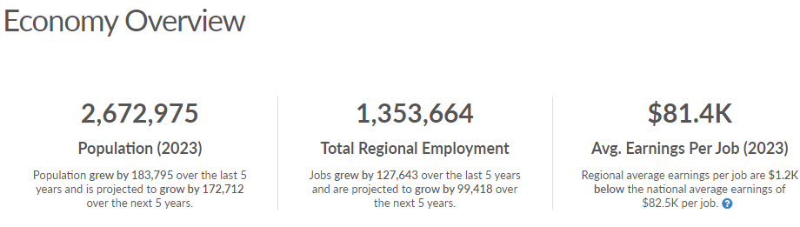
Source: Lightcast, Economy Overview
As of 2023, the region's population increased by 7.4% since 2018, growing by 183,795. Population is expected to increase by 6.5% between 2023 and 2028, adding 172,712. From 2018 to 2023, jobs increased by 10.4% in the North Central Prosperity Zone from 1,226,021 to 1,353,664.
This change outpaced the national growth rate of 3.6% by 6.8%. As the number of jobs increased, the labor force participation rate increased from 62.0% to 64.1% between 2018 and 2023.

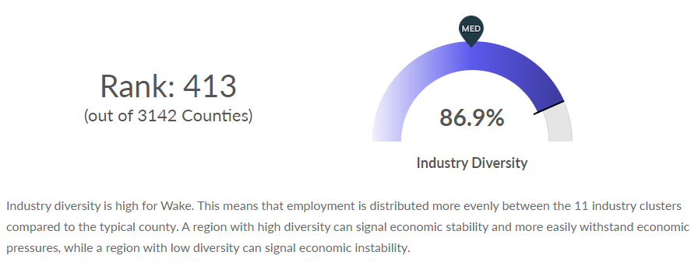
Source: Lightcast, Industry Diversification
In 2017, a Regional Skills Analysis was conducted by RTI in partnership with Capital Area Workforce Development, Durham Workforce Development Board, Kerr-Tar Workforce Development Board, Wake County Economic Development, and the City of Raleigh. This study surveyed over 500 businesses across 15 counties and 10 industry sectors to uncover projected growth, skills and education requirements, and workforce challenges. One significant finding this study revealed was that 73% of companies surveyed expected to grow in the next 3 years, resulting in between 22,000-36,700 new jobs – not considering new economic development growth that was likely to also be entering our market.
Companies revealed their greatest source of talent is through friends and networks, highlighting the challenges many in our region’s workforce face with barriers to access these industries and occupations. The research also demonstrated the need for degrees and technical education. Companies value employees with a 4-year college degree, but there is variation in education expectations across industries. Some industries place a higher value on education, while others focus on technical training. Respondents across all industries have a pressing need for employees who can take initiative and think critically.
The results of the 2017 study have provided much-needed guidance to workforce and education partners. This critical data has helped to drive decisions on programs, initiatives, and funding and has been cited regularly in grant applications, sector partnership discussions, and broader workforce development programs and initiatives. Private and public partnerships have been created and strengthened as a result of this data gathering and alignment of services.
In 2023, the Regional Skills Analysis survey was updated for the 15-county area with almost 1,000 responses and 11 industry sectors. 77.5% of the companies surveyed expect to grow their workforce in the next three years. There are four key themes from the survey:
- Company hiring expectations are the highest we have seen in our survey, with few industries planning to downsize.
- Healthcare and the public sector have consistently high demand, driven by growth in both sectors.
- Four-year degrees remain top of mind for employers, but they are considering more options and looking for additional, specialized credentials.
- Small and medium-sized businesses are underutilizing many resources available for sourcing talent.
Our region’s economic developers have continued to receive interest inquiries from prospective employers looking to relocate to our region, demonstrating the strength and value of our market – including our workforce and educational system.
An analysis of the regional economic conditions by the numbers is listed below for an existing and emerging in-demand industry sectors and occupations.
Existing Industry
Instead of looking at specific industries, cluster analysis catches the potential spillovers of technology, skills, and information that cut across industries, workers, and resources.
Industry clusters most important to the region are Education and Knowledge Creation, Information Technology & Analytical Instruments, Biopharmaceuticals, Local Financial Services, Financial Services, and Local Health Services. “Importance” considers earnings, growth, regional competitiveness (regional job growth exceeds the national average job growth), location quotient (workforce specialty), and GRP and assigns a *Score. The top industries within each cluster are shown.
(This data is not a benchmark against other regions; it only compares the relative performance of clusters to each other.)
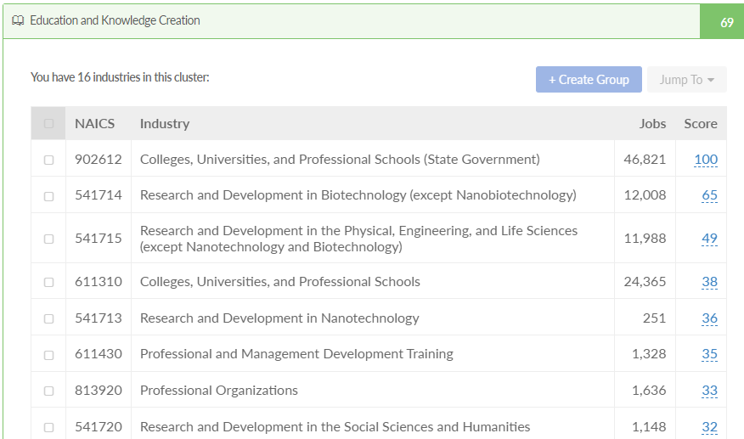
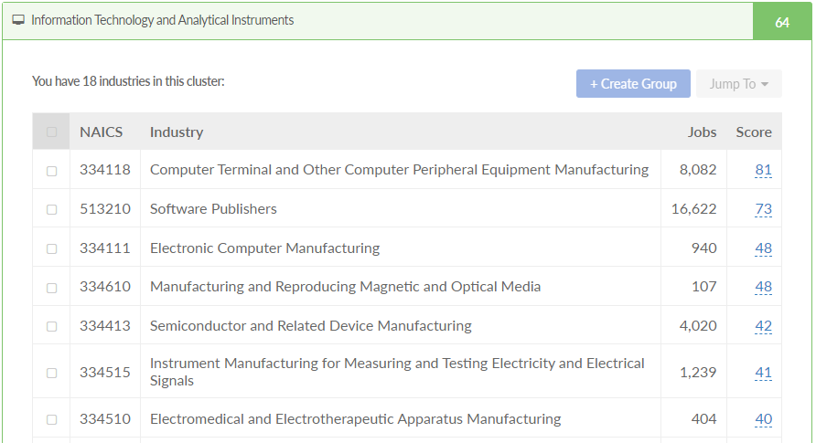
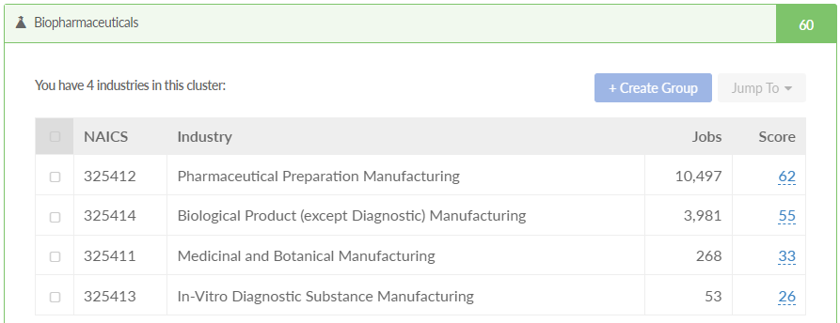
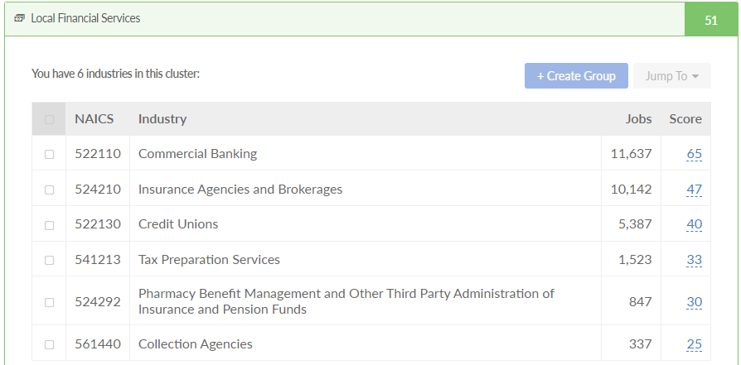
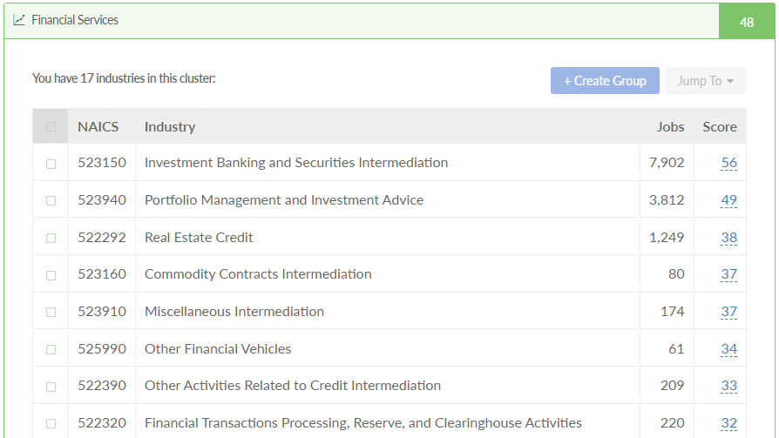

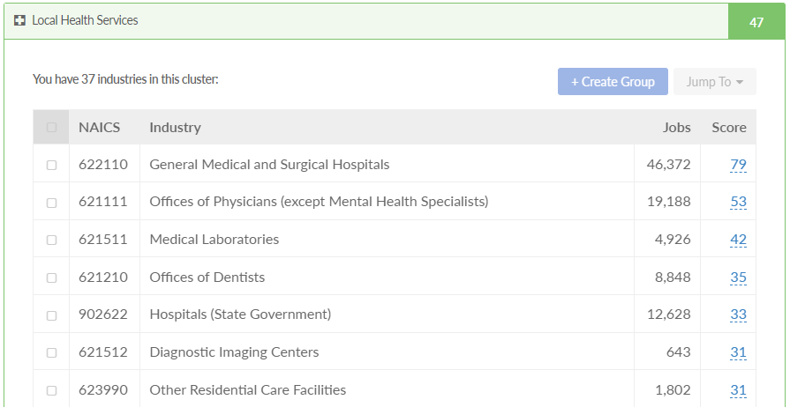
Source: Lightcast Industry Cluster Identification
*Our average cluster score is 32 (out of 100) points. Clusters ranked higher than 32 are above average. Top clusters must have a score of at least 40, while bottom clusters must have a score of 17 or less. These thresholds are determined by applying the average deviation (plus or minus 7) to the average cluster score 32.
Occupations
Below are the largest occupations in the region; the types of work people are performing. They are ranked by 5-year job growth and do not consider the industry where work is being performed.
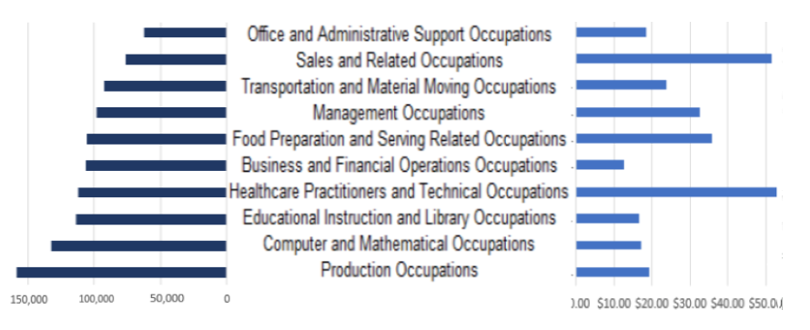

Occupations
Below are the largest occupations in the North Central Prosperity Zone: the types of work people are performing.
They are ranked by 5-year job growth and do not consider the industry where work is being performed.
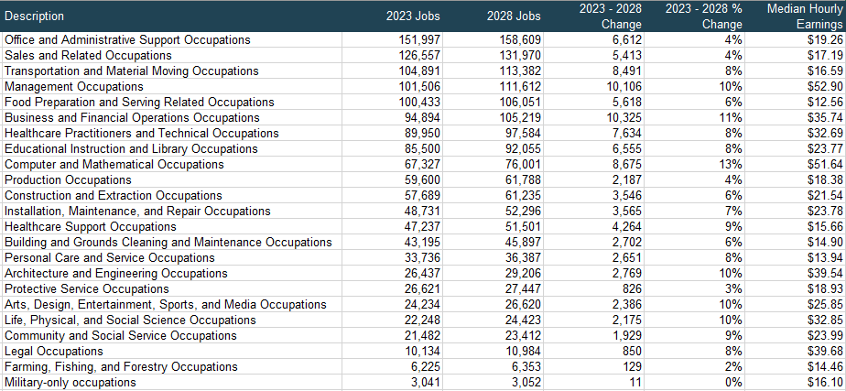

Fastest Growing Occupations
Ranked by ‘Change in Jobs’ from 2023 to 2028
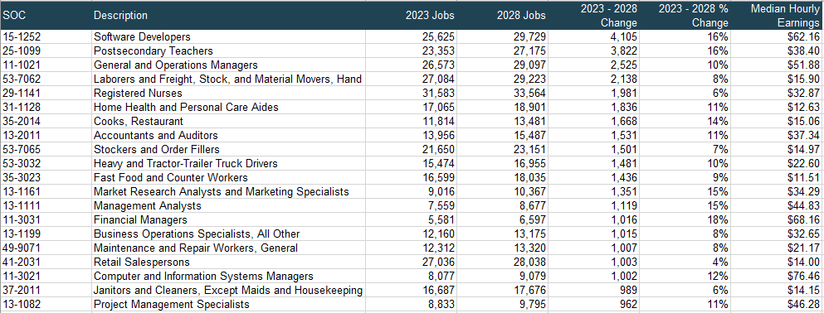

Occupations Shedding Jobs
Below are the occupations decreasing in number. Many of these occupations are related to the industries projected to lose jobs in Table 3 so they are vulnerable to layoffs and closing as companies make workforce decisions.
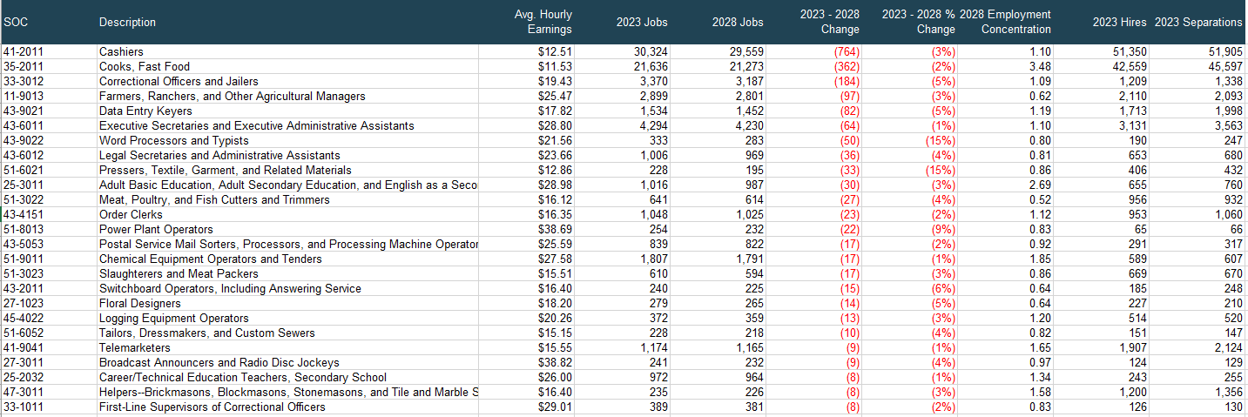

- Describe how the regional strategic vision aligns with the NCWorks Commission’s 2023-2025 Strategic Plan.
(COPY) CAWD
The five Boards identified as a regional area have not traditionally needed to work regionally to address employer needs or job seeker needs. Traditionally, CAWD, Kerr-Tar, and Durham have partnered to work together because of the proximity and shared businesses in Research Triangle Park. However, as a Workforce Board System, Workforce Boards across NC meet every month virtually and face-to-face quarterly to address common needs, share best practices, and more. CAWD will continue to use this forum to determine when it is necessary to partner with Turning Point and Mid-Carolina to meet the needs of employers and job seekers in the region.
The three CAWD, Kerr-Tar, and Durham Workforce Boards’ Business Engagement staff meet regularly to better understand what is happening from an employer perspective. This provides an opportunity for them to identify common challenges and work on solutions as well as share best practices. The Boards will continue regular joint meetings and regional employment engagement when appropriate and plan to include Turning Point and Mid-Carolina. Three Boards (CAWD, Kerr-Tar, and Durham) utilize the same Incumbent Worker Brand (Catalyst 2020), and application, with the only variance being the amount each Board allocates per application and lifetime maximum. The rationale is that if labeled the same when an employer has operations in more than one of the contiguous workforce Boards, there is uniformity causing less confusion (except for the number of reimbursements for the employer). This template will be shared with Turning Point and Mid-Carolina if they wish to use it; however, because they are also part of other regions, this may not be possible.
CAWD, along with Wake County Economic Development sponsored 2023 Skills Survey which included Economic Development, has also served as a source to ensure that Boards understand the skills needs of the employers in our region. The skills survey included a 15-county region which includes all the Workforce Boards identified in the North Central region. Despite challenges related to the pandemic, the survey revealed that a high percentage of businesses plan to continue to grow and many expect to hire for new jobs. The high percentage reflects the strong local economy and suggests that while economic growth will remain slow, a recovery will occur in the Research Triangle region.

- Provide an analysis of the workforce in the region, including current labor force employment and unemployment data, and information on labor market trends, and the educational and skill levels of the workforce in the region, including individuals with barriers to employment. [WIOA Section 108 (b)(1)(C)].
Labor Force
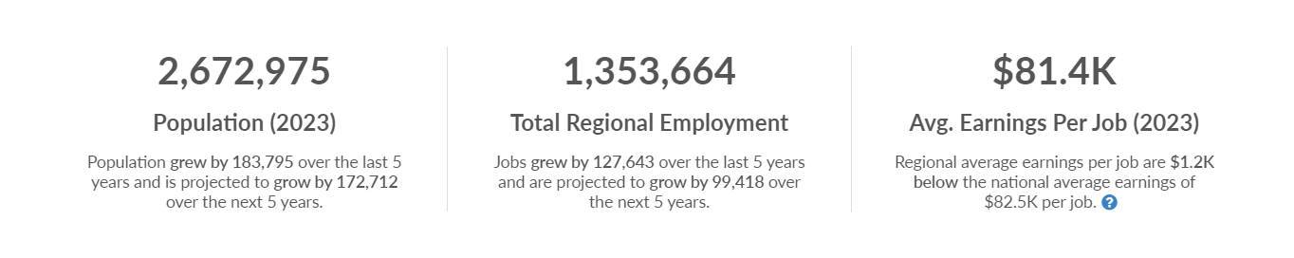
Source: Lightcast.io

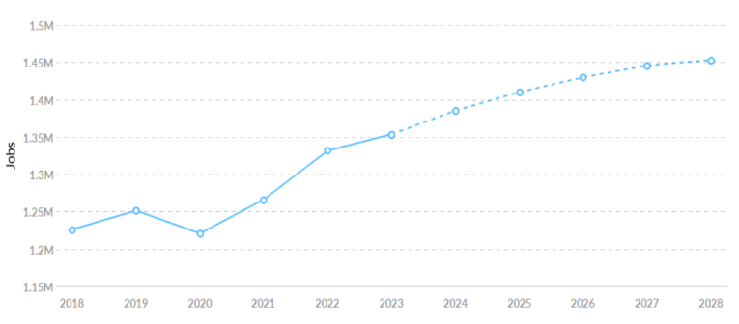
As of 2023 the population of the North Central Prosperity Zone (NCPZ) increased by 7.4% since 2018, growing by 183.795. The population is expected to increase by 6.5% between 2023 and 2028, adding 183,795 people.

Over the same period, jobs increased by
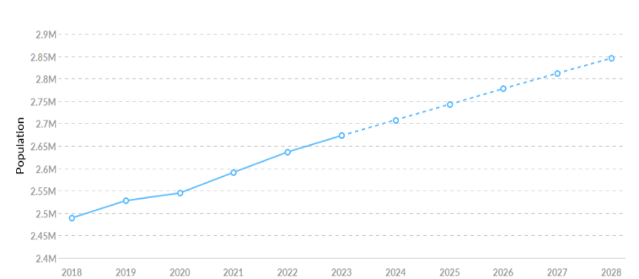
10.4%, from 1,226,021 to 1,353,664. This
change outpaced the national growth rate of 3.6% by 6.8%. The labor force participation rate increased as the number of jobs increased, growing from 62% to 64.1% between 2018 and 2023.

At the end of 2023, the region’s unemployment rate was 3.0%, less than the state (3.2%) and nation (4.1%). Only the Western Region Prosperity Zone was lower at 2.7%.

Concerning educational attainment, 26% of the region’s residents possess a bachelor’s degree (5% above the national average), and 9.3% hold an associate degree (0.3% above the national average). High school diplomas are held by 20% and 18% have some college education. Just over 5% only have a 9th-12th grade education and 3.7% have less than a 9th grade education.

Data provided by the Department of Public Instruction to MyFutureNC, a statewide nonprofit focused on educational attainment, indicates that 77.3% of postsecondary degrees and credentials conferred by education institutions in the North Central Prosperity Zone are aligned with labor market needs. They are earned in the region’s top industries: Health Care and Social Assistance, Professional Scientific and Technical Services, Retail Trade, Accommodation and Food Services, and Manufacturing. They also reported that 5,644 individuals participated in an ApprenticeshipNC program in 2020 and that 60% of adults (ages 25-44) in North Central earned a family sustaining wage in 2022.

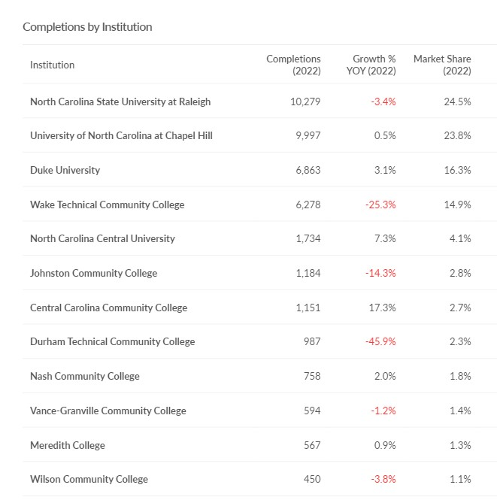
The region has several outstanding educational institutions that contribute to its reputation of having a highly skilled, educated, and motivated workforce and helps to create a strong talent pipeline. The population exceeds minimum education requirements for jobs requiring some college, an associate degree, or graduate degree. The percent of population with bachelor’s degrees is only 5% under the percentage of jobs that require it.
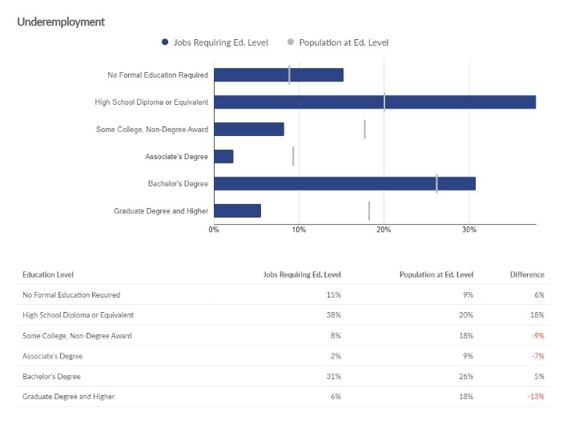

Below is data reflecting the skills on individual job profiles of individuals that have updated their work histories since 2021. The information is ranked by how frequently the skill shows up in the top 10 Specialized Skills group, and the 10 Common Skills group.

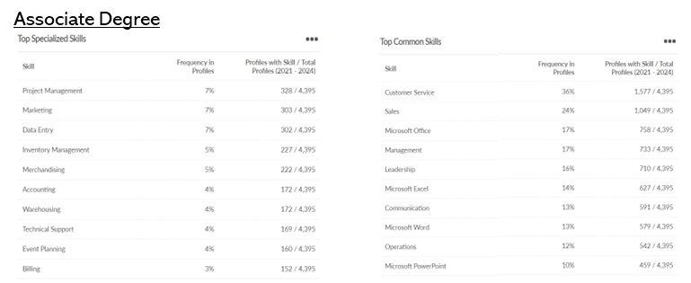

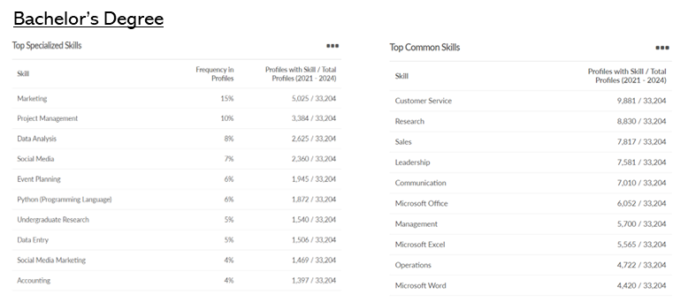

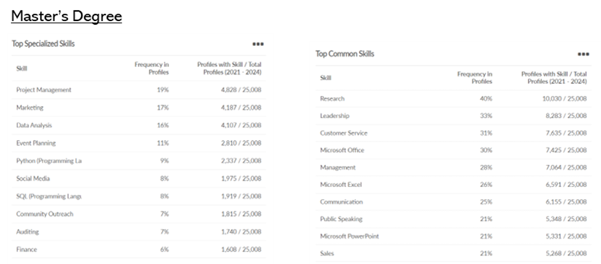

Barriers

The Workforce Innovation and Opportunity Act (WIOA) focuses on serving “individuals with barriers to employment” and aims to provide quality services for these populations. Barriers include:

Lack of Educational Attainment

Despite the education positives in region, the pandemic had a profound effect on overall educational attainment that is ongoing, especially in the more rural counties of the region. A new report analyzing the performance of North Carolina K12 students found that learning progress slowed across all grades and subjects. Students made less progress on average than students in the same grades and courses in previous years. Youth represent the next generation that will drive the workforce and inform innovative developments. They influence societal developments in many ways and have grand contributions to make. But improvements in educational attainment have to be made, especially in the region’s rural areas.

MyFutureNC reported the following for the NCPZ workforce areas:

Turning Point
- 37% of students are chronically absent from school compared to 32% statewide.
- 10,105 less are needed to meet state goal of 11%
- In 2022, 3% of students dropped out of high school (374 total students), compared to 2% statewide.

Kerr-Tar
- 44% of students are chronically absent from school compared to 32% statewide.
- 8,946 less is needed to meet state goal of 11%
- In 2022, 3% of students dropped out of high school (271 total students), compared to 2% statewide.

Durham
- 41% of students are chronically absent from school compared to 32% statewide.
- 10,045 less is needed to meet state goal of 11%
- In 2022, 4% of students dropped out of high school (492 total students) compared to 2% statewide.

CAWD
- 24% of students are chronically absent from school compared to 32% statewide.
- 31,528 less are needed to meet state goal of 11%
- In 2022, 2% of students dropped out of high school (1,193 total students) in line with 2% statewide.

The disruption to postsecondary education caused by the pandemic caused young people to have to rapidly adjust to unexpected circumstances. According to Strada Education, the number of students attending college continues to drop resulting in a 6.5 percent decline in undergraduate enrollment and a 12.3 percent decline in first-year enrollment since 2019. Communities of color have been disproportionately affected, with Native American and Black students experiencing the steepest enrollment drops.

Reconnecting students using a range of modalities, from virtual communication to in-person events, can help provide students with the guidance they need to navigate education and decisions. According to Strada’s research, short-term and career-focused training options can offer an entry point into postsecondary education for students who are focused on starting their careers. Integrating resources and support from community-based services, designating aid programs for specific student populations, are also effective practices. The workforce and education systems must continue to partner with education and community organizations to develop and deliver practices that engage disconnected youth, and continually reassess and refine what works.
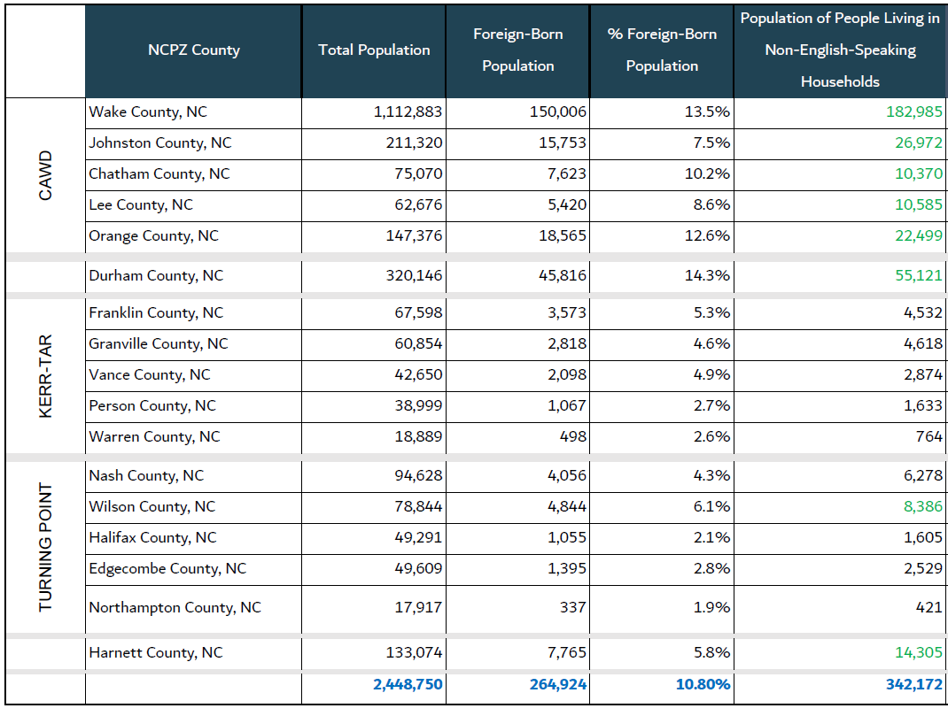
Source: Lightcast.io Community Indicators/2020 U.S. Census
- English Language Proficiency

Over a quarter million people make up the region’s foreign-born population. Every effort is being made to eliminate, to the maximum extent possible, limited English proficiency as a barrier to full and meaningful participation in the workforce. The NC Department of Commerce posits that immigration will play an ever-increasing role in alleviating worker shortages.

The number of people living in non-English speaking households exceeds 342,000. Being able to overcome language barriers is important to ensure accessibility to services for all residents. The workforce system must prioritize having forms and other documents in multiple languages and invest in technologies that ease communication between staff and non-English speakers. Hiring bilingual staff is also critical.

- Previous Incarceration

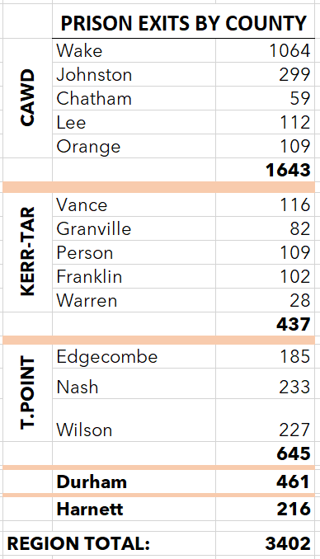
The North Carolina Department of Adult Corrections (DAC) reports that 19,559 individuals were released from North Carolina prisons between February 1, 2023, and January 31, 2024. For the NCPZ, exits totaled 3,420, about the same as the previous year’s total of total of 3,424.

Successful reintegration is paramount for those returning from prison and it is also a matter of public safety and economic necessity. A criminal justice system that emphasizes incarceration but does not support the journey home does a disservice to everyone.

Effective rehabilitation and skill development for those incarcerated and formerly incarcerated is critical to reducing recidivism and strengthening households and the economy. However, returning citizens face tremendous barriers when it comes to gainful employment.

According to LEAD at NC Department of Commerce, even amid North Carolina’s hot labor market of 2021, when job opportunities were plentiful and businesses were desperate to hire workers, fewer than half of people exiting state prisons in North Carolina were employed within a year after release, and those lucky enough to land a job earned a median of only around $7,500 per year.)

LEAD offers several explanations for why the employment outcomes of people exiting prison have gotten worse over the years, including: (a) the changing composition of the prison population, (b) the increased prevalence of pre-employment criminal background checks, (c) the loss of employment opportunities for blue-collar workers and (d) racial disparities.

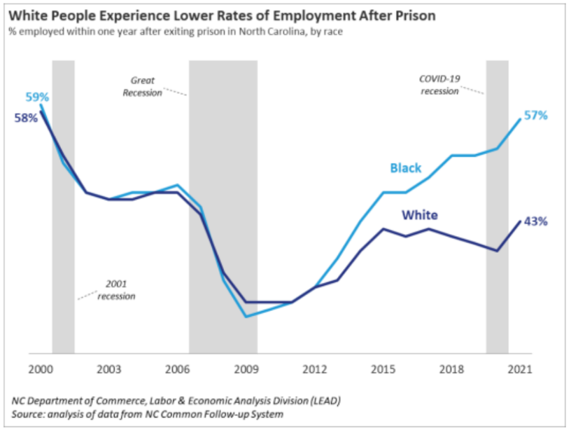
Yet, though Black people are disproportionately represented in our prison system, making up 51% of those incarcerated in state prisons, double their 20% share of the overall statewide population, black people getting out of prison were more likely to find work than their white counterparts. Declining employment rates has been almost entirely accounted for by the deteriorating outcomes of white people leaving prison!

- Vulnerable Communities

Vulnerable communities are groups of individuals or geographic locations that are disadvantaged and susceptible to negative outcomes in a variety of areas. Three areas known to be barriers to employment are disabilities, low income, and poverty.
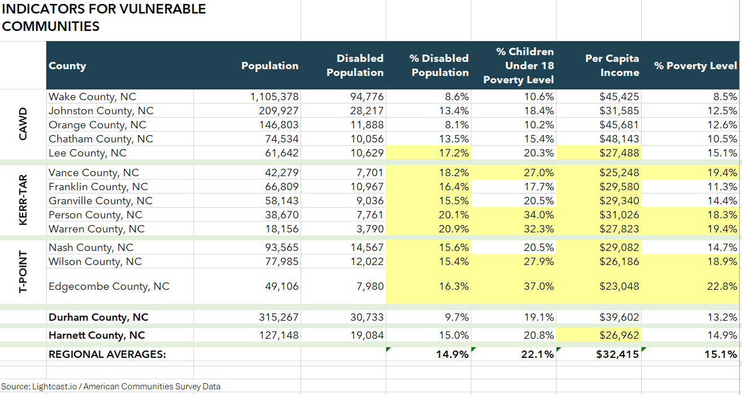
Several counties within the North Central Prosperity Zone have concentrations of disabled individuals and poverty rates that are higher than the regional average and have below-average income per capita.

People with disabilities, seen or unseen, are less likely to be able to access resources and are more vulnerable to long-term unemployment and pay disparities.

According to the Bureau of Labor Statistics, the unemployment rate for people with a disability (7.2 percent) was little changed in 2023. They further state that for all age groups, employment was much lower for people with a disability than for those with no disability. Unemployment rates were much higher for people with a disability than for those with no disability across all educational attainment groups. Workers with a disability were nearly twice as likely to work part-time as workers with no disability, and workers with a disability were more likely to be self-employed than those with no disability.

Advancing Economic Mobility for Low-Income Families: Policy Options for Governors states that low-income individuals experience significant barriers to achieving upward economic mobility because participation in work or education may not be logistically or financially feasible, or because an individual has not been able to establish a solid financial foundation to build upon. Though the link between poverty and education is complex, children who live in poverty perform at a lower level in school, have lower high school and college graduation rates, and lower college enrollment rates than children who are not living in poverty.

For low-income families, many of whom historically have been marginalized, post-pandemic economic recovery outcomes have been uneven, increasing the need for people-focused and sustainable practices to advance economic security, mobility, and resilience. It is within this context that WIOA is designed to help adults and youth access employment, education, training, and support services to succeed in the labor market.

Resources:
https://lightcast.io/
https://dashboard.myfuturenc.org/county-data-and-resources
https://www.census.gov/library/stories/2019/03/do-people-with-disabilities-earn-equal-pay.html
https://www.bls.gov/news.release/pdf/disabl.pdf
https://www.commerce.nc.gov/news/the-lead-feed/nc-post-prison-employment-outcomes
https://webapps.doc.state.nc.us/apps/asqExt/ASQ
https://www.nga.org/publications/advancing-economic-mobility-for-low-income-families-policy-options-for-governors/
Click here to enter text.

- Describe strategies, used to facilitate engagement of businesses and other employers, including small employers and in-demand industry sector occupations. Describe methods and services to support the workforce system in meeting employer needs. [WIOA Section 108 (b)(4)(A)(i)(ii)].

(COPY) CAWD
Workforce Boards and our NCWorks Career Center Business Services staff utilize a highly collaborative and consultative approach to engage and serve our region’s businesses and industries. By leveraging technology and data, partner relationships, outreach and awareness events, and other traditional methods, we create and foster an innovative and effective workforce system that strives to fully meet employer needs. Technology plays a vital role in our ability to identify and connect with employers, including but not limited to our use of the NCWorks Online System and our social media platforms.
As an example, in the Capital Area, employer-specific reports are generated through NCWorks Online to quickly identify companies who are newly registered onto the system as well as existing employers who are utilizing the system to post job openings and source new talent. Our staff uses these reports and updates to plan targeted employer outreach within their designated territories. In addition, our access to EMSI helps to identify prospective customers within our targeted counties. As a result of these outreach efforts, we can initiate and strengthen relationships with businesses and provide consultative support.
The staff regularly references tools within NCWorks and EMSI to obtain critical labor market data that is valuable in conversations with employers regarding wages, talent supply, educational attainment and more.
Our use of social media has greatly increased our capacity to reach a broad and diverse audience and positions our organization as subject matter experts for workforce development. Through these channels, we have raised awareness of job opportunities in our communities, promoted and significantly increased attendance at our sponsored events and workshops, and kept our business community informed of valuable resources, programs, and initiatives that strengthen our region and workforce.
With the involvement and commitment of our Business Services team, our region has built an incredibly robust partner network that is an excellent source of referrals for business customers and job seekers. Our relationships with economic development, local chambers of commerce, industry associations, educational institutions, and other community partners have been invaluable in helping our team establish high-quality connections with business leaders and elevate our service delivery and impact.
The Business Services team gets actively involved in the communities they serve - regularly attending local and regional networking events, serving as exhibitors and community sponsors for job fairs and career awareness events and conducting speaking engagements for workforce-related events and conferences. Being active and engaged in our region helps staff gain critical business intelligence on current challenges and opportunities, workforce needs, gaps in resources, growth trends and more. We develop relationships and interactions with employers of all sizes and across multiple industry sectors.
These employer relationships have been instrumental in our various sector partnership initiatives, employer roundtables, career awareness events, and professional development for our staff. Having access to their insights and expertise helps to ensure that our full team stays on top of our growing sectors and regional workforce needs.
CAWD also takes advantage of a small business grant from the Division of Workforce Solutions to provide workforce support services to businesses with 25 employees or less. As well as a grant from Wake County Government to provide workforce services to businesses with 50 employees or less.
In summary, the Business Services team partners with employers to deliver high-quality talent and workforce solutions. This includes but is not limited to: Recruitment and Screening; Training and Education; Retention and Up-Skilling; Transitional Services; and access to Workforce Information and Data. Additionally, work-based learning incentives such as On-the-Job Training, Work Experience, Incumbent Worker Training, and Registered Apprenticeship programs are also utilized to ensure that the vast needs of employers are met.

- Describe strategies and services used to coordinate workforce development programs and economic development. [WIOA Section 108 (b)(4)(A)(iii)].
(COPY) CAWD
Regionally, The Economic Development Partnership of North Carolina (EDPNC) continues to leverage our local and regional economic development partners for recruitment retention and expansion opportunities. The local and regional economic development teams pull local Boards to the table, with targeted partners, to present information on the labor pool that we must support their company should they choose to (re)locate or expand their business in our area.
The Capital Area region has been recognized as one of the strongest economies in the nation and a top market for new and existing industry investments. This success is due in large part to the collaboration efforts that exist between our private and public sectors. This collaboration is thriving and evident throughout our partner ecosystem - comprised of economic and workforce development, education, government, chambers of commerce, and community partners. This partner network is led and shaped by business and industry and shares a common goal of driving growth and prosperity for our community and citizens. Capital Area’s Business Engagement Director meets regularly with Economic Development for Wake, Johnston, and Lee Counties to collaborate on strategies to ensure we are meeting the needs of employers in our region. CAWD continues to work to strengthen the relationships with its new Counties, Lee, Chatham, and Orange.
Capital Area will continue to engage with Boards in the North Central region as well as other regions based on employer needs and demand. For example, because of the large presence of advanced manufacturing in the Triangle as well as Piedmont Triad, CAWD is partnering with Durham WDB, Kerr-Tar WDB, Mid-Carolina WDB, Greensboro WDB, and Piedmont Triad WDB to address the growing demand of training and employment related to advanced manufacturing. So, while CAWD will continue to meet regularly with workforce Boards in our region, we will also continue to meet with all Workforce Boards as the collaboration needs to be based on the needs of employers, not a geographically drawn line.

- Outline regional transportation issues related to workforce development and ways the region is/will address needs identified. Include a description and map of the regional commuting patterns. [WIOA Section 108(b)(11)].
.
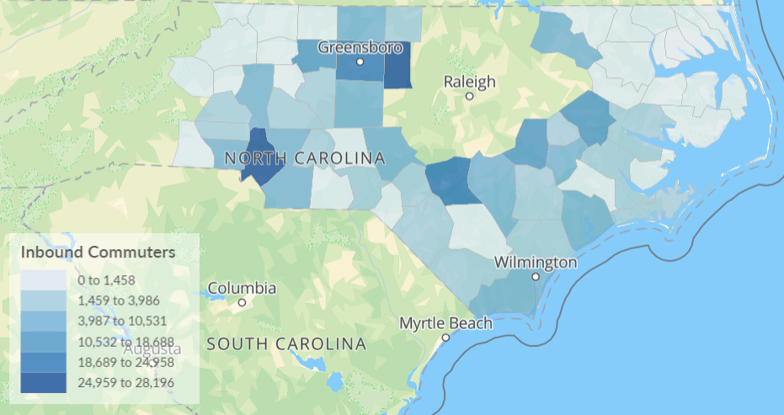
Alamance
Mecklenburg
Forsyth
Cumberland
The 15 counties of the North Central Prosperity Zone, shown above anchored by the city of Raleigh, had a total of 34,227 net commuters for 2023 according to Lightcast.io. Inbound commuters totaled 244.248 and outbound commuters 210,211. Mecklenburg and Alamance, shown in dark blue, have the most inbound commuters of 28,196 and 24,959 respectively. Cumberland, Guilford (anchored by Greensboro), and Forsyth round out the top five with 18,896, 18,689, and 12,170 respectively.
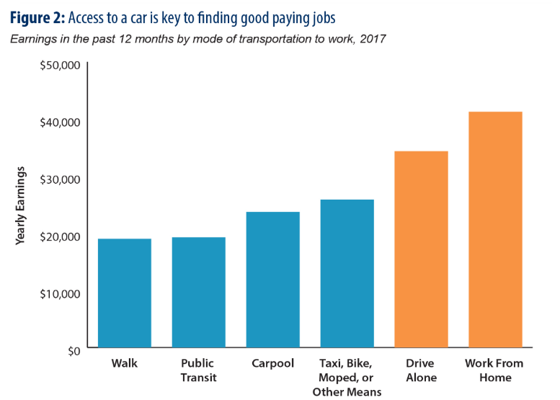
According to a 2019 report by the NC Department of Justice, access to a car is key to finding good paying jobs. Jobs are increasingly concentrated in metropolitan areas where housing is higher.
Many working North Carolinians often can’t afford to live anywhere near where jobs can be found and those that do bridge the live-work divide face long commutes and onerous transportation costs.
More than 7 percent of residents in rural counties face at least an hour-long commute, a nearly 50 percent larger share of commuters than in urban counties. Counties with majority non-white populations also face long commutes at higher rates than majority white counties. In both cases, these long commutes affect communities that already contend with a range of other economic barriers.
Public transit is key to employment opportunities. The share of low-income North Carolinians who rely on public transit is much higher than the national and regional average, a clear sign that access to public transportation is important. Of the three Boards serving the majority of the NCPZ, Kerr-Tar had the most outbound commuters, net -31,839 followed by Turning Point at -8,844. They also have counties with household incomes lower than the region’s average and poverty levels higher than the regional average.
The Kerr-Tar area doesn’t have public bus service, though the Kerr Area Transport Authority (KARTS), a public, rural transportation system providing scheduled/reserved rides, does service residents in Franklin, Granville, Vance, and Warren Counties. Fares vary by the mile and can run $8.00 roundtrip for a rider within 10 miles to $14 for 30-40 miles. Fares to destinations out of the KARTS service area to job centers such as Chapel Hill, Durham, or Raleigh, are $20-$25 round trip. This can really add up and be cost-prohibitive for some families.
The region’s urban centers are not without transportation issues. With unprecedented population growth and traffic congestion, improving public transportation is at the heart of infrastructure discussions. Chief among the discussion is commuter rail that passes through employment centers such as downtown Durham, downtown Raleigh, downtown Cary, Research Triangle Park, Duke University and Medical Center, North Carolina State University and Clayton’s expanding pharmaceutical manufacturers.
Resources
https://www.ncjustice.org/publications/the-budget-story-transportation-infrastructure-connects-people-business-and-communities/
https://www.readyforrailnc.com/feasibility/

- Briefly provide a description of how the Local Area WDB will coordinate education and workforce investment activities carried out in the local area with relevant secondary and postsecondary education programs and activities to coordinate strategies, enhance services, and avoid duplication of services. [WIOA Section 108(b)(10)].

(COPY) CAWD
The region coordinates with secondary education, community colleges, and universities to align strategies, enhance strategies, and avoid duplication of services through coordinating regional applications for career pathways certification through NCWorks Commission, and by regional coordination between Board Business Services staff for employer engagement activities currently for Kerr-Tar, CAWD, and Durham. The Region has collaborated with Incumbent Workers application to ensure with seamless strategies, as well as in past years Job Driven Initiative Strategies coordinating with regional Boards. Community colleges, and WDB Board staff have made this a seamless process. CAWD will include Turning Point and Mid-Carolina in these conversations as they impact their region. AdvancedNC serves as another good example of Workforce Boards working regionally to coordinate education and workforce investment activities to coordinate strategies, enhance services, and avoid duplication of services. The AdvancedNC includes community colleges as well as 2 land grant universities. While secondary education is not part of the partnership today, there has been a conversation about adding them in the future.

- Briefly describe how the NCWorks Career Centers serve military veterans.
(COPY) CAWD
For the Capital Area, NCWorks Career Centers provide Priority of Service to veterans and eligible spouses and immediately work to assess their needs and provide services. Career Center staff provide in-person services during scheduled hours at each location. As part of Priority of Service, veterans are also allowed to view and apply for newly posted positions within NCWorks before the posting is made available to all other job seekers. The Center hosts job fairs targeting veterans and, typically, veterans are also given priority during recruitment events, job fairs, and training opportunities. The Center also presents to community agencies, chambers of commerce, and employers to attract veterans to our local Career Centers as well as enhance services in the community. Both CAWD Tier 1 NCWorks Career Centers have either a Local Veteran Employment Representative (LVER) or a Disabled Veteran Outreach Program (DVOP) located on staff to help veterans with significant barriers overcome their barriers to employment.

- Explain the strategic plan for how the region will respond to national emergencies or weather-related disasters to serve victims (such as lay-off aversion activities) and utilize special grants efficiently throughout the recovery period.

(COPY) CAWD
As a region, we stand ready to respond to national emergencies or weather-related disasters to serve victims and businesses. How each Board services its region varies based on the need and the funding available. For example, CAWD has traditionally not had to apply for special funding for cleanup and other disaster relief in Wake County because the County and the City of Raleigh are usually responsive before Workforce Development Board funds are available. However, in Johnston County, Capital Area did apply for emergency funds as requested by Johnston County to help clean up after a major storm. CAWD’s strategy is to reach out to the counties in our region after an emergency to determine how we can help and based on the need, apply for available funding if the service is not allowed with the funding CAWD already has on hand.

- NCWorks Commission

The NCWorks Commission recommends policies and strategies which value diversity, equity, inclusion, and accessibility while enabling the state’s workforce to compete in the current and future global economy. The commission leads, builds partnerships, forms alliances, and is accountable for strengthening North Carolina’s innovative, inclusive, relevant, effective, and efficient workforce development system.

The Commission is designated as the state’s WDB under the federal Workforce Innovation and Opportunity Act. Led by a private sector chair, the 37-member Commission includes representatives from the business community, heads of state workforce agencies, educators, and community leaders. All members are appointed by the Governor.

Mission of the NCWorks Commission: To ensure North Carolina has an innovative, relevant, effective, and efficient workforce development system that develops adaptable, work-ready, skilled talent to meet the current and future needs of workers and businesses to achieve and sustain economic prosperity; and to ensure North Carolinians are ready for the jobs of today and tomorrow by increasing access to education and skills training, fostering employer leadership to prepare workers, and supporting and scaling local innovation.

After extensive stakeholder work and programmatic reviews, the following systemwide goals and objectives were created for the workforce development system:

- Prepare workers to succeed in the North Carolina economy by increasing skills and education attainment.
- Create a workforce system that is responsive to the needs of the economy by fostering employer leadership.
- Promote replication of creative solutions to challenging workforce problems by supporting local innovation.
- Promote system access, alignment, integration, and modernization.

- Briefly describe how the Local Area WDB engages with local employers and informs them of the wide array of business services offered. Include how the Local Area WDB (a) ensures collaboration with other employer-facing workforce program representatives, such as (b) Vocational Rehabilitation, (c) Agriculture Services, (d) Foreign Labor, (e) Re-Entry, and (f) Veterans Services, through processes and procedures for information sharing and efficient employer customer service delivery.
(COPY)
The Board’s Business Service Manager works closely with Economic Devlopment Directors and Community College Customized and Industry Training Directors to remain abreast of expansion opportunities and training needs from businesses in the region. The Business Service Manager also meets weekly with Re-Entry, Veterans Services and Talent Employment Solutions Career Center Team Members to keep them abreast of pending employer needs. The weekly meetings also include frequent visits by VR, Agriculture Services and Foreign Labor representatives to discuss program updates and potential colaborations. The Business Services Manager and Talent Employment Solutions Team members regularly attend Chamber of Commerce meetings and events, often as speakers. The Business Services Manager also attends local Economic Development Commission meetings and Reentry Roundtable meetings which leads to opportunities to promote the Career Center services and creates opportunities for individual employer engagement.
The Local Area Reentry Roundtable is led by the Kerr-Tar WDB staff which includes regular monthly meetings and events such as a Reentry Simulation where local business and community leaders are invited to experience a walk-in-their- shows type event.

- Please provide a brief overview of the business services team within the local area. Please identify the individual staff roles the Local Area WDB utilizes to conduct business services (that is Business Services Representative (Local Area WDB staff), contractor staff, Business Engagement Coordinator, NCWorks Career Center Manager, DWS staff, Disabled Veterans Outreach Program, identify who makes regional and local employer referrals to Agricultural Services and/or Foreign Labor staff, etc.).
(COPY)
WDB Business Services Manager (BSR)
- Business Service Manager’s representation on VGCC Business Advisory Board
- Participation and representation on Local K-12 School System Business Engagement Councils and CTE Advisory Council
- Exploring/ promoting sector strategies with employers
- Regional collaboration with Capital Area and Durham Workforce Boards BSRs
BSR, Career Center Manager (DWS) & Service Provider Program Manager
- Kittrell Job Corps Business Advisory Board representation
- Joint employer vists with Community College Customized Training Director
- Career Pathways planning, employer engagement activities in collaboration with Capital Area and Durham Workforce Boards
- Next Gen Sector Partnership with Person and Durham for Advanced Manufacturing
- Compile success stories and program information for COG Newsletter
- Compile success stories and program information for VGCC Blueprint industry publication
BSR, Career Center Manager (DWS), Service Provider Program Manager, Veterans Representative and NCWorks Career Center Business Services Staff
- weekly meeting to discuss business services related items and events
- LMI and hiring trends to forecast service level volume and prepare activities
- Utilizing employer data to inform priorities
- Representation at Chamber of Commerce Events
- Representation at Local community events
- Representation at Community College events and Career Days
- Local partner agency events (Vocational Rehabilitation, Chamber Events, etc.)
- Making employer referrals to Agricultural Services and/or Foreign Labor staff
BSR and NCWorks Career Center BS staff
- Business Services team employer calls, visits and check ins
- Promoting work-based learning opportunities to employers
- Utilized Cooperative Extension Ag Agents to meet with hemp employers in the region in an effort to assist with education efforts for employees and other support businesses
Kerr-Tar does not have a Business Engagement Coordinator
- Briefly describe how the Local Area WDB plans to increase NCWorks brand awareness at the local level (consult NCWorks Commission 2023-2025 Strategic Plan).
(COPY)
The Board plans to continue to promote the NCWorks brand as the communities location for jobseeker employment or re-employment resources, where the local community can undertake career awareness and exploration activities as well as learn about opportunities for skill attainment and education advancement. The Board will follow the lead of the DWS Public Information Office, NCWorks Commission Staff, and NC Association of Workforce Boards to assure that the Boards printed and online marketing material is consistent with other Boards in North Carolina.

Communities across North Carolina are developing strong local models of workforce development. North Carolina should build on those successes and replicate them in more places to continue building and expanding innovative solutions.

- Describe how the Local Area WDB and the partners identify, address, and provide new and innovative solutions to support the job growth and business expansions of the local workforce system while including Diversity, Equity, Inclusion, and Accessibility.
(COPY) NEED DEIA
The Board’s Business Service Manager works closely with Economic Devlopment Directors and Community College Customized and Industry Training Directors to remain abreast of expansion opportunities and training needs from businesses in the region. The Business Service Manager also meets weekly with Talent Employment Solutions Career Center Team Members to keep them abreast of pending employer needs. The Business Services Manager and Talent Employment Solutions Team members regularly attend Chamber of Commerce meetings and events, often as speakers. The Business Services Manager also attends local Economic Development Commission meetings which leads to opportunities to promote the Career Center services and create opportunities for individual employer engagement.

The U.S. Departments of Commerce and Labor have jointly identified Recruitment and Hiring; Benefits; Diversity, Equity, Inclusion, and Accessibility; Empowerment and Representation; Job Security and Working Conditions; Organizational Culture; Pay; and Skills and Career Advancement as the eight key principles of a good job. Refer to Training and Employment Guidance Letter No. 07-22 for details.

- Describe the Local Area WDB’s strategy for:
  - incorporating job quality principles into ongoing workforce development activities, to assist with identifying and creating long-term partnerships with employers offering good jobs;
  - creating strategic, flexible career pathways to good jobs that respond to local labor market needs.
(COPY) DETAIL FOR #6 BELOW PREVIOUSLY INCLUDED WITH THIS QUESTION ON OLD PLAN
(Helen narrative for B here)
The Board maintains constant communication with partners (Wagner Peyser, Economic Developers, Customized Industry Training Directors, Vocational Rehabilitation, Job Corps, Adult Basic Education, and K-12 mostly through CTE Advisory Boards and the local community college business advisory board to stay current on labor trends, partners service delivery successes and challenges, and to promote as much system alignment to complement each other’s work. WDB staff attends conferences and collaborative sessions with other WBD’s and workforce related groups to learn best practices and explore innovative ideas that can be utilized in the Local Area. Outreach continues to be a priority so utilizing social media and frequently attending public events has increased awareness and service delivery opportunities for the local workforce system.
a. Communication with the employer is key. It begins with having a clear understanding of the employer needs beginning with a site visit as a preferred early step. Conversations with employers include discussions about how services and programs can help fulfil their current and future workforce needs. Staff meetings are held to ensure that all staff are aware of the employer needs and preferences in order to make most effective referrals. Quality check ins are made with the employer along the way ensure a positive long term partnership.

- Describe how the Local Area WDB ensures that individuals from underserved and underrepresented communities have equitable access to the services of the workforce system and the jobs created in the economic growth spurred by federal investments.
SEE NOTE ABOVE FOR #5
(Previously answer B for number 5 above.)
(Review below for updates)
As a rural area, the vast majority of the individuals we serve are from underserved and underrepresented communities. With this in mind, we design all of our services with this population in mind and use the local Certified Career Pathways as a roadmap to career. We set up in remote sites such as libraries, community centers, housing authority training centers and education partner sites to give citizens in surrounding counties the opportunity to have in person services. We advertise our services through faith based organizations, social media, and word of mouth, as well as radio spots. We have an active leadership role in our local Reentry Roundtable.
- Describe how the Local Area WDB is engaged in work-based learning projects with local employers.
(COPY)
The Local Area WDB through the Kerr-Tar Career Centers have operated a very robust Work-Based Learning program. To enhance or increase opportunities, the Board’s Business Services Manager provides the Career Center referrals and leads. The Board’s Business Services Manager will also make an initial visit with team members to employers who are not currently utilizing Work Experience or On-The-Job Training.

- Briefly describe how the local board will ensure the continuous improvement of eligible providers of services through the system and ensure that such providers meet the employment needs of local employers, and workers and jobseekers. [WIOA Section 108(b)(6)(A)]
Click here to enter text.
- NCWorks Career Centers

North Carolina’s workforce system includes multiple agencies, programs, and funders. Collaboration, policy alignment, systemic communication, integration, and modernization of the workforce system will ensure a strong and healthy workforce system that can adapt to a changing economy.

For any documents that are missing or are unnecessary based on the response provided, please state, “No document is loaded and/or it will be loaded by a specific date”.
- Identify PY 2024 NCWorks Career Center location(s) including Comprehensive and Affiliate Sites; On-site partners; how NCWorks Career Center operator(s) are designated; provider(s) of WIOA career services and method of selection; whether youth service provider is on-site and, if so, youth services offered. Use the PY 2024 NCWorks Career Center Chart. [WIOA Section 121(b)(1)(A) and (b)(1)(B)]
- Name document: Local Area Name PY 2024 NCWorks Career Centers.

- Provide the name(s) of the current One-Stop provider(s), date, and process for when the competitive procurement of the One-Stop Operator(s) occurred. Include the expected length of the contract(s) (one to four years and the current year the contract is (e.g., two of three years). [WIOA Section 108(b)(16)]
(COPY NEED NEW DATES)
On October 2, 2022 Kerr-Tar WDB released a RFP for Bidders for One-Stop Operator. The RFP contained the scope of services, guidelines and requirements, and scoring criteria. An information session was held at the COG office on November 16, 2022 for interested respondents. One proposal was received by the December 16, 2022, 12:00 noon deadline. The proposal was reviewed by Board staff and independent reviewers to assure an arm’s lenghth relationship between Board staff in the review process. The RFP was scored with a passing grade and the NC Commerce Department of Workforce Solutions (DWS) was selected for recommendation. At the March 14, 2023 WDB meeting, it was recommended and the Board approved going into contract with DWS for one year.

- Provide a brief description of how Career and Training Services are provided. [WIOA Section 121(e), 134(c)]
- Provide a description of how Career and Training services are provided to adults.
- Provide a description of how Career and Training services are provided to dislocated workers.
- Provide a description of how Career and Training services are provided to youth.
(COPY)
A. Kerr-Tar one-stop delivery system is the basic delivery system for adult services. Through this system, adults and can access a continuum career and training services. Career services for adults are made available in all Kerr-Tar one-stop centers and affiliated sites in each local area. Adults needing training are provided Individual Training Accounts (ITAs) and access to lists of eligible training providers and programs of training through NCWorks that allows participants to make informed choices on where to use their ITAs. Registration is the process for collecting information to support a determination of eligibility. The NCWorks Career Center Talent Engagement and Talent Development Teams work together with partners to address the needs of the adult job seeker. When a job seekers comes into the career center for assistance, he is assessed by the Talent Engagement team to determine priority of service, education, previous work experience, and skills that are transferable. Assessments tools are used to such as LMI and Onet Online. Active listening techniques are also used to better evaluate customer’s needs. TD will discuss career choices and career pathways to determine any deficiencies. Finally, the adult job seeker is referred to appropriate services and partners to address deficiencies or referred to business services as needed.
B. The NCWorks Career Center Talent Engagement (TE) and Talent Development (TD) teams work together with partners to address the needs of job seekers. When a job seeker comes into the center, he is assessed by Talent Engagement, to determine education, previous work experience, and transferable skills. A profile is developed in NCWorks online, and once this is complete, he is referred to Talent Development. Talent Development determines where the job seeker is and what he wants to ultimately do using assessment tools in NCWorks and ONetOnline and active listening techniques. TD will discuss career choices and career pathways and determine if deficiencies exist and if so where. He will be referred to appropriate services or partners to address these deficiencies, or referred directly to business services if none exist.
C. An intake process is conducted to ensure that a youth entering the youth programs is both eligible and suitable for WIOA services. Following the completed intake, files are reviewed by Program Manager, Director, or Kerr-Tar WDB Program or Coordinator Staff to ensure all documents are compliant prior to enrollment in participation. A career advisor is assigned to meets with the youth to go through the enrollment process [i.e. Objective Assessment, and Individualized Employment Plan or Individual Service Strategy (ISS)]. The individual is co-enrolled in both Wagner Peyser and WIOA youth programs. Eligibility is determined through NCWorks Online VOS case management system. During the enrollment process, the career advisor facilitates the necessary assessments to determine interest and basic skills deficiencies needed to assist the youth in developing a plan for participation and discusses next steps in order to begin meeting necessary benchmarks. Plan Implementation /Program Participation completes the enrollment for the youth who is considered a WIOA participant at this point. Funds (i.e. supportive services, training, incentives etc.) can be made available to the youth as long as the need is documented on the ISS and reflected in a detailed case note. The career advisor supports the youth in providing necessary wrap around services, guidance, direction, technical assistance, career advising, etc. The youth must participates in one of the 14 WIOA elements for youth, whichever is appropriate and necessary for participant to meet their goals.

- Describe how Local Area WDBs determine the need for enrollment in Training Services.
(COPY)
The need for training services will continue to be approved by the EDSI Strategic Program Manager. All assessments will be conducted by the Career Center staff and recommendations for training will be carefully considered based on the recommendation by the center staff. Initial assessments will be case noted in the NC Works online system and as inquiries are made for training services, a Career Advisor will meet with the customer and conduct a more in depth assessment of the customers current skill set and weigh the wishes of the customer along with the needs of the local area to ensure all training dollars are spent on industries expected to support the candidates new skill set. EDSI will continue to partner with both community colleges making sure that the appropriate training classes are available to serve the community. Career Center Talent Development Team member staff are proficient in identifying training opportunities relevant to the Board’s Certified Career Pathways, and on how to check the Eligible Training Provider List if local options are not available.

- Describe how follow-up services are provided through the NCWorks Career Centers. [WIOA Section 134(c)(2)(xiii)]
(COPY)
When preparing a customer for exit, the EDSI Career Advisor has a detailed conversation with the customer to ensure they have all contact information should they have a need for services in the future. Keeping contact with the customer post exit allows for the customer to have access to basic career services through the center which allows for the building of the customers career path. The customer must be allowed multiple entry and exit points while building their individual career path and by providing basic career services at exit, we are providing the necessary tools for the successful development of a career path that will allow the customer access to services as needed. These services could include job readiness classes and assistance with further training options and resources on how to pay for them.

- Describe how:
- New NCWorks Career Center staff (DWS, service providers, and partner staff) are trained in the integrated service delivery system model (include a training timeline).
- How long after the initial start date does staff have full access to NCWorks.gov?
- The staff development activities reinforce and improve the initial training efforts.
- Describe the specific training that staff receive around diversity, equity, inclusion, and accessibility.
- (COPY)
A comprehensive onboarding plan is created for all new staff and completed within 15 days of their hire date. The onboarding process includes, but is not limited to, in-person, and online interactive training, Integrated Services Delivery strategy, Labor Market Information, Customer Service, Confidentiality, Resume Builder, and a 1 to 2 days of required NCWorks.gov training. New staff receives full access to NCWorks.gov after completing the NCWorks Onboarding training with Kerr-Tar Super User/Performance and Accountability Coordinator within the first two weeks of their employment. In addition, internal training or “Power Training” occurs regularly in bi-weekly and monthly team meetings across the career centers where changes in policies, processes, procedures and service delivery areas are discussed. In instances where new staff require additional training/guidance, follow-up training sessions and technical assistance meetings are scheduled as needed and upon request. Service Providers Managers and Center Managers are expected to help facilitate training of their new hire.
The NCWorks Career Center team has ongoing training and development, and has facilitated cross training for DWS center staff and Service Provider/Subrecipient staff as well. The process ensure all the NCWorks team is aware of the functions of each NCWorks team and the functions of the business solutions, talent engagement, and talent development.
- During the first week of onboarding, the new staff member will complete the onboarding skill set required by both the state and local area. Once this training has been completed and signed off, the forms will be submitted to the Performance and Accountability Coordinator for approval and access is requested from the state’s Regional Analyst. Full access is granted following the completion of the onboarding process and/or the state required training. NCWorks Online privileges are based upon staff role and job functions.
- Special attention will be paid to the work being produced by new staff members through audits and individual meetings to ensure they have the support needed to succeed. The EDSI Strategic Program Manager will continue current practice of reviewing cases on a daily basis along with all OJT, ITA and WEX contracts. Continuation of this practice will ensure compliance for the local area. Weekly All Staff meetings will remain in place which is inclusive of all Career Center Partner staff are included to assure all staff receive the same information at the same time. These sessions will focus on questions regarding caseloads, unique customer situations and general case management best practices.
- Our NCWorks team receives Diversity, Equity and Inclusion training via the NCWorks Online and NC Dept of Commerce DWS training modules for Diversity and. Service Providers also have available internal requirements for compliance training. Currently the program service provider EDSI has required compliance training and has local Belonging Ambassadors to facilitate discussions.

- Briefly explain coordination with the Trade Adjustment Act (TAA) to maximize resources and prevent duplicative services. Please include specific details on how case managers for WIOA and TAA programs coordinate to provide seamless services to eligible participants.
(COPY)(Good)
TAA recipients are co-enrolled in WIOA whenever possible to afford customers the most comprehensive support. Case managers are in constant contact to avoid duplication of services or to provide supportive services that would otherwise not be available under TAA alone.

- Briefly describe how the NCWorks Career Center serves persons with disabilities.
(COPY)(Updated Leadership)
Persons with disabilities are afforded all of the services available in the center. In addition, if appropriate, they may be referred to one of our partner agencies (such as Vocational Rehabilitation) for more intensive assistance. The Centers are physically accessible according to the requirements for compliance with the Americans with Disabilities Act. They have been reviewed by Mose Dorsey, WIOA EEO Officer with DWS. Additionally, the CRC computers have the capability to magnify the screen through the settings. A tele-type phone system is available for use at the Center. This device relays the message through a third party to help facilitate the conversation. A quieter space is also available for use for individuals with low or limited hearing.

- Briefly describe the integrated service delivery strategy for serving employers and how the Local Area WDB staff and staff within the NCWorks Career Center coordinate outreach strategies and services to maximize resources and prevent duplicative services.
(COPY)
Designated ISD trained NCWorks Career Center staff (DWS or EDSI service providers) alert the Career Center’s Business Solutions Team (BST) to provide outreach to new employers that have registered an account in NCWorks Online. Business Services targets sector specific employers for engagement, and advises Career Center job seekers of employment opportunities, hiring events, resource fairs, and other employer services offered through the Center. WDB partners with Economic Development and business resource associations, to coordinates public speaking engagements and sponsors strategic business events and outreach campaigns, to promote Career Center services and to support Economic Development initiatives, and provide employer leads that produce warm hand-offs to ISD Center Staff. Business Service Manager convenes joint Business Services team to discuss outreach efforts, aligning business engagement which helps prevents duplication of services.

- Describe Local Area WDB strategies and services that will be used to strengthen linkages between Local Area WDBs and the NCWorks Career Center system and unemployment insurance programs. [WIOA Section 108(b)(4)(A)(iv)]
(COPY)
RESEA and TAA programs are included in the Career Center’s Product Box through the local NCWorks Integrated Service Delivery system. Talent Development Team members have been trained to assist clients while also identifying possible training needs. Since unemployment claims are not being processed in Career Centers, customers are given access to computers for claim filing or given telephone numbers for Division of Employment Security.

- Attach a flowchart for services – flowchart must include:
- initial one-on-one interviews with customers,
- skills assessments, and
- determination of the need for further services.
- Name document: Local Area WDB Name Services Flowchart 2024.

- Attach the Memorandum of Understanding (MOU) between the Local Area WDB and partners concerning operation of the NCWorks Career Center system. [WIOA Section 121(c)(1)(2)(A)]
- Name document: Local Area WDB Name NCWorks Career Center MOU.

- Describe the Local Area WDB’s method for providing oversight to include:
- the review process and the frequency of review for the NCWorks Career Center system in the Local Area, including processes for ensuring quality customer service; and
- the roles and any resource contributions of the NCWorks Career Center partners. [WIOA Section 121(a)(3)] [WIOA Section 108(b)(6)(D)]
(COPY)
(a) Local Area staff conducts regular reviews of eligibility documents scanned into NCWorks for participants who will be entering WIOA funded activities. The Board’s Performance and Accountability Coordinator conducts monthly on-site NCWorks updates to Career Center staff, as well always being available for technical assistance. Center managers will monitor the talent engagement customer flow to assure low wait times; and talent development staff to assure prompt service. Tracking new and returning customers for activities at the center, analysis of customer complaints, and running Future Works performance reports are also used to track quality service.
The Board reserves the right to monitor program, fiscal, personnel and management activities under this contract to assure that performance goals are being met, that appropriate administrative procedures, controls and records are maintained, that contractual terms and conditions are being fulfilled and that personnel and equal employment opportunity requirements are being met. The subrecipient does hereby authorize and agree to permit on-site visits by the Local Area Board, State or their designees, private questioning of employees and participants through an interview and/or questionnaire, and access for review or copying of subrecipient records maintained under this Contract, including but not limited to the pertinent on-site records of Work-Base Learning On-the-Job Training (OJT) and work experience (WEX) training programs. The Oversight process requires fiscal and programmatic monitoring of its subrecipients annually; random file reviews and monthly invoice reviews are also conducted by the Board throughout the program year. Such meetings as requested by the Board regarding the monitoring or evaluation of all programs must be attended by Subrecipient.
The Kerr-Tar WDB Director meets with the Kerr-Tar Leadership Team monthly to discuss processes for ensuring quality customer service to individuals and businesses in the local area. The Performance and Accountability/Program Coordinator provides oversight of the Tittle I Adult and Dislocated Worker programs and meets weekly with the Subrecipient’s Program Director and quarterly with the Performance Matters (compliance) Team to discuss progress toward performance goals, or any issues that may need attention. Management and compliance team meetings are held to discuss policy changes and staff training needs on a bi-weekly basis through the newly implemented Bi-weekly “Power Training Check-In”. Items needing immediate attention are shared with the Performance and Accountability Coordinator (PAC) for quality control; information is routinely shared by the PAC with the WDB Director for accountability, for review and/or implementation of change as needed. The Performance and Accountability Coordinator along with the Program Specialist, Program Coordinator and Financial Monitor reviews monthly expenditures for all programs to ensure that local, state and federal compliance fulfillments are met on an on-going basis.
(b) The Local Area pays occupancy costs at one of the Career Centers and the Business Service Center in the region through its contractor. The Local Area reimburses DWS for MIS charges so that all Career Center staff can have access to the State’s computer network and copier.

- Describe how the Local Area WDB facilitates access to services provided through the NCWorks Career Center delivery system, including in remote areas, through the use of technology and through other means. [WIOA Section 108(b)(6)(B)]
Click here to enter text.

- Describe how NCWorks Career Centers are using virtual technology to provide integrated, technology-enabled intake and case management information systems for programs carried out under WIOA including youth programs, and programs carried out by NCWorks Career Center partners. What software are NCWorks Career Centers using? [WIOA Section 108 (b)(21)]
(COPY)(Updated – Leadership)
The Kerr-Tar Local Area WDB and Career Centers uses O*Net Online for technology-enabled intake assistance and career guidance. This technology-based platform is an extensive directory of occupational titles, complete with in-depth profiles for each, and is used to help individuals explore new careers and find out about job duties and skills required. When providing required and ongoing assessments and employment plans, career advisors have accessed “My Next Move”, online technology for quick, accurate information on a wide variety of careers, which provides staff and customer with a quick and easy way to search and compare skills. In addition, to help career advisors in assisting individual with exploring and cross referencing customer skills before connecting to talent, the Local Area strongly recommends case management and intake service provision be conducted through the use of computer-generated know-how like “NCCareers .org” and “My skills My Future”. Kerr-Tar also utilizes virtual services via the Microsoft Teams or Zoom platform to assist with virtual enrollment as well as DocuSign to secure required signatures on appropriate documents during limited virtual enrollments. The career advisors are able to complete the enrollment process and verify identification. GoToMeeting is also used when WIOA information sessions/orientations are conducted.

- Describe how entities within the NCWorks Career Center system, including Career Center operators and partners, will comply with Section 188, if applicable, and provisions of the Americans with Disabilities Act of 1990 (42 U.S.C. 12101 et seq.) regarding the physical and programmatic accessibility of facilities, programs and services, technology, and materials for individuals with disabilities. [WIOA Section 108(b)(6)(C)]
Click here to enter text.

- Employer Services

- Please describe the efforts of the Local Area WDB staff, Employer services staff and Career Center
staff have made to deliver business services on a regional basis in the following areas:

- Utilizing regional and local economic data to inform priorities [WIOA Section 108 (b)(1)(A)(i)(ii) and (B)].
- Collaborating with employer-facing partners such as Agricultural Services, Foreign Labor and Veteran Services to meet employer needs and jobseeker recruitment efforts.
- Providing local and regional Rapid Response services, including identifying struggling and at-risk businesses and providing services to help avert layoffs. [WIOA Section 108 (b)(8)]
- Coordinating with DWS TAA and Business Services staff to provide Rapid Response assistance and appropriate career and training services to workers for whom a petition has been filed. (20 CFR 618.816)
- Including Historically Underutilized Businesses (OG 20-2021)

- (COPY)
The Business Services team utilizes employer data to inform priorities by referring to LMI Data and hiring trends to forecast service level volume and prepare activities. Success stories and program information are shared monthly in the Kerr-Tar Council of Government Newsletter and in the VGCC Blueprint publication. This information is also shared with Kerr-Tar Workforce Board members at the quarterly board meetings.
- The Business Services team makes regional and local employer referrals to Agricultural Services and/or Foreign Labor staff as well as the Veterans Support staff at the NCWorks Career Center. BSR and Employer services staff also utilize the local Cooperative Extension Ag Agents to meet with and support the hemp employers and other ag related employers in the region. This is done in an effort to assist with education efforts for employees and other support businesses.
- KTWDB staff work closely with the local Economic Developers and other business facing partners to help identify struggling and at-risk businesses and providing services to help avert layoffs by staying in close contact with businesses and understanding their needs and future plans. Since needs and situations can change quickly, it is imperative to follow up and insure that the employers understand the available services. KTWDB Business Services Representative leads the Local Area Rapid Response if the situation is unavoidable. Rapid Response services are conducted by coordinating a local information session for the displaced employees and coordinating a local and regional job fair, if necessary, to facilitate transition opportunities for the displaced employees.
- DWS is included in all Rapid Response activities and has staff trained to provide TAA information and services when and where appropriate. This is done in coordination with WIOA services so that qualified TAA participants can be dually enrolled in both programs. The WDB Business Services Manager along with Career Center staff (DWS & Subrecipient) and the local community colleges coordinate services to present training opportunities and engage local employers that have workforce needs.
- The Business Services team includes historically underutilized businesses by promoting work-based learning opportunities to all employers; large and small. This involves the Business Services team making employer calls, visits, and check-ins. The Business Services team thinks outside the box when expanding their reach to small “mom and pop” businesses with unique opportunities. The team also builds partnerships with other community support agencies to help with outreach and awareness of NCWorks services for employers.

- Please describe employer-focused partnership efforts in the areas of education and training and economic development in the following areas:

- Enhancing the use of On-the-Job Training (OJT), Incumbent Worker Training (IWT), apprenticeships, and other work-based learning opportunities to support the regional economy and individuals' career advancement.
- Coordinating and promoting entrepreneurial skills training and microenterprise services. [WIOA Section 108 (b)(5)]
- Participating in regional economic strategic planning and economic development recruitment, retention and expansions with employers, education partners and economic developers. [WIOA Section 108 (b)(4)(A)(iii)].

- (COPY)
KTWDB staff and NCWorks Career Center staff increase the awareness and potential for On-the-Job Training, Incumbent Worker Training, apprenticeships, and other work-based learning opportunities by partnering with the area Chambers to present for Human Resource Council meetings across the region to educate HR Representatives and plant managers about the programs. The Business Services Manager makes frequent site visits with Economic Development Directors to assure companies are aware and understand these programs and presents to groups at events coordinated by the Economic Developers.
- KTWDB staff and NCWorks Career Center staff promote entrepreneurial skills training by highlighting the partnership with the community colleges and the classes that are available to Career Center customers. Interested entrepreneurs and small business owners are regularly referred to the Small Business Centers on the community college campuses to learn about the many resources available to them.
- KTWDB staff has frequent communication and collaboration with the local Economic Development Directors and Community College Business Engagement team. Through these partnerships and regional collaborative meetings, the KTWDB staff learns of potential growth and expansions happening in the region and develops plans to assist with staffing and training. These plans are tailored to each employer and their specific needs.

- Performance

U.S. Department of Labor (USDOL) has the following WIOA Performance Indicators:
- Employment Rate – 2nd Quarter After Exit
- Employment Rate – 4th Quarter After Exit
- Median Earnings – 2nd Quarter After Exit
- Credential Attainment Rate
- Measurable Skill Gains
- Effectiveness in Serving Employers (system-wide measure, not program specific)

- Examine the Local Area WDB’s current Adult, Dislocated Worker, and Youth performance on the Federal Primary Indicators of Performance for PY 2022-2023 and prior Program Years. (Reports available via FutureWorks BI.) What are some factors that have impacted performance levels both positively and negatively in the current program year?

- Provide at least two examples of positive factors and two examples of negative factors with an explanation of each. Some examples to consider include:
- unemployment rate
- factory closures/openings
- economic development recruitment
- retention and expansion efforts
- regional industry growth priorities
- weather events and natural disasters that may have impacted the area
- internal operational factors
- Are there any factors that you anticipate will impact your performance during the upcoming program year(s) either positively or negatively?
(COPY) SECTION C NOT NEEDED BUT INCLUDED BELOW FOR CONTENT IF USEFUL
A. Kerr-Tar local area serves a population of customers who have overcome many barriers to successfully achieve training and employment goals. Some factors that impact performance positively are strong partnerships with training providers and the employment and economic development sectors, skilled career-center staff and the on-going availability of career development assistance. Maintaining planned career service workshops improves opportunity for jobs and skills enhancement, and better prepares local job seekers for successfully obtaining and retaining unsubsidized employment opportunities. Also, as changes in the labor market continue after COVID and in response to rising inflation, employment and training opportunities have increased and are necessary for some whose pre-Pandemic jobs no longer exist and who want to get into higher paying careers. Doing so requires those affected by these labor market conditions to be equipped with different skills and the workforce board making a greater investment in quality education and training. This increases the potential need to certify more state-approved training providers in the Kerr-Tar Local Area, add more in-demand training programs to the WIOA-approved list of trainings, and recruit more work-based learning prospects. All of which are key components to labor recovery in our local area and can have a vast and positive impact on the overall performance measured by employment after exit from training, skills and credential attainment, and median earnings indicators. One really positive factor that stemed from the Pandemic recession includes the increase in hourly wages available to many local jobseekers; several local employers have increased wages with some now paying wages of fifteen dollars an hour or greater.
Factors that have a negative impact on performance were identified as, parenting youth, justice-involved and living in a high poverty areas, and transportation. KTWDB operates within a rural area that serves a five-county region that is still faced with a limited public transit system. These dynamics combined with a wider distance between customers and their nearest location has negative implications on customers' abilities to visit our one-stop locations and on the availability of our services to participants, especially the youth population. Another factor having a negative impact on performance includes a temporary delay in participant enrollments due to significant reduction in customer responsiveness. This disruption in business resulted in fewer work-based learning opportunities that ultimately had an enormous negative impact on our local performance.
B.
A few of the noticeable differences involves customers who are deficient in computer skills and require more support for basic operations. In addition, the aftermat of the COVID-19 Pandemic continues to have an obvious impact on individuals, families, and communities, especially where educational opportunity is a concern. The educational gaps that existed before the pandemic—in access, opportunities, achievement, and outcomes have widened, with some impact falling excessively on students who went into the pandemic with the greatest educational needs and fewest opportunities-many of marginalized and underserved groups. Again, greater support required for basic operations resulting in longer times for providing staff-assisted services; when coupled with the recent and significant reduction in workforce staff, this task can be demanding and can affect the number of participants staff can adequately and effectively serve.
C.
Kerr-Tar businesses have been impacted by COVID-19 by having a smaller pool of qualified candidates in every industry and a decline in individuals seeking training opportunities. Some companies in the home improvement field have experienced increased demand for their products but the tight labor market has impacted their ability to meet customer demand. Some Kerr-Tar business in the warehouse and distribution industry experienced growth due to an increased demand in retail products being shipped and the demand for certain household goods. Companies in our area that support the shipping industry experienced increased request for packaging material. Truck Drivers with a CDL A endorsement were in high demand prior to the pandemic and the need has not changed. COVID safety protocols led to reduced class sizes that has led to a long wait list of individuals desiring to take the CDL class and in turn puts a strain on local industries. As a response to the tight labor market the Kerr-Tar NCWorks Career Centers are continuing to focus on in-demand industries as well as encouraging job seekers to attend classes at the community college to learn additional skills or get a credential to be more marketable and increase the potential for longterm employment.

- What strategies and methods are in place to meet or exceed performance goals? Include information about tracking performance, ensuring accountability of positive performance outcomes, and training.
Consider including the following information:
- Who is responsible for tracking performance?
- Which reporting resources are used?
- Is FutureWorks BI employed? If so, how, and how often?
- How often is training provided to staff?
(COPY)
Kerr-Tar is staffed by experienced career service professionals who have long-standing working relationships with WIOA external partners (Employer, Community College and other Training Providers), with internal partners (DWS, Contractor, WDB), as well as the community served. Maintaining strong partner relationships are vital to the success of Kerr-Tar LA’s performance and helps to ensure greater reliability when it comes to successful training outcomes for participants and the collection of documentation to support successful attainment of performance indicators. In addition, Kerr-Tar has subrecipient staff in place whose primary role is to ensure that compliance and performance indicators are met. FutureWork Systems and NCWorks Online Detailed Reports are used by all staff to track performance. Management staff and WDB Program Coordinators also generates Predictive Reports and Rosters to track performance and reconcile data. Staff are responsible for correcting data issues immediately. The Superuser also assists with updates and corrections for NCWorks performance data.
The Team continues to design detailed process flows based on practical experience and to standardize service delivery. The result is a more consistent and clearer vision for understanding each team member's functions, as well as helping to identify root cause in deficiencies that may affect performance. Kerr-Tar will continue to cross-train staff to function seamlessly and in innovative ways. The case management team continues to expand their duties to include developing and cultivating relationships with local area training providers. Facilitating this level of communication and collaboration allows our local area to successfully continue its service model despite the continued reduction in career center staff.
The Kerr-Tar NCWorks Team continues to implement strategies and practices to maintain and improve customer flow and availability of training and employment services to local area customers. Career Center staff continues to receive technical assistance and webinar training and will utilize the NCWorks “Live Chat’ and documents upload feature for support of confidentiality-based WIOA participant enrollments, virtually. In addition, the Performance & Accountability Coordinator has implemented Bi-weekly/monthly “Power Trainings” that ensures the Kerr-Tar team is held accountable to adhering to current WIOA guidelines, and receiving and requesting technical assistance as needed or when deemed necessary. Staff are also encouraged to carve out time to access the NCWorks Training Center website and NCWorks Online Staff Resources, as well as attend workforce conferences when likely for continued professional and personal growth and accountability.
- Discuss what corrective action steps are in place if, at any point during the program year, the Local Area WDB is not on track to meet or exceed yearly performance indicator goals.
This question is intended to be hypothetical and is seeking what plan the Local Area WDB has in place to address failing performance, if it were to occur. Answers should address how the Local Area WDB:
- monitors performance,
- communicates with staff,
- makes changes to Local Area WDB performance and training strategies based on reporting data,
- and utilizes follow-up accountability measures.

(COPY)
Kerr-Tar WDB is currently on track to meet all performance indicator goals for all WIOA and WP programs serving adult, dislocated worker and youth. Year-to-date, the Kerr-Tar Local Area has exceeded all program performance goals achieving greater than one hundred percent (100%) of all the state-negogiated performance indicator goals. At this time, corrective actions will not need to be addressed due to the absence of any insufficiency with expected performance indicator goals. Discussions for continuous improvement will continue to be emphasized.
Hypothetically speaking: When corrective action is necessary, the specific insufficiency will be addressed with the service provider and local area team accompanied by a written summary report. All formal corrective actions is implemented and guided by the Workforce Board Director. Local Area WDB Performance and Accountability Coordinator conducts a monthly performance meeting. Staff are expected to attend quarterly “Kerr-Tar Performance Matter” meetings, identify areas that may be hindering performance, and offer resolutions. A quarterly report allows the team to track, trend, identify, and reconcile data which affects performance and ensures that correct information is being keyed into NCWorks Online. Tracking Performance indicators is the responsibility of the WDB Performance & Accountability Staff, Program Coordinator Staff, WIOA Service Provider Program Manager and/or designee, and Center Managers and/or designated DWS staff.
Corrective Action & Resolution Strategies: Performance & Accountability Coordinator shares performance information with the Youth Program Coordinator & Special Projects coordinator, Program Specialist, Business Service Manager, WIOA Service Providers, and the NCWorks Career Center Staff. NCWorks Online and FutureWorks Reports are generated to view and monitor local area performance. If any area of performance is deficient, NCWorks Predictive Reports and FutureWorks Predictive Rosters are used to analyze and reconcile data relevant to credential attainment and measurable skills gains performance indicator goals. For example, the Predictive Roster report may reveal that a customer should be contacted to provide supplemental documentation for the “Enter Employment” indicators. Performance data is also used to emphasize where customer follow-up services requires staff attention; and to identify keying/data entry issues and determine if there are other ways to address or remedy those issues.

- How is performance information shared throughout the hierarchy of staff? Please detail how the Local Area WDB addresses performance data in its relationship with its service provider(s) and how case managers are using performance data to drive Local Area WDB performance.
Consider including the following information:
- How is performance tracked in your organization?
- How is performance information communicated with staff?
- How are staff/contractors held accountable?
- How is training provided in your organization?
(COPY)
KTWBD’s Performance & Accountability Coordinator shares performance information with the Youth Program Coordinator, the Program Specialist, the Business Service Representative, WIOA contractors’ Program Managers and Performance Analyst, and the NCWorks Career Center Management Staff, who in turn share with the career advisors and case management staff, and business service team. NCWorks Online and FutureWorks Reports are run to monitor local area performance. If any area of performance is deficient, NCWorks case note details and FutureWorks Predictive Rosters are used to analyze and reconcile data relevant to credential attainment, measurable skills gains, and exit to employment performance indicator goals. For example, the Predictive Roster report may reveal that a customer should be contacted to provide supplemental documentation for the “Enter Employment” indicators. Performance data is also used to emphasize where customer follow-up services requires staff attention; and to identify keying/data entry issues and determine if there are other ways to address or remedy those issues.

- Discuss the factors that contribute to the Local Area WDB’s credential attainment indicator.
- What are the challenges that the Local Area WDB faces in achieving its credential attainment goal?
- What are some of the strategies that contribute to the Local Area WDB’s success in achieving its credential attainment goal?
- How do case managers make use of NCcareers.org and the NC Workforce Credentials list?

(COPY) SIMILAR CONTENT BUT REEVALUTE FOR NEW QUESTION
The “Measurable Skills Gains” (MSG) performance indicator is a primary indicator of the effectiveness in achieving positive outcomes for individuals enrolled in WIOA-funded training and is useful in ensuring that Kerr-Tar Workforce Development Board (KTWDB) meets credential attainment indicator goals. The successful path of a measurable skills gain, such as a knowledge-based exam, is used to help determine a participant’s level of skills progression. For example, measuring a participant’s progress in attaining occupational skills helps KTWDB to determine that a participant is most likely prepared to take a state-required exam necessary for obtaining a recognized postsecondary credential, state approved license or unsubsidized employment. Alternatively, the MSG indicator helps to identify the participant’s need for a refresher or remedial course or additional skills-related training and is useful for determining the need to adjust an individual service strategy or individual employment plan.
KTWDB’s Performance and Accountability Coordinator uses FutureWork and NCWorks Online systems to generate reports and analyze data on measurable skills gains. This allows Kerr-Tar WDB to track progress, and to assess if a participant is on target for attaining a credentials. Each participant in training is expected to receive measurable skill gains and credentials; although work-based learning participants are excluded from the credential attainment indicator. Reports and data are also used to confirm if participants have earned a measurable skills gain or credential, and that required data and activities has been accurately entered into the NCWorks Online system for accurate performance calculation. Ultimately, the information provided by the MSG indicator is a means used by the Board to help ensure that Kerr-Tar participants achieve successful outcomes and the Board maintains a successful path towards its Credential Attainment indicator goal.

- When selecting an eligible training provider from the State Eligible Training Provider List to certify for local use, what is the review process the Local Area WDB uses to make this decision? How does the Local Area WDB ensure informed customer choice in the selection of training providers? In other words, how are customers advised that they have options in choosing their provider? [WIOA Section 108(b)(19)]
(Review)
Training providers and associated training programs are reviewed and approved at the State level to be on the State Eligible Training Provider List (ETPL), and from this the list, the Kerr-Tar WDB Performance & Accountability Coordinator or designated staff will select the providers or programs to certify in our local area that has the best job prospects for workforce needs and employer hiring. The DWS ETPL Coordinator and Team are responsible for review and approval of all ETPs and training, education, and apprenticeship programs. The review process requires providers to demonstrate an alignment with occupations that are in demand, validate that the credential is industry recognized through employer references, as well as confirm other state requirements. The intent of the ETPL review is to make sure that all providers have a significant interest in working with our local area, demonstrate proven success, and meet regulatory standards. DWS is the designated State agency for WIOA administration and the state’s ETPL Program Coordinator will conduct the initial two-tier eligibility determination review of interested training providers who submits an application through NCWorks Online. The Training provider must be an eligible entities and meet all state required criteria. Training providers will receive a “determination of eligibility letter” from the State electronically and at the conclusion of the review process.
Locally, Kerr-Tar WDB shares a role in this ETPL review process, which is to coordinate and communicate and with the State on an ongoing basis to make sure that our local area has a significant and divers number of training providers offering multiple careers and training services to job seekers that best meets their individual needs and compliments their training, education, and employment goals; and ensuring informed customer choices are maximized and leads to competitive integrated employment for our customers. Moreover, to help ensure well-informed customer choice for our job seekers, NCWorks Career Center staff are able to provide access to tools and resources used for career skills assessment and planning, up-to-date LMI, and access to the ETPL through the NCWorks Online system that provides relevant information about the list of in demand training programs and ensures that job seekers can make an informed customer choice regarding career pathways, apprenticeship, and training that leads to employment in high wage jobs/careers.
- Indicate whether the Local Area WDB has additional requirements for training providers above and beyond those requirements stated in the State ETPL policy. Does the Local Area WDB make use of USDOL’s trainingproviderresults.gov website in its evaluation of which training providers to certify for local area use? If so, how?

(COPY) SIMILAR CONTENT BUT REVIEW FOR NEW QUESTION
Significant number of competent providers is defined as training providers who offer “in-demand”, “high demand”, “targeted industries” of the region taken from NC Works LMI resources to promote opportunities while maximizing informed consumer choice in selecting eligible providers. Also providers are given priority consideration to programs that lead to recognized credentials aligned with in-demand industry sectors or occupations in the local area.
The Kerr-Tar Local Area consists of a significant number of competent providers with two local area community colleges available on the State’s Eligible Training Providers List (ETPL) and demonstrating expertise in assisting individuals with disabilities and individuals in need of adult education & literacy activity; one for-profit training providers; and access to all providers through the NC state-approved ETPL. However, all Training Providers are evaluated based on state and local ETPL policy and procedures. In addition, ETPs are required to enter WIOA and non-WIOA performance outcomes in NCWorks annually. The Kerr-Tar WDB does not use stricter performance metrics to evaluate ETPs.
- Name Document: Local Area WDB Name ETPL Policy.

- Equal Opportunity

- Describe processes to ensure individuals are not discriminated against based on age, disability, sex, race, color, or national origin. [WIOA Section 188]
(COPY)
The EO officer conducts outreach and education about equal opportunity and nondiscrimination requirements and how an individual may file a complaint to subrecipient staff. The employee participates in continuing training to maintain competency. The EO officer also informs its participants, employees, and program beneficiaries of their EEO rights and responsibility, and how the discrimination complaint system works.
Subrecipient must provide initial and continuing notice that it does not discriminate on any prohibited basis (Equal Opportunity is the Law) along with language highlighting the right to file a complaint under What to Do if You Believe You Have Experienced Discrimination. This notice/poster must meet the following criteria:
• Posted prominently, in reasonable numbers and places, in available and conspicuous physical locations and on the recipient’s website pages;
• Disseminated in internal memoranda and other written or electronic communications with staff;
• Provided to each participant and employee, the notice must be made part of each employee and participants file. It must be a part of electronic files.
• Included in employee and participant handbooks or manuals regardless of form,
including electronic and paper form if both are available.

- Attach the Local Area WDB’s current Equal Opportunity (EO) Complaint Grievance Procedure to address EO requirements [29 CFR 38.35].
- Name document: Local Area WDB Name EO Complaint Grievance Procedure.

- Describe the methods used to ensure local Equal Opportunity procedures are updated.
(COPY)
Periodic training is recommended for the Local Area EO Officer and subrecipient staff to keep abreast of equal opportunity issues. Training on nondiscrimination and equal opportunity is available through the State EO Officer. The State EO officer also conducts oversight reviews of the Local Area to assure that policies, procedures and EO requirements are current.

- Adult and Dislocated Worker Services

- Provide an analysis of the strengths and weaknesses of existing Adult and Dislocated Worker education and training services.
- Include how services are provided and the capacity to address the identified education and skill needs of the workforce and the employment needs of employers.
- Describe plans to address any weaknesses identified. [WIOA Section 108(b)(1)(D)]
The first and most important strength is the real integration of the Career center staff and the extremely cooperative relationship with Board Staff. Board Staff are part of the Career Center Leadership Team, which positions them to provide relevant and needed technical assistance needed for Front Line Integrated Services Team Members. Another strength is the implementation of weekly All Staff Meetings, where all front line Career Center staff receive information on policy or MIS changes, and share updates of current issues between Talent Engagement, Development and Talent Employment Solutions team members. Strong linkages between Adult/DW Talent Development and Youth staff with the Talent Employment Solutions Team members have proven most beneficial. Speakers are sometimes invited to give all staff information on services in the region. Another strenghth to highlight is training. The Center Manager schedules and tracks training requirements are being met by all staff, and with coordination with Board staff, developed and implemented Career Pathways Training with front-line staff.
A weakness that can be identified is the lack of funding to provide childcare assistance as a supportive service, due to the average cost of the service for participants who are in work-based and classroom training. Also, though the Local Area does provide transportation assistance; however, the rural nature of the region makes evening and weekend transportation an issue. There has been collaborative conversations around both weakness. Hybrid classes have helped with some of the training options at the community college but the childcare and transportation remain as barriers to training and employment.

- Provide a description and assessment of the type and availability of adult and dislocated worker employment and training activities in the local area. [WIOA Section 108(b)(7)]
Click here to enter text.
- Provide the date and process for the competitive procurement of the Adult and Dislocated Worker Programs that ensures an arm’s-length relationship between the Local Area WDB and service delivery. Include the expected length of the contract(s) (one to three years and the current year status of the contract (e.g., two of three years). Identify any service provider contract extensions. [WIOA Section 108(b)(16), CPS 04-2022]
(COPY) UPDATE DATES
On October 2, 2022 Kerr-Tar WDB released a RFP for Bidders for Adult/Dislocated Worker Intergrated Services. The RFP contained the scope of services, guidelines and requirements, and scoring criteria. An information session was held at the COG office on November 16, 2022 for interested respondents. Two proposals were received by the December 16, 2022, 12:00 noon deadline. The proposals were reviewed by Board staff and independent reviewers to assure an arm’s lenghth relationship between Board staff in the review process. The highest scoring RFP was Educational Data Solutions, Inc. At the March 14, 2023 WDB meeting, it was recommended and the Board approved going into contract with EDSI for an initial year, with the option to renew if performance is satisfactory. Board staff do not conduct any direct services, but only provide oversight, training, technical assistance, and invoice reviews for Adult/DW Service Providers.

Note: While Final Regulations Section 679.410 (b) and (c) provide exceptions to the competitive procurement process, Local Area WDBs must have an arm’s-length relationship to the delivery of services.

- Attach the Local Area WDB’s Adult/Dislocated Worker Service Provider list effective July 1, 2024 using the PY 2024 Adult/Dislocated Worker Service Provider List provided.
- Name document: Local Area WDB Name PY 2024 Adult/Dislocated Worker Service Provider List.

- Describe the Local Area WDB’s vision for serving the WIOA eligible Adults and Dislocated Workers to include (a) high level goals, (b) outreach strategies, (c) services delivery, and (d) expected outcomes.
(COPY)
The Kerr-Tar Workforce Development Board (WDB) envisions a collective, comprehensive and competitive workforce system comprised of marketable employers, highly skilled/trained jobseekers, and motivated workforce staff that when strategically aligned will expand employment opportunities to help the community to flourish. The Boards’ vision hinges on strong community partner relationships and is carried out by means of community outreach and integrated services consisting of product-box services that are available at our Career Centers for the adults, dislocated workers, and employers we serve. Outreach strategies include the presence of Businesses/Employers, WIOA partner staff, DWS staff and WIOA Service providers at on-site and virtual career fairs and hiring events, the creation of Talent Connect events, and a robust emphasis on relationships with community partners to provide referrals, which will help drive the upsurge in employment outcomes in the region. The WDB and its subrecipient (EDSI) will continue its partnership with the local community colleges and continue the current referral process resulting in an increase of short and long-term occupational skills training and work-based learning opportunities available in the region. These will be aligned with the Board’s Career Pathways or customized to local industry demand. The Local Area WDB has expanded outreach to include, attending community events, Chamber memberships and Chamber HR Committee Meetings in the counties, and by publicizing hiring events in the area for local employers. These strategies so far have created heightened awareness of Career Center Services in the region. An assessment of natural ability for a skill set will be conducted in conjunction with resume assistance, interview tips and general job seeking skills. Once the customer completes this portion of the program, he/she will be moved forward for a prescreen interview with center staff. The center staff will conduct the prescreen interview and determine suitability for placement opportunities. This is a service for both the employer and the job seeker. The ultimate desired outcome for Adult/DW participants is unsubsidized employment, preferably in a Certified Career Pathway.
The Board will continue serving WIOA eligible Adults and Dislocated Workers through continuous implementation of integrated Service Delivery. Enacting a seamless customer-centered approach and ensuring WIOA cross training is available to WIOA Adult and Dislocated Worker staff and Wagner-Peyser staff at both NCWorks Career Centers will encourage more shared functionality among the Center staff and provide ease of services for all customers; resulting in improved employment outcomes overall. In addition the Board embraces professional development opportunities for center staff as a strategy to help strengthen and simplify service delivery that engages all workforce community. All Center staff are encouraged to participate in staff development trainings offered through the NCWorks Training Center. Trainings such as Career Development Facilitator or Reentry Specialist Certification helps to support the appropriate and professional delivery of career services to targeted population, for example; the justice involved community leading to greater employment gains for this population.
Finally, the Kerr-Tar Workforce Development Board supports a vision that embraces change in the areas of a data-driven approaches to include customer-centered questionnaires and surveys that will continue to be utilized in order to ensure our responsiveness to businesses’ needs and to economic shifts. A Review of local and regional labor market information is one of the tools used to achieve this, however; direct employer feedback as to their current and predicted demands are strongly taken into consideration when making such decisions. The Kerr-Tar WDB will continue to embrace the idea of flexibility and promote continuous improvement for change through building collaborative and cohesive business relationships with service partners, serving employers, workers, and job-seekers in an effort to expand training opportunities that are linked to resulting in in-demand employment outcomes.

- Describe the Local Area WDB’s method for ensuring that a sufficient number of adults receiving individualized career and training services in the Local Area are from one of the following priority of services categories: public assistance, low-income individuals and individuals who are basic skills deficient. [134(c)(3)(E), 3(24)]
Kerr-Tar WDB adheres to DWS Priority of Service guidelines by ensuring that at least 75% of the individuals enrolled in Title I Adult meet the criteria of at least one of the priority of service categories: public assistance, low-income individuals and individuals who are basic skills deficient. The NCWorks Career Center team are expected to manually tracks individuals enrolled who do not meet the Priority of Service category. Career Center program management staff can gain accesses to performance data through FutureWork to that captures priority of service data. Center staff partners with community agencies like DHHS to ensures a significant number of individuals who are receiving public assistance are referred to and have access to NCWorks Career Center services.

- Describe follow-up services provided to Adults and Dislocated Workers. [WIOA Section 134(c)(2)(xiii)]
Once a customer is placed in employment, the Career Advisor prepares the case for exit from the WIOA program and completes an exit audit. The Career Advisor will follow up with the client after 30 days to conduct job retention coaching sessions and thereafter at the first quarter, second quarter, third quarter and fourth quarter after exit. Once a customer is placed in employment, he/she will be followed and supported throughout the retention period. If the participant is still enrolled in a training component when employment is obtained, contact with the participant is maintained and services can still be provided. The participant would remain in active status in NCWorks.
Follow-up services are available for adults and dislocated worker participants who are placed in unsubsidized employment, for up to 12 months after the first day of employment. Kerr-Tar Local Area has established policies that define what are considered to be appropriate follow-up services and for identifying when to provide follow-up services to participants. Local policies are based on State guidance. During the case management process and prior to Exits to Employment (as mentioned in the preceding paragraph), Adult and Dislocated Worker participants are informed that under WIOA, follow-up services are available and may consist of but not limited to counseling about the work place or limited assistance with transportation to and from employment until initial paycheck is received; for this follow up service pre-authorization and budget planning for adult program is required. Follow up services must be appropriately recorded in NCWorks Online, and recommended on a quarterly basis for adult and dislocated workers. Kerr-Tar case management staff are required to enter a detail case note referencing required follow up services provided to customer.

Per Training and Employment Guidance Letter (TEGL) 19-16 and Section 134(C)(2)(A), funds described shall be used to provide career services, which shall be available to individuals who are adults or dislocated workers through the one-stop delivery system and shall, at a minimum, include - (xiii) follow-up services, including counseling regarding the workplace, for participants in workforce investment activities authorized under this subtitle who are placed in unsubsidized employment, for not less than 12 months after the first day of the employment, as appropriate.
- Please describe the process for monitoring the service provider(s) in the Local Area WDB. Include details such as how it is conducted, who is involved, and how often.
(COPY)
The Kerr-Tar Local Area Workforce Development Board (KT-LAWDB) staff monitors WIOA programs and the performance data of all service provider contractors through the review of client records and reports. KTWDB’s approach to monitoring uses a combination of on-site and desk-review monitoring. Desk reviews are routine and ongoing and conducted on a monthly basis. The Performance & Accountability Specialist, Youth Program Coordinator, and Finance Manager conducts an annual on-site monitoring review, at minimum, once per program year, however, can be performed at the WDB’s discretion on an as need basis. The office Finance Manager conducts financial reviews to ensure WIOA expenditures are recorded correctly, and, the Accountability and Performance Coordinator, Youth Program Coordinator, and Program Specialist conducts a review of WIOA participant files to determine compliance for eligibility, ensure documents are scanned in for review and redacted, ensure credentials and employment are captured, ensure case notes are thorough and accurate, ensure activities as well as participant-related expenditures are coded correctly. WDB monitors hold an entrance conference with the service provider at the beginning of the monitoring process. This Process includes virtual file reviews through NCWorks Online, entering sites or premises to examine program and fiscal records, questioning employees and interviewing appropriate participants. A “monitoring tool” and random sample technique are used to conduct the review of program records and activities, and to ensure compliance with applicable administrative federal, state, and local area requirements. The NCWorks Online system allows for virtual, desktop monitoring of all participant files and the upload of supporting documentation. The Performance & Accountability Coordinator utilizes FutureWorks and NCWorks Online reports to routinely monitor service provider’s performance and conduct monthly desktop reviews of participant files. The WDB Performance & Accountability Coordinator, Youth Program Coordinator, Program Specialist, Finance Manager, and WIOA Program Manager have the ability to run reports on the NCWorks Online system to monitor performance on a regular basis.
The Performance and Accountability Coordinator, Youth Program Coordinator, and Finance Manager conduct a wide-ranging review of all program and financial activities to confirm appropriate use and management of funds and maximize performance outcomes; an examination of cost limitations, inventory and expenditures to determine these have been made against the proper cost categories; an evaluation of internal activities to determine programmatic and disability compliance and equal employment requirements with WIOA, program administration, integrated service delivery, outreach, NCWorks accuracy of Online data entry, and policy compliance, and the identification of any required corrective actions. At the close of the monitoring process, an exit interview is provided to emphasize strengths, to identify training and technical assistance needs, and isolate issues that may result in noncompliance and/or questioned costs. After the on-site review and exit conference interviews are concluded, additional technical assistance is offered to service providers to improve program & financial operation and management capabilities. Monitoring is an integral parts of Kerr-Tar Workforce Development Board’s (KTWDB) program and financial management systems. Documents and information obtained is used to identify areas of system strengths and weaknesses in operations with the intent of developing program performance.
- Youth Services

USDOL provides funds to states who in turn provide local workforce areas resources to deliver a comprehensive array of youth services that focus on assisting out-of-school youth and in-school youth with one or more barriers to employment, prepare for post-secondary education and employment opportunities, attain educational and/or skills training credentials, and secure employment with career/promotional opportunities. USDOL and North Carolina’s priorities are:

- Out-of-School Youth (OSY) – A minimum of 75% of the Youth funds allocated to Local Area WDBs, except for the Local Area WDB expenditures for administration, must be used to provide services to OSY;
- Work Experience – Not less than 20% of Youth funds allocated to the Local Area WDB, except for the Local Area WDB expenditures for administration, must be used to provide paid and unpaid work experiences; and a
- Focus on Partnering – Co-enrollment encouraged where appropriate with Title II and IV.

- Provide a general overview of the local current total population (within five years) of the Title I WIOA eligible youth by Local Workforce Development Board area. Include the following general information:

In-School Youth Analysis
- Approximately, what number of the Youth are ages 14-21?
- Approximately, what percentage of these youth are low-income (eligible for WIOA In-school program)?
- Approximately, what number of these Youth are in the current school dropout statistics?

Out-of-School Analysis
- Approximately what number of Youth ages 16-24 of the current total population (within five years) make up the population?
- Youth ages 16-24 represent what % of the population?
- What are the general educational levels of this age group?
- What is the general employment status of this age group?

(Need Info)
In-School Youth Analysis:
a. 61
b. 100%
c.
Out-of-School Analysis:
a.
b.
c.
d.

*NC Division of Labor and Economic Analysis Division (LEAD) is a data resource.

- Based on the analysis in question 1, does the local Workforce Development Board plan to
serve In-School Youth?

Yes

- Provide a description and assessment of the type and availability of youth workforce activities in the Local Area WDB, including activities for youth who are individuals with disabilities. Include identification of successful models of such youth workforce investment activities being used and/or planned. [WIOA Section 108 (b)(9)]
Youth Workforce Activity | Activities For Persons with Disabilities? | Brief Assessment/Model Used | Success Rating
Job Referrals, Job Readiness Preparation & Assistance, and Resume Preparationnter | Job Referrals, Job Readiness Preparation & Assistance, and Resume Preparationnter  Yes: Referrals to agencies for further services such as mental health agencies, vocational rehabilitation, and services for the blind. | CASAS/TABE assessment used to assess the youth’s basic skills deficiency levels in reading and math. Onsite and virtual career fairs have been successful in exposing youth to new employment opportunities. The local community colleges complies with ADA requirements ensuring accessibility of programs, facilities, services, technology and materials for individuals with disabilities. | Very good success, no known participant complaints of noncompliance.
Paid Work Experiences/Job shadows and On the Job (OJT) opportunities | Yes: Youth are placed on jobs that will employ youth with disabilities and accommodate their needs based on their job skills set | The Objective Assessment and IEP are used as ongoing documents to identify the needs of the youth participant. Working with more private and small businesses has been helpful in getting participants placed at worksites. The local community colleges complies with ADA requirements ensuring accessibility of programs, facilities, services, technology and materials for individuals with disabilities | Very good success, no known participant complaints of noncompliance.
Occupational Skills Training ETPL | Yes: The participant’s learning needs are identified by assessments prior to applying for a training. Referrals are made to vocational rehab if further services are determined needed. Tutoring services are also provided by if needed. | The Objective Assessment and IEP are used as ongoing documents to identify the needs of the youth participant. Referrals are sent to appropriate programs/agencies for participants in need of services. The local community colleges complies with ADA requirements ensuring accessibility of programs, facilities, services, technology and materials for individuals with disabilities. | Very good success, no known participant complaints of noncompliance.
Enrolled in Traditional Secondary School | Yes: The participant’s learning needs are identified by assessments prior to applying for a training. Referrals are made to vocational rehab if further services are determined needed. Tutoring services are also provided by if needed. | The Objective Assessment and IEP are used as ongoing documents to identify the needs of the youth participant. Referrals are sent to appropriate programs/agencies for participants in need of services. The area school systems complies with ADA requirements ensuring accessibility of programs, facilities, services, technology and materials for individuals with disabilities. | Very good success, no known participant complaints of noncompliance.

- Describe how the Local Area WDB’s Young Adult (NextGen) Program design is unique to include:
- providing objective assessments;
- supportive services needed; and
- developmental needs of each participant, for the purpose of identifying appropriate services and career pathways for participants. [WIOA Section 129(c)(1)(A)]
(COPY)
The local area’s broad Youth Adult (NextGen) Program design is systematic to offer youth a comprehensive set of service strategies and linkage to the labor market. The program supports an integrated service delivery system and gives a framework through which locally-based youth programs can leverage other resources to support the youth. The overall goal of the youth program is to help youth complete a high school diploma or equivalent GED and to prepare for a career pathway that will transition into skilled employment and/or post-secondary education. The youth program outcomes should prepare youth for post-secondary educational opportunities, provide better linkages between academic and occupational learning, prepare youth for employment; and offer effective connections to intermediary organizations that provide strong links to the job market and employers.
Objective assessments: The local area will ensure all participates have been provide an Objective Assessment. The OA will identify service needs, goals, interests, academic levels, abilities, aptitudes, supportive service needs, and measures barriers and strengths. It also will include a review of basic and occupational skills, prior work experience, the potential for employment, and developmental needs and assessments for basic skills deficiency.
Supportive service needs: The need for a WIOA supportive service will be identified on the participants ISS/IEP and case noted prior to approval for youth. The supportive service will be a service that enables the youth to participate in WIOA activities. These services can include, but are not limited to linkages to community services, assistance with transportation, assistance with educational testing, reasonable accommodations for youth with disabilities, assistance with uniforms or other appropriate work attire and work-related tools, assistance with books, fees, school supplies, and other necessary items for students enrolled in postsecondary education classes and payments and fees for employment and training-related applications, test and certifications.
Developmental needs of each participant, for the purpose of identifying appropriate services and career pathways for participants. [WIOA Section 129(c) (1) (A)]: The development strategy will focus on the participant’s objective assessment and ISSP/IEP to ensure a successful transition to higher education, job skills and careers. Youth development activities include leadership development opportunities that encourage responsibility, employability, and other positive social behaviors. It is expected that each youth will participate in more than one of the fourteen program elements required as part of any local youth program. All youth must receive some form of follow-up services for a minimum period of 12 months following the completion of participation in the program.

- How does the Local Area WDB ensure the Individual Service Strategy (ISS) identifies appropriate services based on the objective assessment and is linked to youth performance indicators, career pathways, and program elements? [WIOA Section 129(c)(1)(B)] How does the provider ensure the ISS is unique to the individual?
(COPY)
The ISS will be used as the basic instrument for the service provider to document the appropriateness of the decisions made concerning the combination of services for the participant, including referrals to other programs for specified activities. The WIOA youth service providers are required to develop an ISS for each eligible youth that meets the WIOA requirements. The ISS contains the results of the objective assessment required for all youth, including any results related to basic skills, work readiness skills, career pathways goals, occupational skills, performance indicators, and must clearly describe assessment results and planned program elements services. Each skill attainment goal must be clearly articulated and recorded on the ISS in NCWorks online. The ISS will contain education and employment goals (including, in appropriate circumstances, non-traditional employment), associated achievement objectives, including competency levels to be attained by participants as a result of program participation. All supportive services provided will also be included in the ISS. Training provided by the service provider should be in accordance with the ISS. Modifications to the ISS may be implemented if major changes occur that impact the youth’s ability to achieve the stated goals.

- Describe the Local Area WDB’s strategy to ensure Youth (NextGen) Program activities lead to a high school diploma or its equivalent or a recognized post-secondary credential and post-secondary education and training opportunities. [WIOA Section 129(c)(1)(C)]
(COPY)
The Kerr-Tar WDB’s goal is to provide training and support to assist NextGen participants with entering post-secondary education and obtaining a recognized industry credential suitable for a high growth, high demand job. Youth service provider staff have received training on the Certified Career Pathways for the region. During the assessment process, and during the Individual Service Strategy Plan (ISSP) development, this information along with obtaining career and educational goals are used to develop ISSPs, which are required to be regularly updated. During the ISSP development is when an assessment is made on whether or not training (classroom or work-based) will be utilized to achieve the ultimate goal of unsubsidized employment or post-secondary education. Occupational skills training will be offered to participants that can best benefit from participating in a training program to gain employment. Participants will have the option to enroll in short-term training programs to complete their educational goals. Utilizing the traditional secondary school settings, alternative school settings, and occupational skills training will help the local area meet its credential rate and measurable skills gain goal. Through traditional secondary school settings, alternative school settings, and occupational skills training the local area will provide participants with the necessary information to make an informed decision about their educational goals. Services such as tutoring, study skills training, and instruction leading to secondary school completion, including dropout prevention strategies are made available to all participants. In addition, participants that do not wish to enter into a traditional school setting have the option to seek an alternative school. Participants are referred to the local community colleges’ Basic Skills Lab for tutoring assistance in all academic areas. The Lab is open to those that wish to attain their high school diploma or equivalency.

- Describe how follow-up services will be provided for (NextGen) youth. [WIOA Section 134(c)(2)(xiii)]
(COPY)
Follow-up services are critical services provided following a youth’s exit from the program. The goal of follow-up services is to help ensure that youth are successful in employment and/or postsecondary education and training. All youth participants will receive appropriate follow-up services for at least twelve months after program participation. As a part of the WIOA NextGen Youth program, it is specified that WIOA service providers will ensure that comprehensive career guidance and follow-up services will be integrated into the overall youth program design. Youth service providers will be responsible for conducting appropriate follow-up services for all youth to ensure continued success. Follow-up services may include regular contact with a youth participant’s employer, including assistance in addressing work-related problems that arise. Monthly contact is maintained throughout the twelve months following WIOA Youth case closure, either over the phone, via electronic communication, or face-to-face visits with WIOA Youth participants. Case managers gain valuable updates about participants’ progress and motivate them to continue to hone their skills, focus on credential attainment, advance on their job and. Data is entered as the follow-up counseling or activity occurs during that quarter, paying particular attention to placements, credentials, retention in employment or education, or earnings. Human Resources Development (HRD) and NCWorks Career Center workshops are offered to participants in follow-up as a way to promote job retention and advancement and the value of continued education and training. Case managers also work with training providers, employers, parents, and other advocates or counselors to provide the necessary tools for participants to be successful. During the follow-up period, case managers continue to offer leadership development activities, mentoring, career guidance, or supportive services and connect young adults to other community services, advocacy groups, or peer support groups. Young adults still have the same opportunities to participate in WIOA-sanctioned events, workshops, or group activities as they did when considered active WIOA Youth participants. Often, these participants in follow-up are asked to share their experiences or achievements with active participants during peer-centered activities as a way to engage and inform young populations. They are also encouraged to stay active in NCWorks Online and connect with the region’s NCWorks Career Centers.

Note: All youth participants must receive some form of follow-up for a minimum duration of 12 months.

- Where does the Local Area WDB plan to serve the young adults (NextGen): NCWorks Career Centers Specialized Centers, Services Provider Offices, or Hybrid situations? Explain if it is both NCWorks Career Centers and Provider Offices or some other option.
(COPY)
The Local Area will serve Youth Participants at the Tier 1 NCWorks Career Center in Vance County. Youth will also be served on the campuses of both Community Colleges (VGCC and PCC) in the region, as well as at a Tier 2 Career Center site in Warren County.

- Attach the Local Area WDB Youth Service Provider’s chart, effective July 1, 2024, using the PY 2024 Youth Service Provider List provided. Complete each column to include specifying where Youth Services are provided.
- Name the document: PY 2024 Local Area WDB Name Youth Service Provider List.

- Provide the date and process for the competitive procurement of the Youth Programs that ensures an arm’s-length relationship between the Local Area WDB and service delivery. Include the expected length of the contract(s) (one to three years and the current year status of the contract (e.g., two of three years). Identify any service provider contract extensions. [WIOA Section 108(b)(16), CPS 04-2022]
(COPY) UPDATE DATES
On October 2, 2022 Kerr-Tar WDB released a RFP for Bidders for WIOA Youth Services. The RFP contained the scope of services, guidelines and requirements, and scoring criteria. An information session was held at the COG office on November 16, 2022 for interested respondents with a call-in option. Three proposals were received by the December 16, 2022, 12:00 noon deadline. The proposals were reviewed by Board staff and independent reviewers to assure an arm’s lenghth relationship between Board staff in the review process. The highest scoring RFPs were Educational Data Solutions, Inc. (EDSI) and Vance-Granville Community College (VGCC). At the March 14, 2023 WDB meeting, it was recommended and the Board approved going into contract with EDSI and VGCC for one year..

USDOL granted North Carolina a waiver for Program Years 2022 and 2023, which reduced the minimum Title I Youth expenditure rate requirement for OSY from 75% to 50% and allowed the maximum expenditure rate for in-school youth (ISY) to be increased from 25% to up to 50%. NC is requesting the same waiver for Program Year 2024.

- Provide the Local Area WDB’s approach to meeting the required 75% minimum (NextGen) youth expenditures on out-of-school youth and include special outreach efforts and highlight planned program design.

- State how the WDB will achieve the 75% OSY expenditure rate and describe the steps that will be taken to comply with the WDB's programmatic goals and outcomes.
- Describe why there is a need to serve additional ISY in the local area region and state how the WDB will achieve the 25% ISY expenditure rate.
- Describe how the local area region will be able to meet the demand for youth services by using the waiver.

[WIOA Section 129(a)(4)(A)] (CPS 09-2021, Change 1) (OG 07-2022, Change 1)
(COPY) CONTENT COPIED BUT NOT CHECKED TO EXACT QUESTION DETAIL
Staff of the WDB will determine when negotiating contract amounts and budgets with Youth Service providers that the 75% and 25% rates are reflected in the budget. From the RFP analysis of proposals submitted the WDB Youth Lead has determined that proposed amounts meet these requirements.

- How does the Local Area WDB ensure that the minimum of 20% of funds is spent on work experience and is the Local Area WDB expending the 20% minimum on work experience, to include an estimate of expenditures that will be paid wages to youth? If the Local Area WDB has not been meeting the minimum of 20% of funds, please explain additional measures to be taken this year. [WIOA Section 129(c)(4)] (CPS 09-2021, Change 1)
(COPY)
WDB staff determine when negotiating contract amounts and budgets with Youth service providers that the 20% rates are reflected in the budget. When the monthly reimbursements are received, there is a formula built in the Monthly Financial Reimbursement Request spreadsheet that gives a current year-to-date percentage of the allocation to the service providers that are being spent on work experience. The WDB will meet its expenditure requirement to expend at least 20% of funds on WBL opportunities by offering youth year-round paid WEXs and Summer Employment Internships, Job Shadows and On the Job Trainings (OJT) as well as offering incentives for successful completion of these opportunities. The WDB has looked extensively at work experience opportunities and ways to increase expenditure by maximizing the allowed hours per WEX, implementing Job shadowings, increasing OJTs and offering incentives for successful completion and milestone trainings will ensure expending the minimum 20% on work experience. Youth will be able to explore their career options through work experience opportunities while in the program. This will help to create more work-based learning opportunities for youth participants to help service providers spend more of their money on paid work experiences. WIOA funds will be utilized to pay for Participant Wages and Fringes, Employability Skills Training, as well as Staff time and staff wages and fringe expenses while working on these opportunities. The Kerr Tar WDB plans to continue to host Job Fairs for WEX, OJTs and Summer Employment to ensure that the local area will meet the 20% requirement to expend funds on WBL opportunities.

- Does the Local Area WDB have a dedicated full-time Youth Business Services Representative (or similar title) at the Local Area WDB level or at the Provider level. If so, state at which level, how many representatives, and how this impacts the Youth Program Design?
NO

- Does the Local Area WDB have special programs for young adults that are Justice-Involved or have a substance use disorder? If yes, please briefly describe them.
NO, However the WDB has a Reentry Roundtable and reentry services through the NCWorks Career Center where young adults can be referred to services and resources.

- Describe how the Local Area WDB partners, aligns, and leverages, as appropriate with:
- Title II Adult Education and Family Literacy Act program resources and policies.
- Title IV Vocational Rehabilitation program resources and policies.
- Integrates adult education with occupational education and training and workforce preparation, as Local Area WDB’s and the creation of career pathways for youth. [USDOL TEGL 8-15]
(COPY)
a. Title II Adult Education and Family Literacy Act program resources and policies.
Title II and Title I WIOA make referrals between programs with out-of-school youth. Title II leads in attainment of a diploma and GED, and Human Resource Development partnering with Title I to get get Youth customer placement, additional training assistance (classroom or work-based) either when being served or after completion of Title II services.
b. Title IV Vocational Rehabilitation program resources and policies.
With Title IV being an integral part of the NCWorks Career Center Service Delivery Product Box, Youth Service Providers through the assessment process deems whether or not to make a referral to Title IV for additional services for Youth clients. Title IV staff are on site at the Career Centers on a routinely scheduled basis.
c. Integrates adult education with occupational education and training and workforce preparation, as Local Area WDB’s and the creation of career pathways for youth. [USDOL TEGL 8-15]
Youth service provider staff have received training on the Certified Career Pathways that have been certified for the region. During assessment process, and during the ISSP development, this information along with obtaining career and educational are used to develop ISSPs which are required to be regularly updatded. During the ISSP development is when a plan is developed to whether or not training (classroom or work-based) will be utilized with the ultimate goal to be unsubsidized employment or post-secondary education.

- Specify if the Local Area WDB plans to offer incentives for (NextGen) youth. If yes, attach the Youth Incentive Policy, which should include:
- criteria to be used to award incentives;
- type(s) of incentive awards to be made available;
- whether WIOA funds will be used; and
- the Local Area WDB’s internal controls to safeguard cash/gift cards.
- Name document: Local Area WDB Name Youth Incentive Policy.

Note: Federal funds may not be spent on entertainment costs. Youth Incentive Policies should include: compliance with the Cost Principles in 2 CFR part 200; identify types of items that may be awarded (gift cards, plaques, certificates, checks); identify types of achievements/completion of activities (an inclusive list is required); practices for internal controls for safeguarding incentives, and provide a sample list of required documentation for reimbursement (diploma, evaluations).

- If the Local Area WDB does not offer incentives for (NextGen) youth, please explain why.
N/A

- Describe the local strategy to prepare the youth (NextGen) for unsubsidized employment, including with small employers, specifically those that include in-demand industry sectors and occupations of the local and/or regional labor markets. [WIOA Section 129(c)(1)(C)(v)]
(Copy)
The Local Area works with the Career Center Talent Employment Solutions NC Works Career Center Team to help identify immediate work-based learning opportunities for Youth customers who are deemed to be work-ready and may need Work Experience opportunities; as well as to coordinate placement opportunities to include On-The-Job Training opportunities. Community college Youth service providers tend to make referrals to the Career centers or to identify work experience opportunities to Youth to supplement classroom training either in process or that has been completed.

- Please complete the Youth Program Elements chart provided to demonstrate how the Local Area WDB ensures each of the 14 youth program elements is made available to youth participants. Be certain to complete both columns of the chart to demonstrate partnerships and potential use of shared funding. Please specify partners. [WIOA Section 129(c)(2)(A)]
- Name document: Local Area WDB Name Youth Program Elements Chart.

- Does the Local Area WDB have a standing committee to provide information to assist with planning, operational, and other issues relating to the provision of services to youth? [WIOA Section 107(b)(4)(A)(ii)]
- If no, describe how oversight to planning, operational, and other issues relating to the provision of services to youth will be provided.
(COPY)
NO
In Planning, the Youth Coordinator assists the Workforce Development Director in the development of Comprehensive State Plan and subsequent annual updates for policies and services to be provided. The Youth Coordinator attends all statewide YouthLeads and NCWorks Superuser meetings to assure that the Local Area remains currents on system updates, changes, challenges, and best practices for Youth Programs throughout the State. For technical assistance to the contractors, the Youth Coordinator conducts monthly NCWorks OnLine system reviews both randomly and during the times of invoice receipts to assure compliance with eligibility determination and reporting requirements. Training is provided for Youth Contractors at least quarterly, and any information that is pertinent for Youth Operators are conveyed either via Policy Statement (Local Area) or presented via email or at Career Center weekly On-Staff Meetings. The Youth Coordinator is also a part of the NC Works Career Center Leadership Team in order to assure that Youth Services are in alignment with the local NCWorks Career Center. The employee conducts an Annual Comprehensive monitoring review to assure that all policies, MIS changes, records are in place. In the event of the need of a corrective action, the Youth Coordinator works with the Service Provider in the correction of files, systems, and policies.
- If yes, please provide a response to the following
- Provide the committee’s purpose/vision.
N/A
- Provide the youth committee’s top three goals or objectives for PY 2024.
N/A
Click here to enter text.
Click here to enter text.
- Provide a list of youth committee members to include members’ agency/organization, one of which must be a community-based organization with a demonstrated record of success in serving eligible youth. Provide the Committee’s Chair information in the first block (who must be a Local Area WDB member).
- Name document: Local Area WDB Name Youth Committee Members [WIOA Section 107(b)(4)(A)(ii)]
- Complete the following chart for the PY 2024 Youth Committee’s planned meeting schedule to include dates, time, and location. (Expand form as needed or mark Not Applicable.)
Date | Time | Location (include address and room #)
N/A. | Click here to enter text. | Click here to enter text.
Click here to enter text. | Click here to enter text. | Click here to enter text.
Click here to enter text. | Click here to enter text. | Click here to enter text.

- Local Area WDB Innovations

- List all additional funding received by the Local Area WDB (for example, to include but not limited to, special grants, NC Job Ready Workforce Investment Grants, Business Services funds, National Dislocated Worker Grants (NDWG) (disaster), YouthBuild, Foundations, American Rescue Plan Act (ARPA), Partners for Reentry Opportunities in Workforce Development (PROWD), NCWorks Commission Local Innovation Fund Grant, and/or outside funding to include a brief description of the source and the amount received).
Grant  Name/Kind | Brief  Description | Beginning  and End date | Source and Amount | Partner Organization (if applicable)
NC PROWD | Federal Reentry Grant | Click here to enter text. | Click here to enter text. | Click here to enter text.
VR Grant | Click here to enter text. | Click here to enter text. | Click here to enter text. | Click here to enter text.
Click here to enter text. | Click here to enter text. | Click here to enter text. | Click here to enter text. | Click here to enter text.

- Provide a clear and detailed example of the Local Area WDB’s best or promising Adult/Dislocated Worker program practice that has yielded positive results with evidence, which affirms this practice is effective.
(COPY) EXAMPLE
A best practice for our area has been to ensure suitability for training by requiring pre-assessments are completed and discuss with participants prior to enrollment. This gives the Talant Employment Solutions Team a more comprehensive list of the participant’s skills and abilities. The pre-assesment information also gives the Career Center team some insight as to how successful the customer will be at completing their goals. Another best practice that is part of this customer service process is the integrated weekly team meetings where the Career Center is updated on success stories, in-progress activities and job seeker as well as business customers in need of services.

- Provide a clear and detailed example of the Local Area WDB’s best or promising Youth program practice that has yielded positive results with evidence, which affirms this practice is effective.
(COPY) EXAMPLE
Kerr-Tar WDB Youth Program Coordinator and the Youth contractors participate in a monthly meeting/training entitled Youth Elements. This meeting/training support building and strengthens the contract program managers and case managers competencies in WIOA regulations, local and state policies and procedures that enhance workforce development services to youth participants and ensure providers are competent about their requirements and responsibilities. Youth Elements also focus on youth eligibility criteria, performance measures, and procedures. The monthly interactions also help develop a stronger understanding of how to recruit and serve OSY, especially practices related to serving youth with barriers.
Kerr-Tar has also implemented OJT for Out-of-School Youth through Career Center services. The Youth Contractor makes referrals to the Talent Employment Solutions Team Members for job ready youth. This is a service that had not been previously offered in the Kerr-Tar Career Centers.

- Provide a clear and detailed example of the Local Area WDB’s best or promising regional strategy that has yielded positive results with evidence, which affirms this practice is effective.
(COPY) EXAMPLE
A regional best practice has been the implementation of Regional Virtual Job Fairs in coordination with the Capital Area and Durham Workforce Boards. By coordinating our efforts and combining communication channels we have been able to give our local area job seekers and employers exponentially more access to opportunities using a platform that is easily accessable. This practice has also helped improve relationships that have benefited in-person job fairs in our LA due to the collaboration and awareness.

- Provide a clear and detailed example of the Local Area WDB’s best or promising virtual services strategy that has yielded positive results with evidence, which affirms this practice is effective.
(COPY) EXAMPLE
KTWDB in collaboration with the NCWorks Career Center staff hosted an innovative event, Cyber Hire 2023, which allowed employers to join virtually while job-seekers attended in person. The LIVE presentation was broadcast across five locations simultaneously throughout the Kerr Tar Region, one location in each county. The local area community colleges were onsite to assist job-seekers following the presentation. By recording the employers presentations on available job opportunities, NCWorks was able to rebroadcast the cyber hire event on multiple occasions at different times and days. Job seekers who participated were able to hear about multiple opportunities and learn about companies across our five counties. Employers were releaved by the opportunity to participate virtually since they only had to devote a small window of time away from their facilities to promote their companies and the opportunities available. The onsite event provided opportunities for more job seeker engagement and fostered opportunities to discuss job search assistance with NCWorks and training opportunities with the onsite community college staff. Broadband and technology access are major concerns in our region so having onsite events at community recognized locations in all of our counties simultaneously with support staff onsite provided the best opportunity for our jobseekers. The event was a huge success!

- Provide a clear and detailed example of the Local Area WDB’s innovative business services strategies and engagement practices that demonstrated employers taking charge and driving the agenda that has yielded positive results with evidence, which affirms this practice is effective.
(COPY) Example ?Workforce Wednesday?
An innovative business services strategy that we have put into effect is connecting with all of the non-profit and government agencies in the area. This also includes expanding our partner list with whom we share weekly updates. Connecting with these partners lead to our services reaching more people and also lead to opportunities for us serve their customers/clients. These partners also provided referrals and opportunities for Work-Based Learning programs.

- Program Year 2024 Local Area WDB Plan Required Policy Attachments

- The following policies are required to be attached as separate documents in WISE as part of the PY 2024 Local Area Plan. The Local Area Plan is not complete without these documents.
- Name Each Document: Local Area WDB Name, Policy Name.

- In the first column, state if the policy is attached or why it is missing and when it can be expected. If two of the policies have been combined, please make a notation.
- In the second column mark “Yes” only if the policy has been changed/revised for the PY 2024 Plan and has not been previously submitted to the DWS.
- Revised policies should be submitted with a highlight or summary of the changes made to the local policy.
- Do not add an empty document in WISE as a “placeholder”.

Required Local Area WDB Policies | Attached (Yes/No).  If no, why? | Revised for PY 2024 (Yes/No) and needs review
- Adult/Dislocated Worker Experience Policy | Click here to enter text. | Click here to enter text.
- Competitive Procurement Policy | Click here to enter text. | Click here to enter text.
- Conflict of Interest Policy | Click here to enter text. | Click here to enter text.
- Nondiscrimination/Equal Opportunity Standards and Complaint Procedures | Click here to enter text. | Click here to enter text.
- Financial Management Policy for Workforce Innovation and Opportunity Act Title I | Click here to enter text. | Click here to enter text.
- Individualized Training Account Policy | Click here to enter text. | Click here to enter text.
- On-the-Job Training Policy | Click here to enter text. | Click here to enter text.
- Oversight Monitoring Policy, Tool and Schedule | Click here to enter text. | Click here to enter text.
- Priority of Service Policy | Click here to enter text. | Click here to enter text.
- Youth Work Experience Policy | Click here to enter text. | Click here to enter text.
- Supportive Services Policy | Click here to enter text. | Click here to enter text.
- Local Area WDB WIOA and TAA Co-enrollment Policy | Click here to enter text. | Click here to enter text.
- Eligible Training Provider Policy | Click here to enter text. | Click here to enter text.
- Non-Criminal Complaint Procedures | Click here to enter text. | Click here to enter text.

- Designate whether the following local Optional Policy is included and used at the Local Area WDB and is included in the Local Area Plan or write “N/A” implying “Not Applicable”, if the Local Area WDB does not have this policy and; therefore, does not use these services.
In the second column mark “Yes” only if the policy has been changed for PY 2024 and has not been previously submitted to the DWS.
- Do not add a blank document in WISE as a “placeholder”.
- These policies are required to operate/offer these services
- If “Yes”, load the policy as a separate document.
- Name document: Local Area WDB Name, Policy Name. (Example: IWT Policy – Yes. Attached as Board Name IWT Policy.)
Optional Local Area WDB Policies | Yes- the Local Area WDB has a policy or N/A  (Not Applicable) | Revised for PY 2024 (Add Yes or N/A for this column)
- Local Area WDB Guidance for Local Incumbent Worker Grants | Click here to enter text. | Click here to enter text.
- Local Area WDB Needs-Related Policy | Click here to enter text. | Click here to enter text.
- Local Area WDB Transitional Jobs Policy | Click here to enter text. | Click here to enter text.
- Local Area WDB Youth Incentive Policy | Click here to enter text. | Click here to enter text.

- Individual Training Accounts (ITAs) are required [Regulations Section 680.300] to pay the cost of training provided with Adult and Dislocated Worker funds and limitations on duration and amount may be included [Regulations Section 680.320]. Please provide the following ITA elements in summary:
Individual Training Accounts (ITA) Summary
Dollar Amounts | Click here to enter text.
Time Limits | Click here to enter text.
Degree or Certificates allowed (Associate, Bachelor’s, other) | Click here to enter text.
Procedures for determining case-by-case exceptions for training that may be allowed | Click here to enter text.
Period for which ITAs are issued (semester, school year, short-term, etc.) | Click here to enter text.
Supportive Services covered by ITA (provide examples such as uniforms, tools, physical exams, etc.) | Click here to enter text.
Other | Click here to enter text.

- Provide a description of how training services under chapter 3 of subtitle B will be provided in accordance with section 134(c)(3)(G), including if contracts for the training services will be used, how the use of such contracts will be coordinated with the use of individual training accounts under that chapter and how the local board will ensure informed customer choice in the selection of training programs regardless of how the training services are to be provided. [WIOA Section 108(b)(19)]
Click here to enter text.

- Please specify the supportive services provided by the Local Area WDB Supportive Services Policy. List specific items under Supplies, Emergency, and Other, as identified in the Local Area WDB policy. (Expand form as needed.)
Transportation | Childcare | Supplies  (include examples) | Emergency  (include examples) | Other  (include examples)
Click here to enter text. | Click here to enter text. | Click here to enter text. | Click here to enter text. | Click here to enter text.
Click here to enter text. | Click here to enter text. | Click here to enter text. | Click here to enter text. | Click here to enter text.
Click here to enter text. | Click here to enter text. | Click here to enter text. | Click here to enter text. | Click here to enter text.

Note: The Local Area WDB must adequately safeguard all forms of supportive services payments (i.e., gas cards, cash, gift cards, etc.) and assure that they are used solely for authorized purposes. The Supportive Services Policy must include the Local Area WDB’s internal controls to safeguard supportive services. The internal controls must address issuance, storage, and reconciliation of supportive services throughout the area and be clearly stated within the policy.

Attachment Checklist from Local Area Plan Instructions

☐ Local Area WDB Signed copy of Consortium Agreement (if applicable)
☐ Local Area WDB Administrative Entity Organizational Chart
☐ Local Area WDB Board Members (form provided)
☐ Local Area WDB By-Laws
☐ Local Area WDB By-Laws Required Elements Crosswalk (form provided)
☐ Local Area WDB Organizational Chart
☐ Local Area WDB Administrative Entity Certification Regarding Debarment* (form provided)
☐ Local Area WDB Workforce Development Area Signatory Form* (form provided)
☐ Local Area WDB NCWorks Career Centers (form provided)
☐ Local Area WDB Adult and Dislocated Worker Service Provider (form provided)
☐ Local Area WDB Eligible Training Provider Policy
☐ Local Area WDB 14 Youth Program Elements Chart (form provided)
☐ Local Area WDB Youth Committee Meeting Schedule (optional)
☐ Local Area WDB Youth Committee Members (optional)
☐ Local Area WDB Youth Service Provider (form provided)
☐ Local Area WDB Youth Incentive Policy (optional)
☐ Local Area WDB WIOA and TAA Co-enrollment Policy (required)
☐ Local Area Adult/Dislocated Worker Work Experience Policy
☐ Competitive Procurement Policy
☐ Conflict of Interest Policy
☐ Nondiscrimination/Equal Opportunity Standards and Complaint Procedures
☐ Financial Management Policy for Workforce Innovation and Opportunity Act Title I
☐ Local Area WDB Individualized Training Account Policy
☐ On-the-Job Training Policy
☐ Local Area WDB Oversight Monitoring Policy, Tool, and Schedule
☐ Priority of Service Policy
☐ Youth Work Experience Policy
☐ Local Area WDB Supportive Services Policy
☐ Local Area WDB Incumbent Worker Training Policy (optional)
☐ Local Area WDB Needs-Related Policy (optional)
☐ Non-Criminal Complaint Procedures
☐ Local Area WDB Transitional Jobs Policy (optional)
☐ Memorandum of Understanding
☐ Customer Flow Chart
*Mail signed and unfolded originals to assigned DWS Planner at:

N.C. Division of Workforce Solutions
313 Chapanoke Road, Suite 120
4316 Mail Service Center
Raleigh, NC 27699-4316

DocuSign® (or similar) signature pages may be uploaded in WISE.
Appendices

NC Local Area WDB By-Laws Required Elements | Appendix A
By-Laws Guidance | Appendix B
Guidance Regarding Meetings and Conferencing via Electronic Means | Appendix C
Local Area WDB Membership Requirements | Appendix D

At a minimum the Local Area WDB by-laws must include the following items for DWS approval. When submitting the Local Area WDB by-laws, please specify the section (provide a clear crosswalk) where the following required elements are located within the submitted by-laws.

Elements 1-7 are the required elements designated at WIOA Final Rule 679.310(g).

- The nomination process used by the Chief Local Elected Officials (CLEOs) to elect the Local Area Board Chair and members.
- The term limitations and how the term appointments will be staggered to ensure only a portion of membership expire in a given year.
- The process to notify the Chief Local Elected Officials (CLEOs) of a Board member vacancy to ensure a prompt nominee within ninety (90) days of the vacancy.
- The proxy and alternative designee process that will be used when a Board member is unable to attend a meeting and assigns a designee as per the requirements of 20 CFR 679.110(d)(4).
- The use of technology such as phone and web-based meetings, that will be used to promote Board member participation (20 CFR 679.110(d)(5)).
- The process to ensure Board members actively participate in convening the workforce development system’s stakeholders, brokering relationship with a diverse range of employers, and leveraging support for workforce development activities.
- A description of any other conditions governing appointment or membership on the Board as deemed appropriate by the Chief Local Elected Officials (CLEOs); (20 CFR 679.310(g)(1-7)).

North Carolina specific requirements that must be specified within the by-laws:

- The adopted generally accepted parliamentary procedure, such as Robert’s Rules of Order, chosen by the Board.
- Whether an appointee filling a vacancy will serve the remainder of the unexpired term or be appointed for a new full term.
- The Board’s policy assuring attendance and participation of its members.
- Quorum requirements to be not less than 51% constituting 51% of the total filled Board positions.
- Any standing committees the Board has established shall be included in the by-laws.
- The Board’s conflict of interest policy, which may not be any less stringent than the requirements of the DWS’s Policy, shall be referenced in the by-laws.
- The process the Board will take when expedient action is warranted between Board meetings, such as calling a special meeting or allowing the Executive Committee to act on behalf of the Board.
- Board meetings will be held in accessible facilities with accessible materials available upon prior request.
- The Board will meet no less than four times per program year.

This template is provided for guidance purposes only. It contains sample language that may be used in by-laws development. It is not required that Boards utilize this template or language within. This template reflects multiple counties within a Consortium. Single-county Boards and non-Consortia will need to adjust their by-laws accordingly.

Article 1
Name and Purpose
Section 1. Name
The name of this organization shall be the Click Here to Enter WDB Name. Board (hereinafter referred to as the “Board”).

Section 2. Purpose and Responsibilities
The purpose for which the Board is organized is to perform all functions of a WDB and Local Workforce Development Area as set forth in the Federal Workforce Innovation and Opportunity Act of 2014 (“WIOA”), or the corresponding provision of any applicable federal or state laws of related purpose and the rules and regulations promulgated thereunder, and Section 143B-438.11 of the North Carolina General Statutes and to perform such functions with the Click Here to Enter WDB Name. WDB.

The Board services area shall encompass the counties of Click Here to Enter WDB Name..

The Board responsibilities shall include:

- Develop and submit Local Area Plan annually to the Governor, a comprehensive 4-year Local Area Plan, in partnership with the Chief Local Elected Official.

- Perform workforce research and regional market analysis.

- Convene local workforce development system stakeholders to assist in the development of the Local Area Plan and identify non-federal expertise and resources to leverage support for workforce development activities.

- Lead efforts to engage with a diverse range of employers and with entities in the region involved.

- Lead efforts with representatives of secondary and postsecondary education programs in the Local Area to develop and implement career pathways within the Local Area by aligning the employment, training, education, and supportive services that are needed by adults and youth, particularly individuals with barriers.

- Lead efforts in the Local Area to identify proven and promising strategies and initiatives for meeting the needs of employers, and workers and jobseekers in the local workforce system, and to identify and disseminate information on promising practices carried out in other local areas.
- Develop strategies for using technology to maximize the accessibility and effectiveness of the local workforce development system for employers, workers, and jobseekers.

- Conduct program oversight.

- Negotiate and reach agreement on local performance accountability measures.

- Designate or certify one-stop operators, contractors, and service providers and, in appropriate circumstances, terminate for cause the eligibility of such operators.

- Coordinate activities with education and training providers in the local area.

- Develop a budget for the activities of the Local Area WDB consistent with the Local Area Plan and the duties of the Local Area Board and subject to the approval of the Chief Local Elected Official.

- Annually review the physical and programmatic accessibility provisions of all one-stop centers, as well as locations for contractors and service providers, in the local area, in accordance with the Americans with Disabilities Act of 1990.

Article 2
Board Members

Section 1. Appointment

There shall be a Board of no more than Click Here to Enter Number. Board members. Members of this organization shall be appointed by the following procedure: The Chief Local Elected Official (of the Click Here to Enter Name. County Board of Commissioners, hereinafter referred to as the CLEO) shall appoint members based on nominations from the following: local business organizations; local education agencies; vocational education institutions, community-based organizations, and higher educational institutions; and private and proprietary schools; state or local labor organizations and other interested organizations.

The number of business sector nominees shall be at least 51% of the number of individuals to be appointed and are appointed from amongst individuals nominated by local business organizations and business trade associations. The nominated candidate or company must be a member of the nominating organization. A majority of the Members shall be representatives of businesses in the local area (including small businesses or organizations representing businesses that, at a minimum, include high-quality, work-relevant training and development in in-demand industry sectors or occupations in the local area) and are owners, chief executives or operating officers, or other business executives or employers with optimum policy making or hiring authority. The members of the local Board shall represent diverse geographic areas within the local area.
Section 2. Composition

Organized Labor and Community Based Organizations: Not less than 20% of the Members shall be representatives of the workforce within the local area, who:

- shall include representatives of labor organizations, who have been nominated by local labor federations, or other representatives of employees;
- shall include a representative, who shall be a member of a labor organization or a training director, from a joint labor-management apprenticeship program, or if no such program exists in the area, such a representative of an apprenticeship program in the area, if such a program exists.
- may include representatives of community-based organizations that have demonstrated experience and expertise in addressing the employment needs of individuals with barriers to employment, including organizations that serve veterans or that provide or support competitive integrated employment for individuals with disabilities; and
- may include representatives of organizations that have demonstrated experience and expertise in addressing the employment, training, or education needs of eligible youth, including representatives of organizations that serve out-of-school youth;

Education and training activities: The Board shall include representatives of entities administering education and training activities in the local area, who:

- shall include a representative of eligible providers administering adult education and literacy activities under Title II of the WIOA;
- shall include a representative of institutions of higher education providing workforce investment activities (including community colleges);
- may include representatives of local educational agencies, and of community-based organizations with demonstrated experience and expertise in addressing the education or training needs of individuals with barriers to training;

The Board shall include representatives of governmental and economic and community development entities serving the local area, who:

- shall include a representative of economic and community development entities;
- shall include an appropriate representative from the State Employment Service Office under the Wagner-Peyser Act serving the local area;
- shall include an appropriate representative of the programs carried out under Title I of the Rehabilitation Act of 1973, serving the local area;

- may include representatives of agencies or entities administering programs serving the local area relating to transportation, housing, and public assistance, and
- may include representatives of philanthropic organizations serving the local area; and

This Board may include such other individuals or representatives of entities as the Chief Local Elected Official determines appropriate.

Section 3. Tenure

All appointments will be for a two-year term to expire on June 30 of each respective term. No member shall serve more than three consecutive terms (6 years) or a total of five terms (10 years) in any one appointed position. An individual whose initial appointment is to fill an unexpired term or an initial staggered term of less than two years, shall be eligible to serve the number of full-length terms other members are eligible to serve, unless, prior to the time for reappointment that individual has already served six consecutive years. Members may be re-appointed at the discretion of the Chief Local Elected Official subject to the term limitations outlined in this section.

Terms shall be staggered to ensure that at any given time a percentage of the members are experienced in WDB functions.

The Board shall advise the Consortium Counties of potential Board member vacancies prior to the end of the term. In the case of a midterm vacancy, an immediate replacement shall be requested of the Consortium County represented by the departing Board member. The appointed Board member shall fill the remaining term of office.

The Board shall not compensate Board Members for their services, but by resolution of the Board, a fixed sum and expenses, if any, may be allowed for attendance at each regular or special meeting of the Board.

Section 4. Termination for Cause

By two-thirds majority vote of the membership or by action of the Chief Local Elected Official, a member may be removed for cause from the Board. Cause would be for such actions as malfeasance, misconduct, or any action which would be deemed not in the best interest of the Board; or three unexcused absences from regular scheduled meetings within the preceding twelve calendar months. Notice that a removal vote that may be taken for cause must be included on the agenda of said meeting. The Chair shall send a precautionary letter to the said Board member upon two unexcused absences within the preceding twelve calendar months prior to the next meeting.

Section 5. Resignation

Letters of resignation must be submitted to the Click Here to Enter WDB Name. Chair. Three consecutive absences without justification and no response to the above referenced letter from the chair will be considered acceptable terms for resignation. Justification must be submitted in writing. The Board Chair has the authority to accept or deny justification.
Section 6. Vacancies

Upon vacancy of any position on this Board, the procedure in Article II, Section 1, will be followed to provide replacement representation to complete the remainder of that term of appointment.

Article 3
Meetings

Section 1. Regular Meetings

The Board shall meet at a public location at such time and place as determined by the Chairperson. All meetings must be held in an accessible facility, in accordance with the Americans with Disabilities Act (ADA) requirements. All materials must be in an accessible format (i.e., large print, Braille, interpreter, etc.), as needed or indicated.

The Board will meet no less than four times per program year. Regular Board meetings are face to face; however, Board members may attend meetings via conference call, video communications and other alternative methods.

Five working days’ notice shall be delivered to each member stating a reasonable time, date and place of the meeting and the meeting’s purpose unless deemed an emergency by the Chair or Executive Committee calling for said special meeting.
Section 2. Special Meetings

The Chair of the Board and Committee Chair may, when deemed necessary, call a special meeting of the Board via conference call, video communications, or alternative media sources for transacting any business designated in the call.
Section 3. Quorum

At all meetings (regular or special) of the Board, a majority of the Board members present constitutes a quorum for transacting business. A quorum shall require the participation of Board members constituting 51% of the total filled Board positions. Proxy representatives who are unable to cast votes shall not count toward meeting the quorum requirement. Votes may be cast via electronic medium for remote attendees. The act of the majority of the Board members present at a meeting at which a quorum is present shall be the act of the Board. However, a two-thirds vote of those present shall be required to amend any provision of these by-laws.

Section 4. Conduct of Meetings

All meetings of this Board shall be conducted in accordance with the latest edition of Robert’s Rules of Order.

Section 5. Open Meetings

Local Area Board Conducts Business Openly: The Local Area Board must conduct its business in an open manner as required by WIOA sec. 107(e), by making available to the public, on a regular basis through electronic means and open meetings, information about the activities of the local Board. (20 CFR 679.390) This includes:

- Information about the Local Area Plan, or modification to the Local Area Plan, before submission of the Local Area Plan;
- List and affiliation of Local Area WDB members;
- Selection of one-stop operators;
- Award of grants or contracts to eligible training providers of workforce investment activities including providers of youth workforce investment activities;
- Minutes of formal meetings of the Local Area Board; and
- Local Area Board by-laws, consistent with § 679.310(g).

Section 6. Proxy Representation and Voting

A member may designate a representative to attend a meeting of the Board in his/her absence. The proxy must meet the membership criteria for the member’s affiliation type. The proxy will count toward the appointed member’s attendance. The representative may participate in discussions and may vote so long as the member provides written voting instructions to the Chair allowing his/her proxy representative to cast votes in accordance with the written voting instructions.

Each Board member present shall be entitled to one vote on each matter for which a vote is taken. Votes may be cast telephonically or via electronic medium.

Section 7. Conflict of Interest and Voting

No WDB member (whether compensated or not) shall engage in any activity, including participation in the selection, award or administration of a sub-grant or contract supported by WIOA funds if a conflict of interest, real or apparent would be involved. Such a conflict would arise when:
- The individual,
- any member of the individual 's immediate family,
- the individual's partner, or
- an organization which employs, or is about to employ any of the above, has a financial interest in the firm or organization selected for the award.

No WDB member, member of his/her immediate family, officers, employees, or agents of the WDB member's agency or business, shall neither solicit nor accept gratuities, favors, or anything of value from contractors, potential contractors, or parties to sub agreements.
A WDB member shall not cast a vote on, or participate in, any decision-making capacity on the provision of services by such member (or any organization which that member directly represents), nor on any matter which would provide any direct financial benefit to that member.

No WDB members shall participate in a governmental decision including voting on a matter (including recommendations, appointments, obligating or committing the WDB to a course of action) when such action influences a decision or exercises judgement in making a decision. Any member with a potential or actual conflict of interest shall comply with requirements for public disclosure and recusal.

Article 4
Organization

Section 1. Officers

The officers of this Board shall be a Chair, a Vice-Chair, and a Secretary.

Section 2. Election of Officers

Officers of this Board shall be elected in June for two-year terms. The Chair and Vice-Chair will be elected from among the members who are representatives of the business sector. The secretary will be elected from among all members.

The Chair shall appoint a nominating committee to recommend officers who shall be elected from the Board's business sector membership and shall begin their term at the beginning of the new program year effective July 1. These officers shall serve until their successors are elected and qualified or until they are no longer Board members. If an officer is unable to complete his/her term the Board shall elect a successor to complete the remaining portion of the original term. The Vice-Chair shall not be required to succeed the Chair at the end of the Chair’s term of office.

Section 3. Chair

The Chair shall preside at Board meetings, designate standing and ad hoc committees deemed appropriate and appoint their Chair and members. The Chair shall not vote except in the case of a tie, in which event he/she shall cast the deciding vote.

Section 4. Vice-Chair

The Vice-Chair shall assume all duties and responsibilities of the Chair in his/her absence from meetings. In the event that the office of Chair is vacated before the end of the term, the Vice- Chair shall assume the office in an acting capacity until such time as the Board elects a new Chair.

Section 5. Secretary

The Secretary shall be responsible for proper notification of meetings, review, and submission of the minutes to the Board, and shall carry out any other duties deemed appropriate by the Chair. Local Area staff will serve as support personnel in performing these duties.

Section 6. Executive Committee

The Executive Committee shall consist of the Chair, Vice Chair, Secretary (from a sector other than business), and the previous Chair or Vice-Chair. As determined by the Chair of the Board, chairs of Board committees will attend Executive Committee meetings. Responsibilities of the Executive Committee are as follows: make standing committee assignments and coordination among committees, prepare recommendations to Board on state and national issues, act as needed between regularly scheduled Board meetings, and develop immediate and long-range goals for Board concurrence.

Section 7. Vacancy

If an office becomes vacant, the Board shall elect a successor at its next meeting.

Article 5
Committees

Section 1.

The Chair of the Board shall have the power, except as otherwise provided in this Article, to appoint the members of any Committee for a term of two (2) years. No Committee, except as elsewhere provided in this Article, shall take any action or position on behalf of the Board, bind the Board, or exercise the authority of the Board in the management of the Corporation. The Chair of all the Committees shall be members of the Board. The Executive Committee of the Board shall meet at the call of the Chair of the Board or the written request of any two (2) members of the committee. The Board's other Committees shall meet at the call of their respective Chair or the Chair of the Board.

Section 2.

Electronic meetings shall be permissible in lieu of face-to-face committee meetings at the discretion of the Committee Chair. An electronic meeting of the Committee occurs when Board members are in different locations, connected by electronic means, through audio, video, or both. All votes taken during an electronic meeting shall be by roll call. All scheduled electronic meetings shall be held in such a way that all members participating can hear each other at the same time. When speaking, each member will be asked to clearly identify himself, so that proper recognition is given and recorded. All Board policies, administrative practices, and by-laws shall apply equally to electronic meetings.
Section 3.

The Local Area WDB may establish standing committees to provide information and assist the Board in carrying out its responsibilities (20 CFR 679.360).

Article 6
Amendments

Section 1. Amendment Procedure

Board by-laws can be amended at any regular Board meeting provided the proposed amendment(s) has been submitted in writing to the Board members at least two weeks prior to the meeting.
Section 2. Vote Needed

The by-laws shall be amended upon affirmative vote by a two-thirds majority of the Board.

Article 7
Severability

In the event that any of the rules, regulations, restrictions, covenants, or conditions of these
by-laws are held to be partially or wholly invalid or unenforceable for any reason, such holding shall not affect, alter, modify, or impair in any manner any of the other terms, provisions, rules, regulations, restrictions, covenants, or conditions contained herein.

Adopted This NUMBER DATE Day of MONTH, YEAR.
Board Director, Printed Name and Signature |  |  |  | Date
Chief Local Elected Official Printed Name and Signature |  |  |  | Date

Board Chair, Printed Name and Signature |  | Date

All public WDB meetings and Committee meetings will be held at specified times and places which are convenient and open to the public.

The Board believes it is in the best interest of its members, systems, and customers that the fullest participation and attendance in all meetings be achieved whenever possible. Furthermore, it recognizes that the use of electronic, audio or video conferencing for meeting attendance and voting requirements is permissible so long as the meeting is conducted in accordance with the Sunshine Provision.

The Board in all of its regular and special, standing committee, and ad hoc committee meetings complies with and intends to comply with the provisions of the Sunshine Provision. Therefore, the Board hereby adopts this policy, to be used when needed, to make use of the capabilities for conferencing by electronic means or any other type of audio or video conferencing for its meetings or any of the standing committee and ad hoc committee meetings as set forth and adopted according to the following rules as applicable:

- All pertinent provisions of the Sunshine Provision must be complied with, including specifically the proper notice of any regular or special meeting, the proper record keeping or minutes of each meeting, the appropriate agenda preparation for each meeting, which in addition shall be posted along with the notice of the meeting; and, in particular, any use of closed sessions shall be in compliance with the provisions of WIOA.

- All Board and Committee members attending meetings by electronic conferencing shall be entitled to vote as if they were personally and physically present at the meeting site so long as a quorum is, in total, present and accounted for, and their votes shall be recorded by the Board Director.

- A Board or Committee member who attends a meeting by electronic, video, or audio conference must provide notice to the Board Director at least 24 hours prior to the meeting unless such advance notice is impracticable.

- The location of the meeting included on the notice shall be equipped with a suitable transmission system (e.g., a speakerphone) in order that the public audience, the members in attendance and any staff in attendance will be able to hear any input, vote, or discussion of the conference and that the member attending by electronic means shall have a similar capability of hearing and participating in such input, vote, or discussion.

- As the Board or its committees begin each new matter of business, the Chair will check with all remote locations(s) where members are to ensure that each such connection is active.

- When a motion is made, and seconded, and discussion regarding the motion begins, the Chair will check that the connection with remote location(s) where members are present is active. Prior to closing discussion and taking any vote, the Chair will ask all remote location(s) where member(s) is(are) present whether there are any additional comments, questions, or information to be added to the discussion.

- All decisions will be made using majority rule except when a higher vote is required. There will be no muting of any connections with remote location(s) where members are present at any time. There will be no sidebar discussions.

- The procedures outlined above shall also apply to each Board and its Committee members.

Representative of Business (WIOA Section 107(b) (2)(A))

Who May Satisfy the Requirements:

The majority of the members of the Local Area WDB must be representatives of private sector business in the local area. At a minimum, two members must represent small business as defined by the U.S. Small Business Administration. Business representatives serving on Local Area WDBs may also serve on the State Board. Each business representative must meet the following criteria:

- be an owner, chief executive officer, chief operating officer, or other individual with optimum policy making and hiring authority;
- provide employment opportunities in in-demand industry sectors or occupations, as those terms are defined in WIOA section 3(23); and provide high-quality, work-relevant training and development opportunities to its workforce or the workforce of others (in the case of organizations representing business as per WIOA Sec. 107(b)(2)(A)(ii); and
- are appointed from among individuals nominated by local business organizations and business trade associations.

In North Carolina, examples of allowable business organizations may include chambers of commerce, trade organizations, large non-profit organizations, such as Rex Hospital, and for-profit organizations, such as Duke Hospital, depending on the specific circumstances. Examples of unallowable business organizations include the N.C. Department of Public Safety or other state or municipal agencies.

Representative of Workforce (WIOA Section 107(b)(2)(B))

Who May Satisfy the Requirements:

Not less than 20% of the members of the Local Area WDB must be workforce representatives. These representatives:
- must include two or more representatives of labor organizations, where such organizations exist in the local area. Where labor organizations do not exist, representatives must be selected from other employee representatives;

Employee representatives must come from organizations that advocate, enhance, or protect the rights of a group of employees. In North Carolina, such examples include the North Carolina Association of Educators (NCAE), the State Employees Association of North Carolina (SEANC), and the National Guard Association). The National Council for Accreditation of Teacher Education (NCATE) is an example of an organization that is not allowable as a labor organization.

- must include one or more representatives of a joint labor management, or union affiliated, registered apprenticeship program within the area who must be a training director or a member of a labor organization. If no union affiliated registered apprenticeship programs exist in the area, a representative of a registered apprenticeship program with no union affiliation must be appointed, if one exists.

In addition to the representatives enumerated above, the Local Area WDB may include the following to contribute to the 20% requirement:
- one or more representatives of community-based organizations that have demonstrated experience and expertise in addressing the employment, training, or education needs of individuals with barriers to employment, including organizations that serve veterans or provide or support competitive integrated employment for individuals with disabilities; and

In North Carolina, examples of allowable community-based organizations include organizations such as Goodwill and community action agencies.

- one or more representatives of organizations that demonstrated experience or expertise in addressing the employment, training, or education needs of eligible youth, including representatives of organizations that serve out-of-school youth.

Community College representatives would not be appropriate for this category.

Representatives of Education and Training (WIOA Section 107(b) (2)(C))

Who May Satisfy the Requirements:

The balance of Local Area WDB membership must include:
- At least one eligible provider administering adult education and literacy activities under WIOA Title II;
- At least one representative from an institution of higher education providing workforce investments activities, including community colleges; and
- At least one representative from each of the following governmental and economic and community development entities:
  - Economic and community development entities;
  - The State Employment Service Office under the Wagner-Peyser Act (29 U.S. C. 49 et seq.) serving the local area; and
  - The programs carried out under Title I of the Rehabilitation Act of 1973, other than Sec. 112 or part C of that title.

In addition to the representatives enumerated above, the Chief Local Elected Official (CLEO) may appoint other appropriate entities in the local area, including:
- Entities administering education and training activities who represent local educational agencies or community-based organizations with demonstrated expertise in addressing the education and training needs for individuals with barriers to employment;
- Governmental and economic and community development entities who represent transportation, housing, and public assistance programs;
- Philanthropic organizations serving the local area;
- and Other appropriate individuals as determined by the Chief Local Elected Official (CLEO).
- The board chair shall be elected among the business representatives.

The Division of Workforce Solutions may request additional information from Local Area WDBs on representatives and the organizations they represent at any time in order to determine compliance with these requirements. The final determination on whether requirements are met is made by the Division of Workforce Solutions.

